P E D O
PAKHTUNKHWA ENERGY DEVELOPMENT ORGANIZATION Government of Khyber Pakhtunkhwa

PEDO Address: 38/B2, PEDO house, Phase-V, Hayatabad, Peshawar, Pakistan. Tel: +92-91-9217463
Updated by Pakhtunkhwa Energy Development Organization (PEDO), with support from Project Management Consultants Pakistan, for the Asian Development Bank/Asian Infrastructure Investment Board. This is an updated version posted in (Month Year) available on https://www.adb.org & https://www.pedo.pk.
JANUARY-2022

Land Acquisition and Resettlement Plan
(Updated Sectional Draft)
Mouza Paras and Bela Sacha

(Volume-02)
Appendix A to N

ADB Loan No: 4057
AIIB Loan No: L0339A

Prepared by:
Project Management Consultants (PMC)

May-2022
Balakot Hydropower Project Khyber Pakhtunkhwa – Pakistan

Volume-02
APPENDIXES
Appendix A: Project Layout Plan 2
Appendix B: Dam Reservoir; left side Abutment and Access Road to Dam will be established at PARAS’ settlement. The Dam Right Side Abutment and Diversion Tunnel at Bela Sacha settlement 3
Appendix C: Questionnaires Used for Field Survey 4
1. Baseline Socioeconomic Conditions 4
2. Census of Affected Persons and Project Impacts 16
3. Business Survey Form 20
4. Inventory of Affected Public and Community Assets 22
Appendix D: Institutional / Community Consultation Logs 25
1. Institutional Consultation Logs 25
2. Women Community Consultation Logs 38
3. Male Community Consultation Logs 42
Appendix E: Terms Of Reference for ERM 48
Appendix F: Template of Complaints Registration Form 55
Appendix G: Template Of Grievance Log of Village Level GRC 56
Appendix H: Template Of Grievance Log of Project Level GRC 57
Appendix I: TOR For Implementing Community Support / Development Program- Consultant-Ngo National Ngo-Consulting Firm 58
Appendix J: Notification of Section 4 and 5 62
4. Section 4 62
5. Section 5 73
Appendix K: Assessment of Agriculture Department 74
Appendix L: Forest Department Assessment 99
Appendix M: Notification of Grievance Redress Mechanism (GRM) 106

- Project Layout Plan
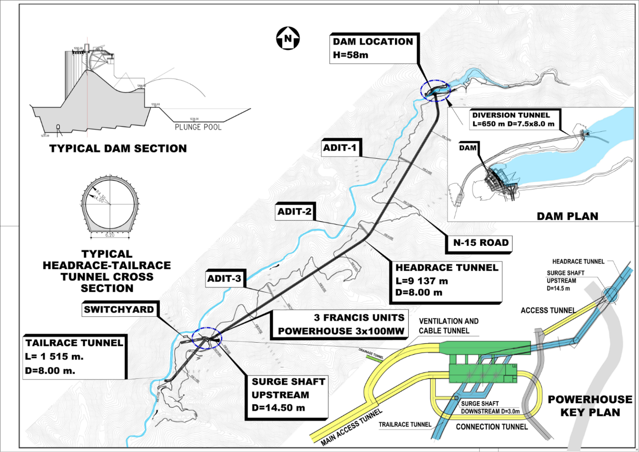
See following pages.

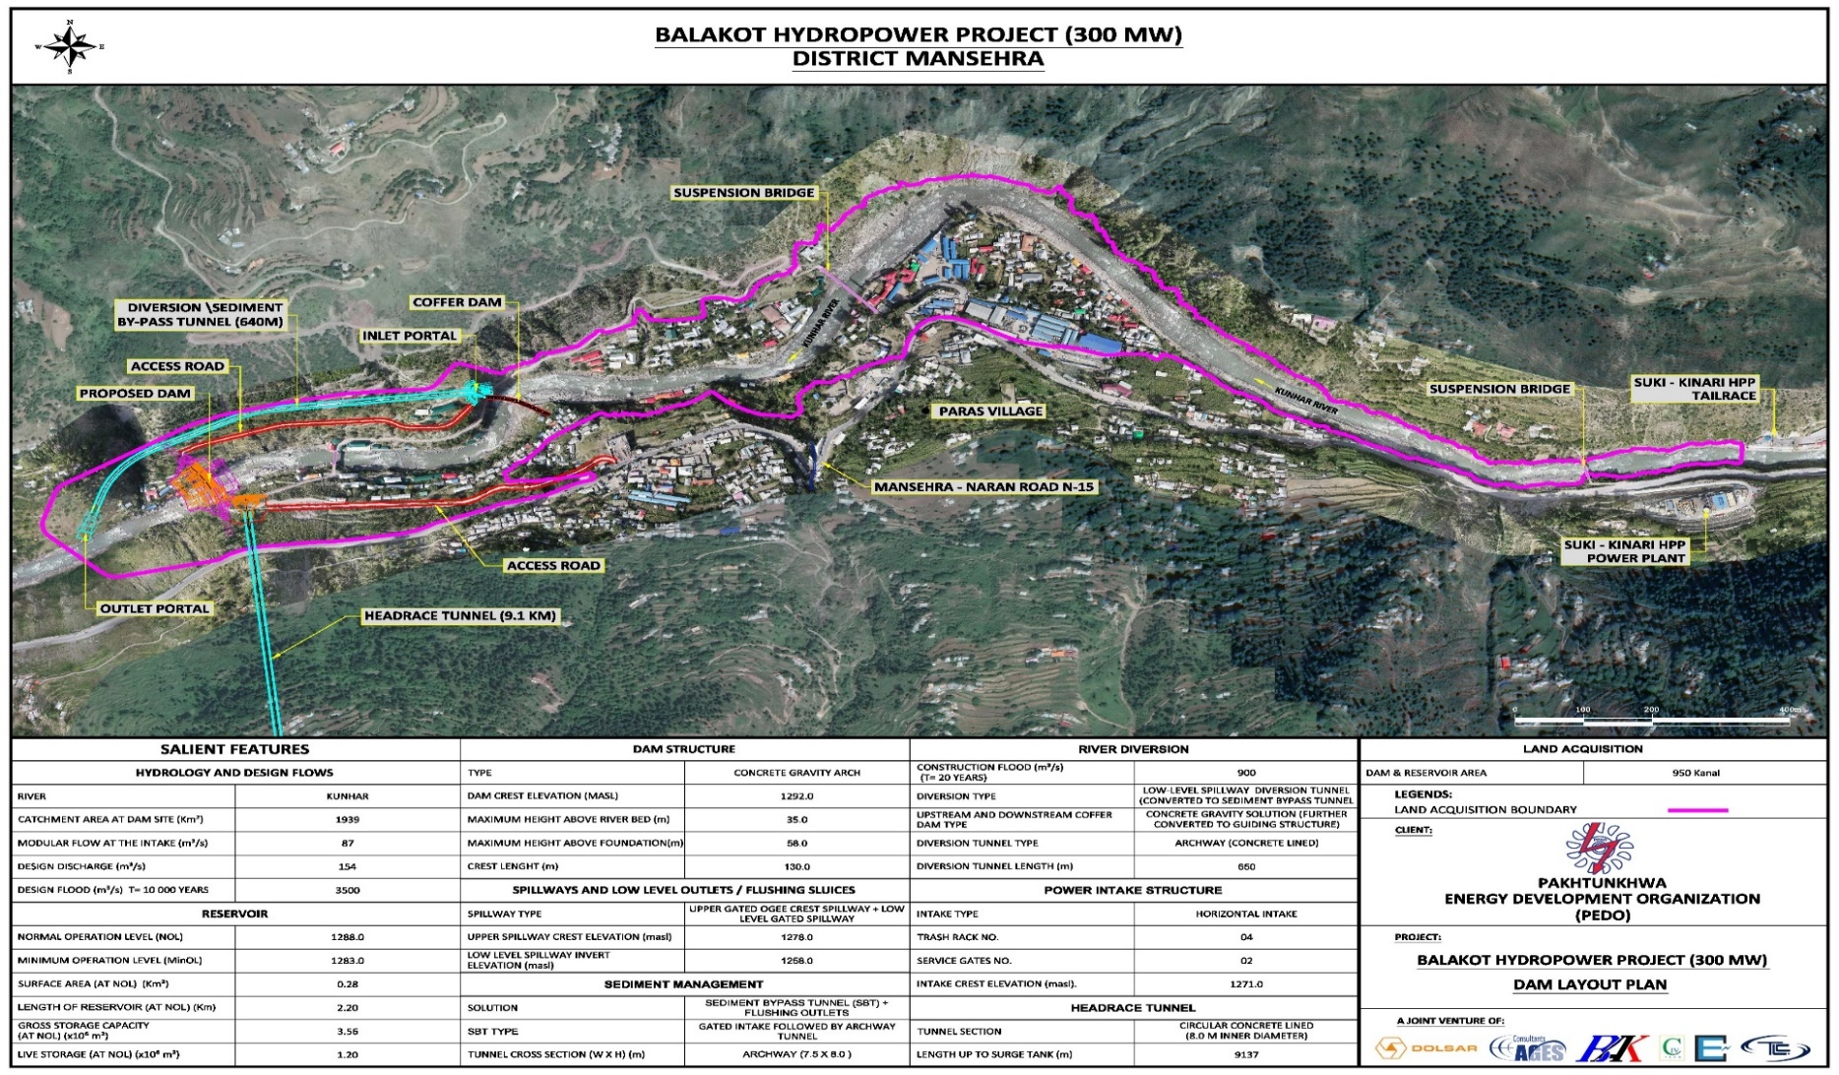
- Dam Reservoir; left side Abutment and Access Road to Dam will be established at PARAS’ settlement. The Dam Right Side Abutment and Diversion Tunnel at Bela Sacha settlement

- Questionnaires Used for Field Survey
See following pages.
- Baseline Socioeconomic Conditions
Questionnaire for Household Profile
- Investigator Information
Name of Investigator(s):
Date: Start Time: End Time:
Note any pause in interview shall be noted in the Comments section on Page 10
- Location Information
Primary Structure ID: Settlement: Mauza:
Other Structures (with explanation):
UC: Tehsil: District:
GPS Coordinate: º ʹ ʺ N, º ʹ ʺ E
- Structure ID should be the same as that on the area map. If the family has more than one structures, list the remaining IDs in the second row with explanation in brackets.
- GPS coordinate to be provided only where GPS is available
- Settlement is the name by which the village is identified by the residents
- Mauza is the revenue village
- Respondent and Head of Household (HHH) Information
 | Respondent | Head of Household
Name
Father/Husband Name
NIC Number
Mobile Number
Gender | Male Female | Male Female
Age (Response)
Year of Birth (as in NIC)
Relation to HHH | Self Father  Brother Son  Other __________________
Education | Illiterate  Madrassah  No or less than Primary  Primary (Class 5 to Class 9)  Matric (Class 10)  Intermediate (FA/FSc)  Graduate (BA/BSc)  Other ____________ | Illiterate  Madrassah  No or less than Primary  Primary (Class 5 to Class 9)  Matric (Class 10)  Intermediate (FA/FSc)  Graduate (BA/BSc)  Other ____________
If respondent is the head of household, the third column should be left blank

- Demographic Profile
Total Number of Persons in the Family (including HHH) _____________
No. | Name (Including HHH) | Relation-ship with HHH | Name of Father  /Husband | Age (Yrs) | Gender  (M/F) | Marital Status | Education Level | Class (School going child) | Primary Occupation | Secondary Occupation | Special Person (Give Detail)
 |  | Self
Note: Go to Next Page if HH members are more than 8.
Occupational Codes (See Additional Notes for further explanation):
Income Generating E-GOV = Employed in government Sector E-PVT = Employed in private Sector S-ART = Self-employed, working as artisans
S-LAB = Working as skilled or unskilled laborer S-STB = Self owned trade and business I-FAR = Income generating farming
Non-income generating N-FAR = non income generating subsistence farming N-LIV = non income generating livestock rearing
For those not working UNE = Unemployed and seeking jobs NEM = Not employed willingly STU = Student against those still studying and not working
Education Codes Ill = Illiterate Mdr = Madrassah No = No or less than Primary Prim = Primary (Class 5 to Class 9)
10 = Matric (Class 10) Int = Intermediate (FA/FSc) Grad = Graduate (BA/BSc) Other ____________
Relationship | Self-Father Mother Husband Wife Brother Sister Son Daughter Grandson Granddaughter Daughter-in-law Other
Marital Status | Married Unmarried Widowed Divorced
Age | Enter whole number only. Round off, where needed; Enter Zero “0” for infants less than 6 months and “1” for infants between 6 months and a year.

No. | Name (Including HHH) | Relationship with HHH | Name of Father  /Husband | Age (Yrs) | Gender  (M/F) | Marital Status | Education Level | Class (School going child) | Primary Occupation | Secondary Occu-pation | Special Person (Give Detail)
 |  | Self

Do you have servants, tenants, or other workers living with you? If yes please provide the details

No. | Name | Job | Age (Yrs) | Gender  (M/F) | Marital Status | Education Level | Is he/she paid in cash or in kind or both?

If the respondent is not part of the household (as listed in Demographic Profile Table) what is his place of residence?
Settlement: ____ Mauza: _______
- Housing
Ownership Status? Owned Rented Free Others
Construction Pucca (Bricks/blocks/stones) Semi Pucca Katcha Others _______
Storeys Number of rooms in the house (including bedrooms)
Number of bedrooms Number of bathrooms/toilets
Number of kitchens Number of rooms/sheds for animals?
Approximate plot size of the house (State units)
Approximate covered area (State units)
When was the house constructed?
Covered area is the area of all floors in the house. Plot size is the size of land on which the house is built and includes the court yard, out houses, driveway etc.
- Available Facilities in the House
Do you have Telephone Connection (landline)? Yes No If “Yes”, when connected (Year)?
Do you have electricity connection? Yes No If “Yes”, when connected (Year)?
Do you have Sewerage System? Yes No

Sewerage system includes constructed septic tanks and soak pit
Drinking Water Source
Spring Groundwater River/Stream Open Pond
Water Supply System from the source
Pipe Electric Pump Hand pump Carried on Animals
Carried by Family Tankers Open channel Other ____________
- Fuel Sources and Consumption
Type | Y/N | Average Bill/expense  (per month) |  | Units Consumed per Month  (mention units) |  | Source  (For LPG, Purchased wood, and Kerosene, the Location of Market; For Gathered Wood, Area where gathered) | Uses
 |  |  |  |  |  |  | L | SH | WH | C
 |  | Winter | Summer | Winter | Summer
Electricity
Fuel wood (Gathered)
Fuel wood (Market)
LPG
Kerosene
Other
L: Lighting SH: Space heating WH: Water heating C: Cooking
- Social Profile
Religion Caste Mother Tongue
Do you marry children outside your tribe/clan? | Yes |  | No
How many of the married members of the HH are married to their first cousins?
- Decision Making
Who takes decision in the family on the following issues, and how?
Issue | How the decision is taken | If unilateral who takes the decision? (Indicate member i.e. HH, spouse, elder son etc.)  If consultative, list the members consulted (i.e. HH, spouse, elder son etc.))
Household budget management | Unilateral  Consultative
Family conflicts | Unilateral  Consultative
Matrimonial decisions | Unilateral  Consultative | Are daughters consulted in their marriage?  Yes No
Property and asset management and inheritance | Unilateral  Consultative
- Migration Patterns
Years since settled in settlement:
If less than 10 years, then previous location:
Purpose of relocation from previous place:
- Family Health
Births and Deaths
Number of births in the family in last 2 years Live Stillbirth
Deaths in the family in the last 2 years
No | Age | Cause
1
2
3
4
Serious illnesses
Did any of your family members suffered from any serious illnesses during the past 2 years?
Person | Illness | Outcome | Treatment Type | Treatment Location | Estimated cost of treatment | Who paid for treatment?

Illness: | Tuberculosis, Hepatitis, Asthma, Jaundice, Tetanus, Paralysis, Diabetes, Cancer, Heart disease, Others (specify)
Outcome: | Treated, Persisting, Disability, Lost job or occupation, Death
Treatment type: | Hospitalization, OPD/Clinic, Herbal/Hakeem, Faith healer, Homeopath, Other (specify)
Accidents
Did any of your family members suffered met an accident during the past 2 years?
Person | Accident | Outcome | Treatment Type | Treatment Location | Estimated cost of treatment | Who paid for treatment?

Accidents: | Fall from height, Snake bite, Road accident, Burns, Electrocution, Accident at work, Other (specify)
Outcome: | Treated, Persisting, Disability, Lost job or occupation, Death
Treatment type: | Hospitalization, OPD/Clinic, Herbal/Hakeem, Faith healer, Homeopath, Other (specify)

Common illnesses
Are the following illnesses common in your family in the specified category (Yes/ No)
Common Diseases (عام بیماریان) |  | Men (مرد) | Women (خواتین) | Adult-Children  (6 to 14) (بالغبچے) | Children  (0 to 5) (بچے)
Tuberculosis | تپ دق
Diarrhea | اسہال
Breathing problems | دمہ
Jaundice | پیلیا
Skin diseases | جلد کے امراض
Cold and flu | بخار اورفلو
Stomach diseases | پیٹ کے امراض
Joint aches | جوڑوں کا درد
Tetanus | تشنج
Paralysis | فالج
Diabetes | ذیابیطس
Cancer | کینسر
Heart problems | دل کے مسائل
Other (specify) | دیگر
- Family Assets
Appliances
If you own any of the following in your house, Please give the quantity.
(Write quantity in figures in front of each item)
Television | Radio | Elec Room Heater | Elec water heater
Refrigerator | Freezer | Washing Machine | Elec Iron
Electric Fan | Sewing Machine | Generator | Computer
Vehicles
If you own any vehicles, please provide the details:
Type | Make (Year) | Model | Year Purchased | Current Value | Use (Commercial/  Personal)

Include cars, motorcycles, trucks, pick-up, etc.

Livestock
Number of Livestock heads of each type owned by you.
Type | Buffalo | Cow | Calf | Goat/ Sheep | Lamb | Oxen | Donkey | Horse | Chicken | Others (specify)
Number
Use
Purpose
Value Rs. /Unit
Income (State monthly or annual)

Number: If the family does not own any animal, enter “Nil”. Do not leave blank.
Use: S: Self C: Commercial B: Both
Purpose: Egg Production, Milk Production, Rearing for Meat, Carrying Load, Riding, etc.
Note: Annual Income should be zero if the livestock is only for self-use.

Are the animals sent for grazing? Yes No. If yes, where
Are the animals given fodder? Yes No. If yes, what is the monthly cost?
Estimated monthly expenses on grazing, feed, fodder and medicine
Land holding
Serial | Land Use | In this village  (mention units) | Overall Land  (mention units)
1 | Cultivated area
2 | Uncultivated area
3 | Banjar jadeed ( بنجر جدید )
4 | Banjar qadeem ( بنجر قدیم )
5 | Ghair mumkin ( غیر ممکن )
6 | Fruit orchard area
7 | Other ________________
8 | Other ________________
 | Total

Farming implements
Do you own any farming implements? Yes No. If yes,
Plough for oxen Plough for tractor Spray machine
Tractor Thresher Other ______________________

- Farming
Agriculture
No. | Crop | Season | Area under Cultivation (Specify units) | Yield / Units | Percent Sold in market | Percent Self consumed
1 | Wheat
2 | Maize
4 | Vegetables
5 | Fodder
6 | Other ____________
7 | Other ____________

What is the annual expenditures to grow crops in your land? | Rabi |  | Kharif
What is your average seasonal earning (PKR/Season)? | Rabi |  | Kharif
Fruit Trees
No. | Tree | Number of trees | Annual Production (Specify units) | Percent Sold in market | Percent Self consumed
1 | Banana (کیلا)
2 | Mulberry (شہتوت)
3 | Apple (سیب)
4 | Persimmon (املوک)
5 | Loquat (لوکاٹ)
6 | Walnut(اخروٹ)
7 | Apricot (خوبانی)
8 | Peach (آڑو)
9 | Orange (مالٹا)
10 | Plum (آلوچہ الوبخارا)
11 | Other ____________
12 | Other ____________

What is annual expenditures to grow fruits?
What is your average annual earnings from fruits?
- Comments and Notes

Additional Notes
Table D. Demographic Profile
Colum 9 — Class (In case of School going): For all children (15 years or less) either enter the class in which the child is studying or “Nil” in case the child is not going to school.
Special persons Persons with physical or mental disabilities
Occupational Codes: For income generating occupations
E-GOV = Employed in government Sector—Person employed for a salary by the government. Includes, for example, armed forces, school teachers, forest guards, and service in the municipal and tehsil administration
E-PVT = Employed in private Sector— Person employed for a salary by a non-governmental organization on any kind of job. Includes, for example, working for NGOs, private schools, and private clinics
S-ART = Self-employed, working as artisans. Earning depends on output of work. Includes, for example, carpet weaving, handicraft making,
S-LAB = Working as skilled or unskilled laborer. Includes, for example, farm labors, off-farm labors, electricians, plumbers, mechanics, mason, and bricklayers, well-diggers
S-STB = Self owned trade and business. Includes, for example, doctors, all shop owners, barbers, livestock traders, tailors, …
For non-income generating activities
N-FAR = non income generating subsistence farming
N-LIV = non income generating livestock rearing
For those not working
UNE = Unemployed and seeking jobs
NEM = Not employed willingly i.e., of their own choice (can include elderly)
STU = Student against those still studying and not working
THIS SECTION SHOULD BE FILLED FOR EACH HOUSEHOLD
Household Economics
Indebtedness
Do you owe any money to others or institutions? | Yes | No
If “Yes”, provide details as below:
Source | Year Borrowed | Amount Borrowed (PKR) | Purpose | Amount Yet to Return (PKR.)
NGO/Bank (specify)
Friends/relatives
Moneylender
Shopkeeper
Others __________________

Household Income (Average over last year)
Source | Average (Rs.) | Monthly/Annual
Salaried Jobs including remittances and pensions
1.
2.
3.
Family Sources
Farming
Livestock
Business
Rent
Arts and craft making
Other (please specify)
Expenditures (Average over last year)
Heads of Expenditure | Average (Rs.) | Monthly/Annual
Food
Clothing
Combustion fuel (gas, kerosene, fire wood, etc.)
Rent or expenditure on dwelling
Veterinary fees and medicines
Electricity charges
Medical
Education
Communication
Transportation
Social obligations (alms, charity, gifts, burials, weapons, litigations etc.)
Farm related expenditures
Other expenditures (Please specify heads below)

Interviewer
Signature:
Name:

- Census of Affected Persons and Project Impacts
Investigator Information
Name of Investigator(s):
Location Information
Settlement: Mauza:
UC: Tehsil: District:
GPS Coordinate: º ʹ ʺ N, º ʹ ʺ E
Respondent and Head of Household (HHH) Information
 | Respondent | Head of Household
Name
Father/Husband Name
NIC Number
Mobile Number
Gender | Male Female | Male Female
Age (Response)
Year of Birth (as in NIC)
Relation to HHH | Self Father  Brother Son  Other __________________

If respondent is the head of household, the third column should be left blank

Project Impacts Checklist
- I. Loss of Residence
- II. Loss of Other Infrastructure
- III. Loss of Cultivated land
- IV. Loss of Uncultivated land
- V. Loss of Fruit Trees
- VI. Loss of Other Trees
- VII. Loss of Livelihood
- VIII. Others

Inventory of Affected Structure
No. | Structure ID | Structure Type | Use
1
2
3
4
5
6
Inventory of Other Infrastructure (Water mill, retaining wall, access road, etc.)
Description | Approximate Size | Approximate value
Inventory of Cultivated Land
No. | Land Unit | Land Category | Crops Grown | Area as Stated by AP*
1
2
3
4
5
6
7
Note: Write the unit as stated by AP. Don’t convert it into any unit.
Inventory of Uncultivated Land
No. | Land Unit | Land Category | Use | Area as Stated by AP*
1
2
3
4
5

Inventory of Fruit Trees
No | Name/Species | Number
 |  | Young | Fruit Bearing | Old
1 | Banana (کیلا)
2 | Mulberry (شہتوت)
3 | Apple (سیب)
4 | Persimmon (املوک)
5 | Loquat (لوکاٹ)
6 | Walnut(اخروٹ)
7 | Apricot (خوبانی)
8 | Peach (آڑو)
9 | Orange (مالٹا)
10 | Plum (آلوچہالوبخارا)
11 | Other ____________
12 | Other ____________
Inventory of Other Trees
No | Name/Species |  | Number
 |  |  | Small |  | Medium |  | Large
1 | Deodar
2 | Blue pine
3 | Chirr
4 | Kikar
5 | Poplar
6 | Wild Olive (Kao)
7 | Eucalyptus
8 | Shishum
9 | Other ____________
10 | Other ____________
Inventory of Livelihood Impacts
Nature of Livelihood | Total Income (PKR/Month) | Loss of Income (PKR/Month)
Agriculture
Livestock
Business
Job
Labor
Other (1) _____________
Other (2) _____________

Inventory of Other Impacts, Observations and Suggestions

If your agricultural land /commercial asset are to be acquired for Balakot Hydropower Plant. Do you have any other sources of income? |  |  |  |  |  |  |  |  |  |  | Yes |  | No
If “Yes” specify the source
In case of relocation, where will you prefer to resettle?
On your own land |  |  |  | Project developed site |  |  |  |  | Within the Same village
Within the District |  |  |  | Don’t know |  |  |  |  | Other
What mode of compensation for land will be your choice?
Cash |  | Alternate Land |  |  |  | Other
If cash payments are made, then expected utilization of the money:
Business | Property |  |  |  | Agricultural Land |  | Other

Respondent | Interviewer
Signature: __________________________ | Signature: _______________________
Name: _____________________________ | Name: __________________________

- Business Survey Form
Investigator Information
Name of Investigator(s):
Location Information
Structure No Settlement: Mauza:
UC: Tehsil: District:
GPS Coordinate: º ʹ ʺ N, º ʹ ʺ E
Respondent and Business Owner
 | Respondent | Business Owner
Name
Father’s/Husband’s Name
NIC Number
Mobile Number
Gender | Male Female | Male Female
Relation to Owner | Self Son  Brother Employee  Other _________________
Detail of Business
Nature of business Service Goods Other
Brief description of business
Which year was the business established at this location?
What is the estimated value of present stock in the shop? | PKR
What is the estimated value of movable assets in the shop? | PKR
What is the estimated average sale of goods/services? | PKR/day  PKR/month
What is the average profit? | PKR/day  PKR/month
Is the space rented or owned?
If rented, rent of the shop

Detail of Employs and daily workers
No. | Name | Father’s / Husband’s Name | Position | Job Status | Monthly earning (PKR) | Place of Stay | Is the residence effected?  (Yes/No) | HH Survey Form No.
1
2
3
4
5
6
7
8
9
10

Position | Property Owner Business Owner Joint Owner (In case of Family Business) Partner Manager Salesman Other (Specify)
Job Status | Permanent Daily wage Contractor

- Inventory of Affected Public and Community Assets
Investigator Information
Name of Investigator(s):
Location Information
Settlement: Mauza:
UC: Tehsil: District:
Respondent Information
 | Respondent 1 | Respondent 2 | Respondent 3 | Respondent 4
Name
Father/Husband Name
NIC Number
Mobile Number
Gender | M F | M F | M F | M F
Age (Response)
Year of Birth (as in NIC)
Occupation
Area and Population of the Settlement
Total area of the settlement _______ Acre. Affected area of the settlement _____ Acre
Total houses of the settlement _______ Affected Houses of the settlement ___________
Total households of the settlement ____ Affected households of the settlement _______
Total Population of the settlement ____ Affected Population of the settlement _________
Affected Public infrastructure in the Village
No | Assets | Structure ID | Unit | Quantity | Construction Type
1 | Schools
2 | Roads and tracks
3 | Dispensary
4 | Offices
5 | Electric Line (Length)
6 | Electric poles
7 | Telecommunication Line (Length)
8 | Telecommunication poles
9 | Access road
10 | Water Supply
11 | Any other (specify)
Affected Community Infrastructure in the Village
No | Assets | Unit | Quantity | Construction Type
1 | Mosques
2 | Rest houses
3 | Electric poles
4 | Water Course
5 | Access road
6 | Hand Pump
7 | Water Supply
8 | Any other (specify)
9 | Any other (specify)
Other Affected Communal Assets
No | Assets | Unit | Quantity
1 | Forest
2 | Play Grounds
3 | Communal Lands
3 | Grazing Lands
4 | Any other (specify)
5 | Any other (specify)
Affected Graveyards
Graveyard No. | Quadrants | Estimated Area (Kanal) | No. of Graves | Estimated Year of establishment of the Graveyard
1.
2.
3.
4.
5.

Comments:

Affected Structures Survey
Investigator
Village
Latitude*
Longitude*
*Mandatory if no structure number
Respondent
Name
Father’s Name
NIC
Cell No
Head of Household
Name
Father’s Name
Form No
CNIC
Cell No
Structure
Use
Type
(Residential, Commercial, ……..)
Ownership
(Private, Government)
Construction Type
(Pukka, Semi-Pukka, Katcha)
When Constructed?
Any Other Information
Under construction; New (<3yr), Recent (After 2005), Old (11-20 yrs), Very Old (>20 yrs)

- Institutional / Community Consultation Logs
- Institutional Consultation Logs
Record of the Consultation Meetings
Stakeholder | Communication & Works Department, Khyber Pakhtunkhwa
Consultation | Stakeholder Consultation for the Updated LARP of Hydropower Development Investment Project
Date: | May 5, 2021
Time: | 12:15 PM
Meeting Venue: | Office of XEN-C&W, Mansehra
Attended by and contact details: | Mr. Bilal Afzal, XEN, Mansehra | 03335035527
 | Mr. Muhammad Zubair Khan, Assistant Director-PEDO | 03009073796
 | Mr. Ali Akbar (RE) | 03435811406
Conducted by: | Ali Akbar (RE)
Recorded by: | Ali Akbar (RE)
Language: | Urdu
Preamble | Mr. Bilal Afzal, XEN, Mansehra was briefed about the purpose of the meeting. Although he was aware of the project but no one from the project side oriented him of the project objectives and updated progress.
Issues Identified
- No dedicated team for the assessment of built-up properties.
- In the beginning of the project there was no regular coordination among C&W and project staff.
- No proper planning and monitoring of the assessment of built-up property.
RECOMMENDATIONS
- The assessment carried out need re-verification.
- Proper team building for re-assessment comprising of an engineer from C&W, PEDO, and a Patwari from the revenue department.
- Shared responsibilities and cross cheque.
- Dedicated additional staff needed for the verification and assessment of built-up properties as the regular staff of C&W department is over burden with their routine work.
- Compensation for additional work
- Logistic support and vehicles for the field staff of C&W to carry out the verification of the built-up properties.

Stakeholder/s: | Forest Department, Mansehra Khyber Pakhtunkhwa
Consultation | Stakeholder Consultation for the final LARP of Hydropower Development Investment Project
Date: | June 1, 2021
Time: | 11: 00 am
Meeting Venue: | DFO Kaghan, Forest Department Office, Mansehra, Khyber Pakhtunkhwa
Attended By: | Mr. Farrukh Sair,  Divisional Forest Officer Kaghan, Mansehra | +92 (997) 410 020,  +92 (346) 9331327
 | Mr. Aman Ullah Khan, SDFO, Mansehra | 03439300777
 | Mr. M. Anees-RFO, DFO office Mansehra | +92 (345) 298 8319
 | Mr. M. Haneef, EDO, DFO office Mansehra | +92 (301) 5965126
 | Mr. Muhammad Sajjad, SC, DFO office Mansehra | +92 (345) 9552719
 | Mrs. Fatima Noor- Field Enumerator- PMC, BHPP | +92 (308)9306188
 | Mr. Ali Akbar-Resettlement Expert (RE), PMC-BHPP | +92 (343)5811406
 | Mr. Fakhar Ul Islam- GIS Expert, PMC-BHPP | +92 (333) 5026670
Stakeholder: | Forest Department, Mansehra Khyber Pakhtunkhwa
Consultation: | Stakeholder Consultation for the final LARP of Hydropower Development Investment Project
Conducted by: | Mr. Ali Akbar (RE)
Recorded by: | Mr. Ali Akbar (RE)
Language: | Urdu
Preamble: | The stakeholder representatives were briefed about the Project and its objectives and impacts. The DFO- Kaghan was newly posted though he was familiar with the project area but was unaware of the project boundaries and demarcation lines.
CONCERNS
Guzara Forest: Guzara forest belong to community while forest department has a 20% share in Guzara Forest. The department fears deforestation due to dam construction.
Forest degradation: The forest already on degradation due to human activity. The locals are cutting trees for their own as well as commercial consumption which causes deforestation.
Project footprint: The forested area in the Project footprint is minimal and not of concern because Project-related activities will not result in degradation of large forested areas.
Reserve Forests: Reserved Forest is the property owned by the provincial Government. There are no concerns with Reserve Forests as these will not be affected by the Project. Areas further away from the Project infrastructure have Reserve Forests but these will not be affected by the Project.
Assessment of Wild Trees: Assessment of wild trees was an issue between the horticulture and forest field staff as none of them was taking the responsibility of measuring these wild trees. The DFO-Forest Kaghan in today’s session clarified that assessment of wild trees is the responsibility of the forest department.
Size of the Project: The Department supports this development because it will generate much-needed electricity for the country. It is viewed as a positive development in addressing national needs.
Ownership of the trees: Most of the trees affected by the project are privately owned.
Project demarcation: The DFO requested for a joint visit of the representative of forest department and PMC for knowing the demarcation lines of the project which was agreed and accordingly a project site visit was arranged.
Forest office in Paras: As the dam is expected to submerge one of the forest offices situated at Mouza Paras. The department requested the project to purchase land and construct a new office for the forest department in the nearby location.
Afforestation/Plantation: The DFO proposed 5 years compensatory trees plantation plan wherein, the department will be responsible for re-plantation of trees with a 1:10 ratio. The project was requested to bring it under the livelihood development plan and finance them for a period of 5 years.

Stakeholder | Wildlife Department Mansehra, Khyber Pakhtunkhwa
Consultation | Stakeholder Consultation for the Updated LARP of Hydropower Development Investment Project
Date: | June 01, 2021
Time: | 03:15 PM
Meeting Venue: | Office of DFO- Wildlife, Mansehra
Attended by and contact details: | Mr. Sayed Taimur Ali Shah-DFO Wildlife, Mansehra | 03339336666
 | Mr. Akhlaq Ahmad (LDNP), Mansehra | 03468860974
 | Mr. Ali Akbar (RE) | 03435811406
 | Mr. Fakhar Ul Islam- GIS Expert, PMC-BHPP | +92 (333) 5026670
 | Mrs. Fatima Noor- Field Enumerator- PMC, BHPP | +92 (308)9306188
Conducted by: | Ali Akbar (RE)
Recorded by: | Ali Akbar (RE)
Language: | Urdu
Preamble | Mr. Sayed Taimur Ali Shah-DFO Wildlife, Mansehra was briefed about the purpose of the meeting. He was quite unaware of the project as before this meeting no one from the project side oriented him of the project objectives and updated progress.
Issues Identified
- Environmental flow to take care of the aquatic life dependent on the river.
- Manshi wildlife reserved area is on a distance of approximately 13 to 14 KM from the project site.
RECOMMENDATIONS
- Extreme care may be taken to avoid damaging endangered species in the dam area of influence.
- It is also recommended that a compound comprising of 3 rooms, kitchen, wash rooms, veranda etc may be constructed to be utilized for wild life research center, watch and ward station. This is would help the department to keep check on the illegal hunting and research will further enrich the department in caring and raring activities of the wild animals.

Stakeholder | District Administration Mansehra, Khyber Pakhtunkhwa
Consultation | Stakeholder Consultation for the Updated LARP of Hydropower Development Investment Project
Date: | June 01, 2021
Time: | 05:45 PM
Meeting Venue: | Office of Additional Deputy Commissioner (ADC), Mansehra
Attended by and contact details: | Mr. Maqbool Hussain-ADC, Mansehra | 0997-920179  03018883635
 | Mr. Ali Akbar (RE) | 03435811406
 | Mrs. Fatima Noor- Field Enumerator- PMC, BHPP | +92 (308)9306188
Conducted by: | Ali Akbar (RE)
Recorded by: | Ali Akbar (RE)
Language: | Urdu
Preamble | Mr. Maqbool Hussain -ADC, Mansehra was briefed about the current development and status of the project.
Issues Identified
- It was brought to knowledge of ADC that the APs in Mouza Paras are not happy with the land prices of their affected land.
- The APs are not cooperating in collection of information about their land and socio-economic status etc.
- The APs are taking the plea that they were betrayed in Sukki Kinnari Project and were not paid as per agreed prices of land and structures.
- The community is politicizing the BHPP project to get undue benefits from the project.
- No proper assessment of the affected assets was carried out in Sukki Kinnari
- Trust deficit due to S.K project.
RECOMMENDATIONS
- Fair, proper and justified assessment need to be carried out for all the affected assets.
- PEDO through contractor must ensure employment opportunities for the locals. And preference may be given to local in skilled and unskilled jobs
- In time compensation against the built-up property, land and associated assets and allowances may be ensured.
- The contractor may be bounded to construct a Mosque for the Muslim employees in the labor colony.
- The contractor may be asked in writing to abide by the national labor laws and give due rights to the employees/laborers.
- As per National Labor law immediate relief may be provided to the laborers in case of injury, death or any other casualty.
- The contractor may be asked to ensure implementation of national labor laws by giving written contract agreement and the agreement may be followed in true spirit.
- Risk allowance and other allowances may be ensured in the written agreement.
- A social mobilization unit may be established in project site to ensure APs mobilization by keeping them aware of the positive developments meant for the community.
- The social mobilization unit keep informed the community about their roles and responsibilities.
- The social unit must give orientation session to the laborers and other project staff on the local values and norms.

Stakeholder: | District Education Office, Male-Mansehra
Consultation: | Stakeholder Consultation for the Updated LARP of Hydropower Development Investment Project
Date: | June 02, 2021
Time: | 10:00 am
Meeting Venue: | Office of District Education Officer -Male, Mansehra
Attended By: | Mr. Muhammad Taimur – District Education Officer, Mansehra
 | Mr. raja Jahangir- Dyputy District Education Officer-Male, Mansehra
 | Mr. Ghulam Jilani -Sub Divisional Education Officer- Balakoyt
 | Mr. Ali Akbar (RE) | 03435811406
 | Mr. Fakhar Ul Islam- GIS Expert, PMC-BHPP | +92 (333) 5026670
 | Mrs. Fatima Noor- Field Enumerator- PMC, BHPP | +92 (308)9306188
Conducted by: | Mr. Ali Akbar (RE), Mr. Fakhar Ul Islam-
Recorded by: | Mr. Ali Akbar (RE)
Language: | Urdu
Preamble | Mr. Muhammad Taimur -DEO-Male, Mansehra was briefed about the purpose of the meeting. He was quite unaware of the project as he was newly posted in Mansehra. For assistance he called two of his colleagues. He was briefed about the about previous and present status of the project and its objectives. Followed by a project map presentation by Mr. Fakhar Ul Islam-GIS Specialist of the PMC.
Issues Identified:
- One Government High School for boys at Nehan, One Government Girls Higher Secondary school for girls at Bela Balsehri and one primary school for girls at Bela Balsehri are to be affected by the construction of dam.
- Relocation and reconstruction of schools.
- Quality of construction.
- New buildings may be constructed before dismantling of the schools’ buildings.
RECOMMENDATIONS
- The DEO office supported the provincial government initiative of construction of BHPP by saying that the project will add to the energy deposits of the province as there is energy shortage which in turn negatively effecting the province economy.
- The schools may be shifted and reconstructed in the nearby locations as these schools are serving a reasonable population living in the surrounding villages.
- It is highly recommended to give us land against land and construct new building for the schools through CCGC or C&W.
- Quality construction may be ensured
- New buildings for schools may be constructed before dismantling the existing buildings.
- An education complex is recommended at a common and accessible location.
- Accommodation may be constructed for the teachers and other staff members both bachelors and family.
- Primary schools may be constructed as per SOPs of the provincial government comprising of 6 Nos Class rooms, one office, 3 Nos wash rooms, 1 No water supply, play area, and solar energy system may be ensured.
- 6 Nos teachers may be posted in each primary school.

Stakeholder: | Public Health Engineering Department -PHE, Mansehra
Consultation: | Stakeholder Consultation for the Updated LARP of Hydropower Development Investment Project
Date: | June 02, 2021
Time: | 11:30 am
Meeting Venue: | Office of Executive Engineer Public Health, Mansehra
Attended By: | Mr. Sayed Shahab Ud Din – Sub Divisional Officer-SDO, Mansehra | +92 -3452740004
 | Mr. Ali Akbar (RE) | +92 -3435811406
 | Mr. Fakhar Ul Islam- GIS Expert, PMC-BHPP | +92 (333) 5026670
 | Mrs. Fatima Noor- Field Enumerator- PMC, BHPP | +92 (308)9306188
Conducted by: | Mr. Ali Akbar (RE), Mr. Fakhar Ul Islam-
Recorded by: | Mr. Ali Akbar (RE)
Language: | Urdu
Preamble | Mr. Sayed Shahab Ud Din – Sub Divisional Officer-SDO, Mansehra was briefed about the purpose of the meeting. He was quite unaware of the project as he was newly posted in Mansehra. He was briefed about the about previous and present status of the project and its objectives. Followed by a presentation on project map by Mr. Fakhar Ul Islam-GIS Specialist - PMC.
Issues Identified:
- The PHE have water supply schemes in the project affected area. The department fear that might be damaged by the project.
- The dislocated people would need water supply. So, what can the project do in constructing new schemes for the water supply.
- The PHE Mansehra so far didn’t identify and measured their assets in the project site.
RECOMMENDATIONS
- A joint visit of the PHE, Mansehra and GIS specialist – PMC proposed by the SDO to verify their assets to be affected by the project within the demarcated area of the project.
- The PHE staff was asked to measure their assets in the project affected site and share the same with the PMC through the office of the Deputy Commissioner Mansehra.
- The PHE will assess the assets and later will be responsible for establishing new schemes for the dislocated population of the project.
- The SDO asked for additional to be incurred on the boring, installation of taping etc. in the new locality.
- The SDO will prepare an estimated budget of the new water supply scheme and will share the same with the DC office in Mansehra.

Stakeholder: | Director Agriculture Department, Mansehra
Consultation: | Stakeholder Consultation for the Updated LARP of Hydropower Development Investment Project
Date: | June 07, 2021
Time: | 10:30 am
Meeting Venue: | Office of the Director Agriculture, Mansehra
Attended By: | Mr. Masood Ur Rahman-Deputy Director Agriculture, Mansehra | +92-997-300149  +92-301-8142672
 | Mr. Nayyer Zoha Khan- Agriculture officer, Mansehra | +92-3149944299  +92-3459576404
 | Mr. Ali Akbar (RE) | +92 -3435811406
 | Mr. Fakhar Ul Islam- GIS Expert, PMC-BHPP | +92 (333) 5026670
 | Mr. Waleed Khan – Field Enumerator- | +92 -3329947792  +92- 3409698025
Conducted by: | Mr. Ali Akbar (RE), Mr. Fakhar Ul Islam-
Recorded by: | Mr. Ali Akbar (RE)
Language: | Urdu
Preamble | Mr. Masood Ur Rahman-Deputy Director Agriculture and Mr. Nayyer Zoha Khan- Agriculture officer, Mansehra were briefed about the purpose of the meeting. Both of them were aware of the project and updated status as back in Feb-March the surveys of the agriculture/horticulture component in the affected project site were carried out by Mr. Nayyer- Agriculture Officer.
Issues Identified:
- The project will affect walnuts, apple and other fruits trees.
- The project will affect main crops i.e., maize and wheat.
- The farmer’s economy in project affected site is dependent on agriculture and horticulture.
- Mode of payment in Sukki Kinari dam was a cumbersome exercise as the affecttees faced a challenging tough time in receiving their compensation against their assets.
Recommendations
- Fruit trees may be restored by planting new trees with a 1-10 ratio.
- Land for land option may be given to the farmers so that they can keep continued with their farming.
- Mode of payment to the APs may be simplified.
- Extreme care may be taken to avoid cutting of fruit trees.
- A new town may be constructed for the affecttees where they can live together.
- To stabilize farmer’s economy and rehabilitate them need the following trainings.
- Value addition training.
- Kitchen gardening
- Archard management
- Fruits plants nursery raising techniques
- Fruits drying techniques
- Off season vegetables etc.

Stakeholder: | Director Livestock Department, Mansehra
Consultation: | Stakeholder Consultation for the Updated LARP of Hydropower Development Investment Project
Date: | June 07, 2021
Time: | 02:00 pm
Meeting Venue: | Office of the Director Livestock, Mansehra
Attended By: | Dr, Muhammad Ilyas-Director Livestock, Mansehra | +92 -307-8171031
 | Mr. Rashid Qureshi- Senior Clark, Mansehra | +92-3469700010
 | Mr. Ali Akbar (RE) | +92 -3435811406
 | Mr. Fakhar Ul Islam- GIS Expert, PMC-BHPP | +92 (333) 5026670
 | Mr. Waleed Khan – Field Enumerator- | +92 -3329947792  +92- 3409698025
Conducted by: | Mr. Ali Akbar (RE), Mr. Fakhar Ul Islam-
Recorded by: | Mr. Ali Akbar (RE)
Language: | Urdu
Preamble | Dr, Muhammad Ilyas-Director Livestock, Mansehra and Mr. Rashid Qureshi- Senior Clark, Mansehra were briefed about the purpose of the meeting. Both of them were not aware of the BHPP objectives and salient features. Background and updated status of the project discussed with the officials.
Issues Identified:
- The project will disturb the ratio of livestock population in the project affected area.
- The project will affect grazing area.
- Effect on crops will have effect on the fodder production.
- Two dispensaries of livestock one each at Ghanool and Paras serving livestock population of the affected area.
- The baseline of livestock population is 2006 survey. No updated information available with the department.
- House hold income from livestock sector will be decreased as the main source of livelihood is the livestock sale & purchase.
RECOMMENDATIONS
- Livestock is a movable property the APs can easily move their livestock to another area.
- Currently the livestock census survey is in progress in Mansehra district.
- Migration of livestock population will disturb the budget, vaccination and other related inputs of both the dispensaries’ as they were meant for serving the project affected population. This is highly recommended to accommodate the dislocated population in the nearby villages.
- The finance department will have to revisit their budgetary allocation for the Project Affected Area as they have been allocating funds on the basis of livestock population in the area.
- Distribution of livestock (Cattle, goats & Poultry units)
- Distribution of livestock inputs (Feed, De wormers, vaccines)
- Livestock Management Training (Female)
- Livestock Management Training (Male)
- Treatment & Vaccination Camps
- Livestock Field days.
- Provision of mobility & honorarium to the staff.
Union Council wise livestock population affected
S# | Name of Union Council | %age Affected
1 | Kawai | 25% (Approx.)
2 | Ganhool | 22 % (Approx.)

Stakeholder: | District Health Officer (DHO), Mansehra
Consultation: | Stakeholder Consultation for the Updated LARP of Hydropower Development Investment Project
Date: | July 07, 2021
Time: | 02:00 pm
Meeting Venue: | Office of the District Health Officer (DHO), Mansehra
Attended By: | Dr. Muhammad Idrees, Deputy DHO, Mansehra | +92 -343-0511251  +92-997-920169
 | Dr. Nasir Rabbi- Coordinator-LHW Program | +92-343-0961926
 | Dr. Shah Fahad-District Entomologist, Mansehra | +92-302-5270702
 | Mr. Israr Shoukat-In charge Development Section, Mansehra | +92-333-5990893  +92-997-920166
 | Mr. Ali Akbar (RE) | +92 -3435811406
 | Mr. Ibad Ullah, PMC-BHPP | +92 (333) 9372387
 | Mrs. Fatima Noor – Field Enumerator- | +92 (308)9306188
Conducted by: | Mr. Ali Akbar (RE), Mr. Ibad Ullah (ARE)
Recorded by: | Mr. Ali Akbar (RE)
Language: | Urdu
Preamble | Dr, Muhammad Idrees, Deputy DHO, Dr. Nasir Rabi- Coordinator-LHW Program Mansehra, Israr Shoukat-In Charge Development Section, Dr Shah Fahad-District Entomologist. The participants were briefed about the purpose of the meeting. The salient features of the project came under discussion. Background and updated status of the project discussed with the officials.
Issues/concerns Identified:
- The participants liked the construction of dam and favored the construction of dam for national interest.
- The project will affect 4 Kanals of land of Basic Health Unit (BHU) land in Rehtar-Mouza Paras. They were worried and raised the question whether the same amount of land will be provided for reconstruction of land or otherwise.
- They wanted same or better-quality construction of the BHU.
- The BHU facilitate/serve about 8000 populations of In-door and Out-door patient. So, they wanted the BHU to be reconstructed in a place accessible for the affected population.
- The BHU is running short of medical equipment and furniture etc. They requested for provision of the same in the new BHU.
- The RE shared proposed site for construction of hospital (staff colony) with the participants. The stakeholders responded that Sangar area is the appropriate and centrally located site for the hospital.
- The stakeholders raise the issue that in case the hospital was demolished then where they will treat the patients during the transitionary period.
RECOMMENDATIONS
- The doctors recommended a well-equipped and modern hospital for the affected population within the project Area of Influence (AOI).
- They proposed a centrally located place for the reconstruction of the hospital.
- The minimum land for the hospital must not be less than 4 Kanals however, up to 8 Kanals of land will even fulfill the future needs of the population.
- They recommended that the hospital must be equipped with modern health technology so that majority of the patients could be treated then and there.
- On behalf of the project the RE assured that the contractor will be asked to construct the new building before dismantling the existing BHU.

Stakeholder/s: | Social Welfare Department, Mansehra
Consultation | Stakeholder Consultation for the Updated LARP of Hydropower Development Investment Project
Date: | July 07, 2021
Time: | 11:30am
Meeting Venue: | Office of District Officer Social Welfare, Mansehra
Attended By | Mr. Sayed Sabir Shah, Social Welfare Officer, Mansehra | +92-344-4533340
 | Mr. Sajjad Ahmad, Assistant Social Welfare Officer, Mansehra | +92-334-5584053
 | Mr. Ali Akbar (RE) | +92 -3435811406
 | Mr. Ibad Ullah,(ARE) PMC-BHPP | +92 (333) 9372387
 | Mrs. Fatima Noor – Field Enumerator- | +92 (308)9306188
PMC Representatives | Mr. Ali Akbar (RE), Mr. Ibad Ullah, (ARE) PMC-BHPP, Mrs. Fatima Noor – Field Enumerator
Stakeholder Representatives | Mr. Sayed Sabir Shah, Social Welfare Officer, Mansehra, and Mr. Sajjad Ahmad, Assistant Social Welfare Officer, Mansehra
Conducted by: | Mr. Ali Akbar (RE)
Recorded by: | Mr. Ali Akbar (RE), Mr. Ibad Ullah, PMC-BHPP
Language: | Urdu
Preamble: | The participants were briefed about the purpose of the meeting. The salient features of the project. Background of the project and updated status of the project.
Concerns
- There will be a significant impact on different facilities in community and thus will have direct impact on the affected person in particular on Person with Disability (PWD). The accessibility code of Pakistan 2006 gives rights to PWDs.
- The youth of the affected community might lose their jobs.
- The daily wagers might lose their income.
- The small business men/women might lose their income sources.
- The small land holders might lose their income.
- Many skilled and unskilled workers might lose their source of livelihood.
- Several communities owned assets might get inundated.
RECOMMENDATIONS
- A comprehensive plan may be devised for the rehabilitation of the affected communities.
- Public infrastructure like schools and BHUs should be relocated.
- Facility may be provided for PWD in the newly constructed buildings.
- Jobs creation for the affected communities’
- Skill trainings for the unskilled youth
- Vocational trainings for the women of the affected communities
- Graves should be managed with the consent of the communities
- Project should provide special assistance to vulnerable households.
- Revival of the small businesses of the APs in the new location.

Stakeholder/s: | District Education Officer (DEO) female, Mansehra
Consultation | Stakeholder Consultation for the Updated LARP of Hydropower Development Investment Project
Date: | July 08, 2021
Time: | 12:30 pm
Meeting Venue: | Office of District Education Officer (DEO) female, Mansehra
Attended By | Mrs. Naghmana Sardar, DEO-Female), Mansehra | +92-334-5621982
 | Mrs. Faiza Shoukat, Principal, Mansehra | +92-331-5584053
 | Mr. Raja Tahir, ADEO | +92-3335470902
 | Mrs. Iffat Jabeen, Deputy District Education Officer, Mansehra | +92-345-5956160
 | Mr. Basharat Shah, Development Assistant – DEO office Mansehra | +92- 346-9630206
 | Mr. Ali Akbar (RE) | +92 -3435811406
 | Mr. Ibad Ullah, PMC-BHPP | +92 (333) 9372387
 | Mrs. Fatima Noor – Field Enumerator- | +92 (308)9306188
PMC Representatives | Mr. Ali Akbar (RE), Mr. Ibad Ullah, PMC-BHPP, Mrs. Fatima Noor – Field Enumerator
Stakeholder Representatives | Mrs. Naghmana Sardar, DEO-Female), Mansehra, Mrs. Faiza Shoukat, Principal, Mansehra, Mr. Raja Tahir, ADEO, Mrs. Iffat Jabeen, Deputy District Education Officer, Mansehra, Mr. Basharat Shah, Development Assistant – DEO office Mansehra
Conducted by: | Mr. Ali Akbar (RE)
Recorded by: | Mr. Ali Akbar (RE), Mr. Ibad Ullah, PMC-BHPP
Language: | Urdu
Preamble: | The participants were briefed about the purpose of the meeting. The salient features of the project. Background of the project, location and updated status of the project.
Concerns
- The main concern of the participants was there two schools one high and one primary for girls. The participants were also worried about the students as the high school is newly constructed and opened for the students. In case the schools were dismantled where the student could be accommodated. This would be great loss to their education because time of students will waste.
- The participants wanted the construction quality of the schools to be of high quality. As the existing buildings they said were funded by USAID and constructed under the strict supervision of their monitoring.
- The building should be earthquake resistant.
- What would be the mode of selection of land for construction of new schools.
- Who will construct access road to schools?
- Who will provide facilities of water supply, electricity, furniture, computers, accessories for computer lab and science lab?
- In case the schools constructed far from the community then residential quarters would be needed for the female teacher and staff. The residential compound they proposed should be comprised of 4 rooms, two common wash rooms, and 1 kitchen.
- Play area for the students.
- They recommended 10 Kanals of land for construction of school building and play ground,
- An NGO with the name “Friends” and with the financial support of KNK-Japan have started 9th and 10th classes in the high school of Paras.
RECOMMENDATIONS
- There should have no compromise on the quality of construction of schools.
- The schools may not be dismantled unless the new are constructed.
- A committee may be formed for site selection of new schools comprising of community elders, representatives of local government, DC office, PEDO officials and revenue department etc.
- Access road and other basic amenities may be provided in the schools before commencement of classes.
- Residential rooms and allied facilities may be constructed for the female teachers and associated staff.
- All future needs may be accommodated in the new buildings for the schools.

Stakeholder/s: | Executive Engineer (buildings) Communication and Works Department, Mansehra
Consultation | Stakeholder Consultation for the Updated LARP of Hydropower Development Investment Project
Date: | July 08, 2021
Time: | 03:30 pm
Meeting Venue: | Office of the Executive Engineer (buildings) Communication and Works Department, Mansehra
Attended By | Eng. H.M. Umair Anwar- XEN (Buildings), Mansehra | +92-324-5080444
 | Eng. Danish Ali-Sub Divisional Officer (SDO) buildings, Balakot | +92-313-5866091
 | Babar Zaman- Sub Engineer, | +92-346-9665813
 | Mr. Ali Akbar (RE) | +92 -3435811406
 | Mr. Ibad Ullah, PMC-BHPP | +92 (333) 9372387
 | Mrs. Fatima Noor – Field Enumerator- | +92 (308)9306188
PMC Representatives | Mr. Ali Akbar (RE), Mr. Ibad Ullah, (ARE) PMC-BHPP, Mrs. Fatima Noor – Field Enumerator
Stakeholder Representatives | Eng. H.M. Umair Anwar- XEN (Buildings), Mansehra, Eng. Danish Ali-Sub Divisional Officer (SDO) buildings, Balakot, Babar Zaman- Sub Engineer
Conducted by: | Mr. Ali Akbar (RE)
Recorded by: | Mr. Ali Akbar (RE), Mr. Ibad Ullah, PMC-BHPP
Language: | Urdu
Preamble: | The participants were briefed about the purpose of the meeting. The salient features of the project. Background of the project, location and updated status of the project.
Concerns
- Meager logistic and other resources with C&W department Mansehra
- We doubted not to meet the targets within due course of time because of lack of human and financial resources, vehicles, POL, as the routine POL and logistics are meant for the routine activities of the department. To do additional work need additional resources.
- Short of field staff (sub engineers) etc. for field activities.
- Challenges from the community as don’t allow for re-assessment or verification of the built-up properties.
- So far, no engineer from the PEDO joined the survey team. To authenticate the data, the inclusion of PEDO engineer or sub engineer is required.
- No stationary, computer or printer provided by the PEDO.
- No additional compensation given to the field staff and other official for their additional work on BHPP.
- No security has been provided to the field staff.

RECOMMENDATIONS
- After discussion with the C&W department it was decided to bring all their demands on paper and write a letter to the concerned for provision of the human and financial support.
- It was also recommended that security of the field staff may be ensured.
- All technical staff may be made available to the department for early completion of the tasks.
- Vehicles’ may and additional compensation may be provided to the field staff and concerned officials against their additional work they are being carrying out.

- Women Community Consultation Logs

Stakeholder/s or Settlement | Paras (Bele Belsari)
Consultation | Community consultation
Date: | May 6, 2021
Time: | O2:00pm
Meeting Venue: | Bele Belsari
Attended by and contact details: | Name | Contact Number
 | Bibi Aziz Fatima | 034309443301
 | Zainab Bibi | 03425279319
 | Bibi Taytalnisa
 | Bibi saraj ul nisa | 03441965609
 | Ammara Shah | 03479253221
 | Bibi sofiya | 03419568501
 | Kaneez Fatima
 | Khushnooda | 03470735020
 | Kosar Bibi | 03444838714
 | Bibi Mahaj | 03478112018
 | Amrat | 03441965609
 | Bibi Musrat | 03484692924
 | Bibi huzify | 03441965609
 | Bibi Musrat | 03465685422
 | Bibi Noorsaba
 | Bibi Zeenat
 | Bibi Khurshad
Conducted by: | Fatima Noor (enumerator)
Recorded by: | Fatima Noor (enumerator)
Language: | Urdu and Hinko where required for Local understanding and better communication.
Issues, Concerns and Suggestions: | - The respondents were found reluctant for giving up their houses, land and other assets. They got an emotional attachment with them.  - The male and female members of this community are on strike for their due rights and the administration of dam and district administration is not listening to them to resolve their issues. They said if the situation remains the same, they will not cooperate in BHPP.  - The women folk demanded land for land and cash for built-up property at replacement cost. If government did meet their demands, then they will not cooperate with the government.  - They suffered a lot due to past interventions. They want the government to be help them rehabilitate and restore their assets and livelihood.  - The women present in this consultation session were brought back from the protestors camp as they are on strike against Sukkii Kinnari for their due rights.  - The protesting women demanded special package for the women and elderly members of the affected community as they suffered several times and their livelihood deteriorated many folds.

Stakeholder/s or Settlement | Paras, (Nihan)
Consultation | Community consultation
Date: | May 6, 2021
Time: | 10:00pm
Meeting Venue: | Nihan
Attended by and contact details: | Name | Contact Number
 | Bibi Sadikya | 03459626670
 | Zainab Bibi | 03459626670
 | Bibi Gul Naseem | 03459682409
 | Marhaba Bibi | 03414246496
 | Yaseem | 03443043147
 | Latifulnisa | 03466225190
 | Bibi Musrat | 03407962805
 | Bibi Nazma | 03459621179
 | Bibi Shafia | 03479315010
 | Mayida Batool | 03479031501
 | Bibi Farzayana | 03469645749
 | Bibi Rahat | 03433733335
 | Bibi Safiya | 03451379181
Conducted by: | Fatima Noor
Recorded by: | Fatima Noor
Language: | Urdu and Hinko where required for Local understanding and better communication.
Issues, Concerns and Suggestions: | - The women in consultation group were found un-happy with the construction of BHPP. As they were worried that dam will wash out their houses, and other assets as well as all means of their livelihood.  - The means of communication, public and community infrastructure will also be washed out by the BHPP. Before dismantling these buildings, the government should reconstruct them at an accessible location for the affected community.  - The respondents want PEDO to give them land for land and cash for the built-up property and other assets at replacement cost. This will capable them to re-built their houses. So, they can resettle in a dignified way at the new location.  - The income sources may be generated for the affected community so they can restore their lost economy and rehabilitate easily.  - The women demanded vocational and other trainings and assistance for the affected women to earn their livelihood.  - Women wanted the government to rehabilitate the hospital and educational institutions on priority basis. They wanted the new bridges to be reconstructed before dismantling the existing two bridges at Nehan and Rehtar settlement so that communication between the right and left side residents of the affected communities remain intact.

Stakeholder/s or Settlement | Paras, Ratar
Consultation | Community consultation
Date: | May 5, 2021
Time: | 10:00pm
Meeting Venue: | Ratar
Attended by and contact details: | Name | Contact Number
 | Bibi Tayyaba | 03414898536
 | Ambreen Bibi | 03459483591
 | Saima Bibi | 03469609520
 | Zohra Bibi | 03451555006
 | Chand Bibi | 03429706640
 | Sidra Bibi | 03425587053
 | Sofia | 03451555006
 | Summera Bibi | 03469659470
 | Mehfuza Bibi | 03468291876
 | Nadia Bibi | 03453987145
 | Sadia Bibi | 03439551375
 | Faiza Bibi | 03420649126
 | Rabia Bibi | 03469634940
 | Suyria Bibi | 03421959449
 | Musrat Bibi | 03469604893
 | Rifhat Bibi | 03445550872
 | Asia Mustaq | 03469634940
 | Nadia Bibi | 03453986389
 | Marium Bibi | 03445550872
 | Noreen Bibi | 03475884010
Conducted by: | Fatima Noor
Recorded by: | Fatima Noor
Language: | Urdu and Hinko where required for Local understanding and better communication.
Issues, Concerns and Suggestions: | - The women in consultation group were aware of the project background. However, they were briefed on the salient features of the project.  - The women in consultation were found reluctant for giving up their assets for the dam construction as they took the plea that they have their sources of income in the project affected area. . The dam will snatch their sources of livelihood and will not bother to restore their previous economic condition.  - Major sources of their income were land, hotel business, crushing stones, selling sand of the river, selling dry and fresh fruits and seasonal income of rent from a portion of their house.  - The women were found worried about the education of their kids. They responded that the available education is already substandard and the government wanted to demolish the schools’ buildings for the construction of dam. This will further depilate the education of the affected area.  - The women demanded college and hospital for their area and relocation of the APs in a nearby location wherefrom they can easily access to basic amenities of life.  - Apart from others a disabled center was demanded by the women for the disabled children of the Corridor of impact.  - The women were also worried for their fire wood as they collect the fire wood from the nearby forests. By construction of dam, they might have no or difficult access to these forests. By thus they will spend a reasonable amount on their fire woods  - The women proposed shifting of the dam to some suitable location where they can minimize the risk of dislocating population.  - The women as a rehabilitation option proposed vocational and skill development trainings for the APs.

- Male Community Consultation Logs
Project Management Consultants- Balakot Hydro Power Project
Public Consultation
Venue: Hotel Green Park – Paras
Date: Jan 14, 2021
Time: 10:00 AM
- Mr. Ali Akbar, Resettlement Expert, Project Management Consultant.
- Mr. Ibadullah, Assistant Resettlement Expert, Project Management Consultant.
- Syed Abdul Mateen Shah, Enumerate, Project Management Consultant.
- Hasrat Shah,Patwari, Project Management Consultant.
- Local Community Members.
- The Consultation started with recitation from the Holy Quran followed by introduction of the participants.
- Brief introduction of the project by Mr. Ali Akbar, Resettlement Expert of Project Management Consultants- Balakot Hydro Power Project
QUESTIONS AND ANSWERS SESSION
- The Socio-economic survey conducted in 2017 was not up to the expectations of the APs and the then resettlement team didn’t record complete information about the socio-economic and census of affected persons and their assets.
Ans: The data collected in 2017 will be revised and updated with the community.
- The community demanded that members from community must be included in different committees to be formed for the BHPP.
Ans: Wherever needed members from the affected communities will be included in the committees.
- The community has serious concerns on promulgation of compulsory Acquisition Act 1894. They proposed market-based negotiation for the land acquisition.
Ans: Though the Govt will promulgate LAA1894 but as per LAA section 23 the market value of the land will be assessed and the LARP team will propose justified prices based on justice and as per law of the land.
- Before commencement of socio-economic and other surveys prices of Land and other assets should be finalized and shared with the community.
Ans: First let the survey complete to bring all the data on paper and then hold negotiation with the authorities for fixing of price.
- The mode of payment should have single cheque for compensation of Land and other assets for the AP.
Ans: Will look into the modalities and possibilities and will propose to the authorities in case found feasible and doable
- In Sukki Kinnari HPP the community was given tough time for getting their compensation amount against their land and non-land assets. They are afraid of repeating the same bad experience in Balakot Hydro Power Project. They now believe in first compensation then civil work.
Ans: The community was assured of in time compensation in an honorable way.
- Technical and non-technical staff may be hired from the local communities in the project.
Ans: It will be recommended to the contractor once they are on board. The community was assured of their due rights in the project jobs.
- The community think of Paras as tourism hub and requests to purchase their land on commercial prices as their livelihood is directly connected to their land and other available assets they owned.
Ans: All out efforts will be proposed to bring about better economic conditions for the affected community or at least restore their previous condition.
- The community demanded free power supply for their domestic use in the operational phase of the BHPP.
Ans: This is a policy decision and the Government got the right to take decision on this issue.
The discussion in consultation was closed with a note of thanks from both the sides.

Minutes of the Meeting Public Consultation of 300 MW Balakot Hydro Power Project
Briefing on the captioned project was convened on 11-03-2021 at 10:00 AM, the following attended: -
- Mr. Ali Akbar, Resettlement Expert, Project Management Consultant.
- Mr. Ibadullah, Assistant Resettlement Expert, Project Management Consultant.
- Muhammad Shahab, Time/Cost Collector, Project Management Consultant.
- Fakhar-ul-Islam, Auto-CAD Operate, Project Management Consultant.
- Syed Abdul Mateen Shah, Enumerate, Project Management Consultant.
- Waleed Khan, Enumerate, Project Management Consultant.
- Local Community Members.
Meeting/Consultation started with recitation of Holy Quran. Opening the discussion, the chair welcome the participants followed by introduction of the participants. Mr. Ali Akbar, Resettlement Expert Balakot Hydro Power Project Management Consultant briefed the participants on the background and present status of the project. During the consultant question/Answers and exchange of views held. During the consultation some main and importance are recorded.
The concerns raised in the consultation meetings with the directly affected communities are summarized as follows:
- Majority of the APs expressed concern about receiving fair compensation rates and payments for lost assets such as houses, land and trees. They proposed that any land that might be affected due to the Project must be compensated Properly or that Project authorities could provide communities with land.
- All land is commercial and the compensation should pay commercially to the AHs.
- The AHs said that we can’t allow the measurement survey of the houses.
- We can’t accept the compensation according to the revenue department data. The revenue should update their record before the compensation process.
- Paras is a tourist hub and a central of all the tourist point.
- Due to the construction of dam our social setup was disturb.
- In agricultural survey the tree is divided in four categories. Some tree is not count in the survey. The AHs request that the tree should add in the survey.
- The AHs demanded Community/public assets like school and health facilities already available in the affected villages and will be provided in relocated villages.
- They said they have bad experience in Sukki Kinari project regarding land and non-land assets compensation so they were requested to treat them leniently in Balakot Hydro Power Project.
- When we displace for our home land the PEDO should compensate properly and the local demand that the contactor should give the employment.
- The local community have bed experience with the contactor in the currently in Sukki kanri HHP.
- Labor and other job opportunities should be provided to the locals in the project.
- Some of them also demand that project developers will pay them complete compensation amount before they leaving their houses.
- Electricity should provide them as free of cost.
- Eligible men and women residents of the area should also be employed in the Project.

Minutes of the Meeting Public Consultation of 300 MW Balakot Hydro Power Project
Briefing on the captioned project was convened on 12-03-2020 at 10:00 AM, the following attended: -
- Mr. Ali Akbar, Resettlement Expert, Project Management Consultant.
- Mr. Ibadullah, Assistant Resettlement Expert, Project Management Consultant.
- Muhammad Shahab, Time/Cost Collector, Project Management Consultant.
- Fakhar-ul-Islam, Auto-CAD Operate, Project Management Consultant.
- Syed Abdul Mateen Shah, Enumerate, Project Management Consultant.
- Waleed Khan, Enumerate, Project Management Consultant.
- Local Community Members.
Meeting/Consultation started with recitation of Holy Quran. Opening the discussion, the chair welcomes the participants introduced themselves. Verbally briefing was presented by Mr. Ali Akbar, Resettlement Expert BalaKot Hydro Power Project Management Consultant. Explain the purpose of the meeting.
The concerns raised in the consultation meetings with the directly affected communities are summarized as follows:
- The AHs added that the C&W department conduct the measurement of our houses and we weren’t allowing another measurement survey of our houses.
- The local community is fully cooperating with the survey team including Resettlement survey.
- The local community said that are living in the area form forefather and the construction of dam will disturb the social setup.
- The local community said that we have no land for residence when the project acquired this land the project should provide land residence or establish a colony for the affectees.
- The community/public infrastructure should construct whenever the local community are shifted.
- The graveyard should according to Islamic rules.
- Most of the graveyard is personally.
- The contractor should give general supply order contract to the local.
- Safety well needed to constructed.
- Employment the right of the local should provide on priority basis.
Outsiders employed in the Project area may breach the privacy of locals especially women;

Public Consultation/Focus Group Discussions (FGDs) with land owners
Date: Oct 7, 2021
Participants: Affected community of Rahthar
- Jaffer Shah S/o Abdur Rahman Shah
- Sayed Rafaqat Shah S/o Feroz Shah
- Sayed Mushtaq Shah S/o Sayed Ghulam Qadir Shah
- Muhammad Aftab S/o Aaif Ur Rahman
- Ghulam Qasim S/o Abdul Latif
- Abdul Jabbar S/o Muhammad Ishaq
- Muhammad Sajif S/o Noor Ahmad
- Sayed Amir Shah S/o Sayed Zakir Shah
- Sayed Fida Shah S/o Sayed Peer Hussain Shah
- Saifur Rahman S/o Maulana Muhammad Ilyas
- Sayed Tahir Shah

Venue: Paras Bazar
Mouza (settlement) Bela Sacha, Rahthar

Issues Discussed and suggestions:
- The participants during the discussion took the stance that they will not accept average one year price of land called “Yak Sala” as this is very low price while the actual market price of land, in their Mouza is many folds higher than “Yak Sala”.
- Land holding in the project affected area is very small and majority of the APs are dependent upon their land. In case they sell out their land on one year average then it would not be possible for them to purchase land with the same amount in the nearby Mouzajat (settlements). As no one will be ready to sale out land to the affectees on one-year average rate.
- The APs said that in case they vacated their houses then where they will go as they will not be able to purchase land and house with amount they will be receiving from the project.
- The project official must think and devise a human friendly strategy for the APs on their resettlement.
- As a protest the APs said that they would not cooperate with any team of the project whether belong to LARP survey or any other team for the purpose of collection information for the Project. The participants’ advised the project teams and other officials to approach them through their representative committee.
- One of their grievances was that after 2013 the revenue department did not conduct any “Jamabandi” which is supposed to be done after each 4 years. The absence of regular “Jamabandi” causes problems in declaration of type of land and its current status.

Minutes of the Meeting Public Consultation of 300 MW Balakot Hydro Power Project
Briefing on the captioned project was convened on 19-01-2022 at 10:00 AM (Paras, Nihan) the following attended: -
- Mr. Ibadullah, Assistant Resettlement Expert, Project Management Consultant.
- Waleed Khan, Enumerate, Project Management Consultant.
- Local Community Members
Meeting/Consultation started with recitation of Holy Quran. Opening the discussion, the chair welcomes the participants followed by introduction of the participants. Mr. Ibadullah, Assistant Resettlement Expert, Balakot Hydro Power Project Management Consultant briefed the participants on the background and present status of the project. During the consultant question/Answers and exchange of views held. During the consultation some main and importance are recorded.
The concerns raised in the consultation meetings with the directly affected communities are summarized as follows:
- Majority of the APs expressed concern about receiving fair compensation rates and payments for lost assets such as houses, land and trees. They proposed that any land that might be affected due to the Project must be compensated Properly or that Project authorities could provide communities with land.
- All land is commercial and the compensation should pay commercially to the AHs.
- The AHs said that we can’t allow the measurement survey of the houses.
- We can’t accept the compensation according to the revenue department data. The revenue should update their record before the compensation process.
- Paras is a tourist hub and a central of all the tourist point.
- Due to the construction of dam our social setup was disturb.
- In agricultural survey the tree is divided in four categories. Some tree is not count in the survey. The AHs request that the tree should add in the survey.
- The community demanded that Chula allowance as has been given in Mohamand dam should be given in BHPP to HHs who will be dislocating from their houses.
- The AHs demanded Community/public assets like school and health facilities already available in the affected villages and will be provided in relocated villages.
- They said they have bad experience in Sukki Kinari project regarding land and non-land compensation so they were requested to treat them leniently in Balakot Hydro Power Project.
- When we displace for our home land the PEDO should compensate properly and the local demand that the contactor should give the employment.
- The local community have bad experience with the contactor as they are working currently in Sukki kanri HHP.
- Labor and other job opportunities should be provided to the locals in the project.
- Some of them also demanded that project developers will pay them complete compensation amount before they are dislodged from their houses.
- Electricity should be provided free of cost. And an electricity connection allowance should be added to the list of allowances so, those dislodged from their houses could get electricity connection for their new house.
- Eligible men and women residents of the area should also be employed in the Project.

Settlement | Paras
Consultation | Community consultation
Date: | Feb 08, 2022
Time: | 11:00 am
Meeting Venue: | Bela Belsari
Attended by and contact details: | Name | Contact Number
 | Arshad Hussain Shah | 0346-9644609
 | Syed Fiaz Hussain Shah | 0349-5228514
 | Syed Amjad Ali Shah | 0346-9608313
 | Sadaqat Ali Shah | 0342-1540983
 | Hasan Din Awan | 0346-9611834
 | Shabir Hussain Shah | 0348-9666021
 | Syed Waseem Hussain Shah | 0345-9564788
 | Asad Mehmood Awan | 0343-9561120
 | Syed Asif Hussain Shah | 0342-0595321
 | Muhammad Hussain Shah | 0346-9644758
 | Muhammad Fareed Shah | 0343-9443183
 | Syed Munir Hussain Shah | 0348-1430678
 | Abid Hussain Shah | 0346-9534319
 | Syed Ashraf Ali Shah | 0341-9128984
 | Syed Israr Ul Haq Shah | 0346-5298882
 | Syed Aurangzeb Shah | 0345-1520694
 | Syed Noor Hussain Shah | 0346-9610117
 | Zakar Hussain Shah | 0346-9524846
Conducted by: | Ibad Ullah (Assistant Resettlement Expert)
Recorded by: | Walid Khan (enumerator)
Language: | Urdu and Hindko where required for Local understanding and better communication.
Issues, Concerns and Suggestions: | - The APs are not agreed with average one year rate as is described in the LAA-1894 and wanted the project to negotiate the rate with the community and come up with market rate.  - The labor belongs to Paras and Bela Sacha and already working with the CGGC Jv GRC (Contractor) in Sukki Kinari Dam want the project to enhance their wages.  - The community were found worried especially for those whose houses will be affected by the project and demanded special financial package for the HHs.  - The locals demanded employment both in PEDO and with the contractor on priority basis and wanted the project to reserve quota for the APs in the employment.  - The APs want their unskilled youth to be transformed into skilled labor in different trads so they are able to earn their livelihood during the project and in aftermath in the open market.  - The land affecttees want from the project to bring some financial assistance package (in cash) for them so, in the aftermath they are able to sustain their financial position.

- Terms Of Reference for ERM
External Resettlement Monitor (ERM)
For the Implementation of Land Acquisition and Resettlement Plan (LARP) of Hydropower Development Investment Project (HDIP)
- Project Background
- The Pakhtunkhwa Energy Development Organization (PEDO) intends to construct a 300 megawatt (MW) run-of-river hydropower plant (the “Project”) with related infrastructure at Balakot, Mansehra District of Khyber Pakhtunkhwa (KP), Pakistan. The Project site is located on the Kunhar River about 18.6 km upstream of the town of Balakot. The Project is a run-of-river type, located on the Kunhar River in the Khyber Pakhtunkhwa (KP) province of Pakistan, in the 12 km stretch from Paras to Sangar Village. All parts of the Project are located on the left bank of the Kunhar River. The dam site is about 18.6 km upstream of the town of Balakot while the powerhouse is located 8 km upstream of Balakot, near Kapi Gali Village.
- The project has involuntary resettlement impacts. Initial assessment based on preliminary design shows that the Project will result in loss of residential commercial and public structures, livelihood, lands, fruit and timber/firewood trees and crops.
- The reservoir and dam, staff colony and access roads require 226.4 acres or 1811 kanals and 7 Marla (91.6 hectare). All the land acquisition for the Project will be considered permanent, as the law (LAA 1894) does not allow authorities to acquire land temporarily for more than three years. Of the total required land, 102.2 acres (817 kanal and 9 Marla) will be required for staff colony and access Road, 3.87 acres (30 kanal and 19 Marla) will be required for Power House, 124.5 acres (962 kanal and 19 Marla) will be required for the reservoir and dam. On whole 2092 households (AHs) with 9451 Affected Persons (APs) in Paras and Bela Sacha settlements will be affected by the project. Additional impacts may be expected from the soil disposal. Details of the known potential impacts are provided in Table 1.
Table 1: Type of Types of land acquisition and resettlement impacts and severity in Paras and Bela Sacha settlements
Type of Loss | Unit of loss  ha, acre/  number/length in km for roads | Quantity  affected | Affected HHs (Including available, deceased and not interested) | Number of DPs(Including available, deceased and not interested) | Number of APs | Severity of impact  (10 or more of productive asset affected and/or physically displaced from housing)
 |  |  |  |  |  | No. of AHHs | No. of DPs |  | Number of APs
Permanent loss of land
Cultivated land | Acre | 42.32 | 959 | 959 | 4334 | Nil | Nil |  | Nil
Uncultivated land | Acre | 35.42 | 1133 | 1113 | 5117 | Nil | Nil |  | Nil
Communal land | Acre | 42.63 |  |  |  | Nil | Nil |  | Nil
Total | Acre | 120.37 | 2092 | 2092 | 9451 | Nil | Nil |  | Nil
Land under houses and other structures* ¹ | Acre | 14.72 | 214 | 214 | 1152 | 190 |  |  | 1021
Temporary loss of land (e.g., contractor camp office, borrow pits, quarries)
Total
Loss of structures
Residential houses | Number | 190 | 196 | 196 | 1063 | 190 | 190 |  | 1021
Loss of other structures*
Retaining Wall | Number
Bathroom | Number
Water Tank | Number
Store | Number
Flooring | Number
Kitchen | Number
Lawn | Number
Mesh | Number
etc
Commercial structures
Hotel / Restaurant | Number | 8 | 8 | 8 | 36 | 8 | 8 |  | 36
Poultry farms | Number | 3 | 3 | 3 | 14 | 3 | 3 |  | 14
Fixed shops | Number | 4 | 4 | 4 | 9 | 4 | 4 |  | 9
Any other structures (specify-add rows to list down all types of affected structures) | Number | Nil | Nil | Nil | Nil | Nil | Nil |  | Nil
Total | Numbers | 15 | 15 | 15 | 59 | 15 | 15 |  | 59
Agricultural/farming related structures*
Animal sheds | Number
Irrigation/water courses | Number
Tube wells | Number
Loss of trees
Fruit trees | Number | 1448 | 118 | 118 | 533 | Nil | Nil |  | Nil
Non-fruit trees | Number | 9189 | 1761 | 1761 | 7955 | Nil | Nil |  | Nil
Total | Number | 10637 | 1879 | 1879 | 8488
Loss of cropped area
Crops | Acre | 7.2
Total | Acre
Loss of public and community infrastructure/assets
Suspension bridges | Number | 2 | Nil | Nil | Nil | Nil | Nil |  | Nil
Schools | Number | 3 | Nil | Nil | Nil | Nil | Nil |  | Nil
Masjid | Number | 2 | Nil | Nil | Nil | Nil | Nil |  | Nil
BHU/ dispensaries | Number | 1 | Nil | Nil | Nil | Nil | Nil |  | Nil
Forest Department offices | Number | 1 | Nil | Nil | Nil | Nil | Nil |  | Nil
Madrasas | Number | 0 | Nil | Nil | Nil | Nil | Nil |  | Nil
Electric poles | Number | Nil | Nil | Nil | Nil | Nil | Nil |  | Nil
Telephone poles | Number | Nil | Nil | Nil | Nil | Nil | Nil |  | Nil
Communal roads and accessways | M² | 0 | Nil | Nil | Nil | Nil |  | Nil |  | Nil
Water course/channel | M² | 0 | Nil | Nil | Nil | Nil | Nil |  | Nil
Retaining/boundary walls | M² | 0 | Nil | Nil | Nil | Nil | Nil |  | Nil
Stair access to buildings | M |  | Nil | Nil | Nil | Nil | Nil |  | Nil
Total (AHH/AP/DP) without double counting |  | N/A | 2092 | 2092 | 9451 | 195 | 195 |  | 1035

- As per ADB Safeguard Policy Statement (SPS, 2009), a draft land acquisition and resettlement plan (LARP) was prepared based on preliminary design. Once the detailed design and final alignment is approved, the LARP will be finalized based on a census, detailed measurement surveys, follow-up consultations, and valuation of the affected assets following the notification of Section 4 and 5 of the Land Acquisition Act (LAA, 1894).
- LARP implementation is subject to both internal and external monitoring. PEDO is required to ensure that (a) no land shall be acquired for the purposes of the Project under the emergency acquisition provisions of the LAA; and (b) no physical or economic displacement takes place in connection with the Project until; (i) compensation and other entitlements have been provided to APs in accordance with the final LARP; and (ii) a comprehensive income and livelihood restoration program has been established in accordance with the final LARP.
- Pakhtunkhwa Energy Development Organization (PEDO), the Project executing agency (EA), PEDO has already established a PMU for the Project. A Social and Environment Unit (SEU) and a Purchase of Land Unit (PLU) will be established within the PMU. The SEU and PLU will be responsible for the implementation of the LARP of the project with support from a project implementation consultant (PIC).
- The Project will be implemented through an engineering, procurement and construction (EPC) contract. Hence, the installation and construction phase (and commencement thereof) is conditional to: (i) the submission to and clearance by ADB of a final LARP for the Project based detailed design; and (ii) PEDO’s notification to the contractor and ADB in writing that due consultation, compensation payments and other entitlements have been provided to APs fully in accordance with the approved final LARP as verified by an external resettlement monitor.
- PEDO requires the services of an independent experienced individual consultant (external resettlement monitor-ERM) to carry out the periodic external monitoring of the final LARP, including the income and livelihood restoration program on an intermittent basis.
- Purpose and objective of Assignment
- The objective of External Resettlement monitoring is to review the LARP implementation, and assess the (i) achievement of resettlement objectives, (ii) restoration of the economic and social conditions of the displaced persons (DPs), (iii) the effectiveness and impacts of the proposed entitlements, (iv) the need for further mitigation measures if any and (v) institutional arrangements and capacity to implement resettlement plan. External monitoring should confirm if compensation payments have been completed in sections with LAR impacts which can be handed over for civil works and timely advise PEDO to make decisions on corrective measures, if required, to implement the LARP effectively.
- Qualification and Experience
- The consultant should possess the following qualifications: (i) well versed in operational research; latest tools and techniques; (ii)Master Degrees in Social Sciences; Anthropology, Social/Rural Development, Economics, Sociology, etc., or Bachelor Degree in Civil Engineering; (iii) proven track record of 10 years or more in the preparation, monitoring and evaluation of development projects, with focus on resettlement monitoring; (iv) familiar with ADB Safeguard Policy Statement (2009) and land acquisition related to Pakistani laws and regulations; and (v) good English writing skills.
- The ERM can hire 2 social mobilizers/enumerators (one male and one female) to support data collection and processing, consultations and reporting. Qualifications of the social mobilizers/enumerators include: (i) a degree in social/community development, sociology or related fields and (ii) at least 3 years’ experience of data collection, surveying and public consultations.
- Major Tasks
- The major tasks for the ERM include the following:
- Identify, through field verification and review of records, any gaps in the resettlement baseline information, including list of APs, vulnerable groups, affected assets and livelihood, and suggest steps to update the data;
- Review and verify the effective implementation of the LARP (including the income and livelihood restoration program) according to requirements of the loan covenants and ADB involuntary resettlement safeguards;
- Monitor and assess whether resettlement objectives of enhancing, or at least restoring the livelihoods of all APs in real terms relative to pre-project levels and improving the standards of living of the displaced poor and other vulnerable groups have been met;
- Review and verify results of internal monitoring reports prepared by PMU through review of records and random field-visits involving APs and community groups;
- Assess the adequacy of information disclosure and consultation activities in meeting the disclosure and meaningful consultation requirements as per ADB SPS (2009);
- Assess if the required grievance redress mechanism (GRM) for the project is existing and functional, status and actions taken on grievances received and recommend measures for improvements, if required;
- Verify completion of compensation payments in sections with LAR issues and confirm which sections can be handed over for civil works;
- Identify problems/potential problems and emerging LAR issues during project implementation; and recommend to PEDO the required corrective actions and measures to mitigate problems;
- Verify if the livelihoods and the standard of living of APs, including those of the non-titled DPs, are restored or improved; and,
- Within six months prior to the project closing, conduct a post-evaluation of the implementation of the LARP (including the income and livelihood restoration program) and learn strategic lessons for future policy formulation and planning.
- Monitoring Indicators
- The monitoring will assess the extent to which the provisions in the LARP are being followed and if objectives are being met. Some key indicators for external monitoring include the following:
Table 2: Indicators for Verification by External Monitor
Monitoring Indicator | Basis for Indicator
Basic information on APs’ households  (gender- disaggregated data essential for all aspects) | Location  Composition and structure, ages, education and skill levels  Gender of household head  Ethnic group  Access to health, education, utilities, and other social services  Housing type  Land and other resource-owning and -using patterns  Occupations and employment patterns  Income sources and levels  Agricultural production data (for rural households)  Participation in neighbourhood or community groups  Access to cultural sites and events  Valuation of all assets
Restoration of living standards | Were house compensation payments made free of depreciation, fees, or transfer costs to the APs?  Have APs adopted the housing options developed?  Have perceptions of community been restored?  Have APs achieved replacement of key social and cultural elements?
Restoration of livelihoods  (Disaggregate data for APs moving to group resettlement sites, self-relocating APs, APs with enterprises affected) | Were Compensation payments free of deductions for depreciation, fees, or transfer costs to the displaced persons?  Were compensation payments sufficient to replace lost assets?  Was sufficient replacement land available of suiTable standard?  Did income substitution allow for re-establishment of enterprise and production?  Have affected enterprises received sufficient assistance to re-establish themselves?  Have vulnerable groups been provided income-earning opportunities?  Are these effective and sustainable?  Do jobs provided restore pre-project income levels and living standards?
Levels of APs’ satisfaction | How much do the APs know about resettlement procedures and entitlements?  Do the APs know their entitlements?  Do they know if these have been met?  How do the APs assess the extent to which their own living standards and livelihoods have been restored?  How much do the APs know about grievance procedures and conflict resolution procedures?
Effectiveness of resettlement planning | Were the APs and their assets correctly enumerated?  Was the time frame and budget sufficient to meet objectives, were there institutional constraints?  Were entitlements too generous?  Were vulnerable groups identified and assisted?  How did resettlement implementers deal with unforeseen problems?
- Methodology
- The methodology for the assignment includes the following:
- The ERM will review the data and process of the detailed measurement survey (DMS), census and socio-economic surveys to establish the baseline for monitoring and evaluating project benefits. The review will include a review of records (including database, DMS records, questionnaires), a random sample interview using a structured questionnaire and focused group discussions (FGDs) with some APs. The sample size for the sample interviews will be proportionate to the number of APs in each section/package. The interviews and FGDs will check the DMS process from identification to agreement on DMS results and evaluate if DMS activities were carried out in a participatory and transparent manner;
- The ERM will synchronize its AP and asset database with the PMU database to come up with a common baseline for internal and external monitoring. The database will include validated data on affected assets and categories of APs, including those who are severely affected, vulnerable, APs requiring relocation and APs with legal and administrative impediments i.e. out of the project area, with inheritance mutations, with disputes, APs with missing documentation, etc.
- The result of the review will be presented in an inception report which will include the validated list of APs and affected assets, review of the LARP updating process, a monitoring work plan (including the preparation of audit reports and semi-annual monitoring reports), and recommendations for addressing gaps noted in the review. The inception report will be submitted to the PMU and ADB for review and approval;
- Resettlement audit. For sections to be handed over for clearing and civil works, the ERM review the status of compensation award as per Section 11 of the LAA through review of records and random interviews of APs. The review will confirm disbursement of compensation payments and cash assistance (including applicable rehabilitation assistance/allowances: relocation assistance, livelihood restoration allowance, severe impact allowance, income loss compensation, etc.) and adequacy of notification and consultations. The review will also assess cases with legal and administrative impediments to compensation, including adequacy of actions taken by the project to address these impediments. Based on the review, the ERM will submit resettlement audit reports confirming the sections/sites that may be handed over for civil works;
- Six months after mobilization and every six months during the implementation of the project, the ERM will undertake regular external resettlement monitoring to cover (i) the overall progress in compensation payments, (ii) status of income and livelihood restoration activities including employment of APs in project-related jobs, (iii) LAR issues and non-compliances arising during project implementation, (iv) grievance redress mechanism and status of complaints, (v) information disclosure, (vi) and consultation activities. These semi-annual reports will be submitted to PEDO and ADB for review and will be uploaded on the ADB website for disclosure. Input to these semi-annual external monitoring reports is the internal monitoring report to be prepared by the PIC;
- A post-resettlement survey will be carried within 6 months before the closing of the project. Sampling for the will include 100% of severely affected and vulnerable households, as well as at least 30% of all other APs. The post-resettlement survey results will be compared with the baseline information collected by the ERM at the start of his/her assignment. FGDs will also be conducted with APs and relevant agencies to help compare pre and post-LARP condition of the APs. Results will be presented through a post-resettlement/final report which will also be submitted to PEDO and ADB for review and disclosure;
- Reporting Requirements
- An Inception Report, including baseline survey report, final list of APs and assets, draft formats (as appropriate for various outputs, such as questionnaires, guides, etc.) and draft outlines for various reports (including resettlement audit reports, semi-annual monitoring report and post-LARP implementation/final report within 1 month upon signing of the contract;
- Section/package-specific resettlement audit reports within 2 weeks after receipt of request for handing over for civil works (supported by a compensation monitoring/progress report)
- Semiannual monitoring reports within 6 months from mobilization and every after 6 months
- Post-LARP implementation/final report within 6 months before closing of the project.
- All reports prepared on ADB format will be submitted to PEDO, for onward transmittal to ADB. An abbreviated version of the monitoring report will be provided in accessible places (i.e. village and district heads offices) and in Urdu/Pashtu for the information of APs.
- Change of Scope
- The ERM will adhere to any change in scope of work, after consultation with PMU and in true spirit of monitoring and evaluation of resettlement activities during his period of engagement.
- Selection Procedures
- Selection of the External Monitoring will be done as per "Guidelines on the use of Consultants by Asian Development Bank (ADB) 2013" for Individual Consultants.

- Type of Contract
- The ERM assignment is on an intermittent basis. Payments shall be linked to the outputs and timely submission of deliverables as defined in section 6 of TORs. Milestones will be finalized during contract negotiations.
TERMS OF REFERENCE FOR RESETTLEMENT EXPERT
- Qualification
- The Resettlement Expert (RE) must be a graduate in social sciences or in a related field, with at least 10 years of experience in resettlement planning and implementation. Experience in infrastructure projects, particularly, in large-scale hydropower projects, is an added qualification.
- The SRE is expected to possess a good knowledge of involuntary resettlement and indigenous people safeguards policies of ADB and other international financial institutions. The RE’s key activities include:
- Review resettlement and indigenous people plans, livelihood restoration plans, and community development plans and work out in detail, their implementation strategies, budgets and timelines. Prepare, if required, additional resettlement and indigenous peoples plans to address social safeguards issues identified during project implementation.
- Monitor implementation of resettlement plan as agreed by PEDO with ADB and submit timely report to PEDO on any non-compliance with the approved resettlement plan.
- Assist PEDO in updating Land Acquisition and Resettlement Plan (LARP) as and when needed with first revision at dam design approval stage.
- Ensure that LARP delineates responsibilities (pertaining to land acquisition, compensation payment, physical relocation and economic rehabilitation of project affected persons) of PEDO, EPC contractor(s), PM Consultant team, Government of Pakistan agencies, ADB, Independent Advisory Panel and any other parties engaged in BHPP construction and operations.
- Review, update and submit monitoring requirements and budget line items of LARP for approval of PEDO.
- Orient EPC on ESMP’s guidelines on involuntary resettlement and rehabilitation of the project-affected people and its reporting requirements.
- Coordinate with PEDO’s on-site management team on ESMP implementation and reporting requirements, including compensation payment and physical relocation of the project-affected persons and communities.
- Conduct routine inspection and prepare monitoring reports as per LARP.
- Where necessary, prepare corrective action plans.
- Coordinate with the environmental specialist, Independent Advisory Panel, and 3rd party external monitoring consultant on the implementation of LARP.

- Template of Complaints Registration Form
Name of Complainant
Father/ Husband Name
NIC Number:
Contact Address:
Contact Number:
Nature of Grievance or Complaint:
Environmental: |  | Social: |  |  |  | Gender:
Details:

Complainant |  | Recipient Village GRC |  | Recipient District GRC
Signature: |  | Signature: |  | Signature:
Name: |  | Name: |  | Name:
Dated: |  | Dated: |  | Dated:

- Template Of Grievance Log of Village Level GRC
Complaint No. | Registration Date | Name of The Complainant | Summary of Complaint | Summary of supporting Documents* | Summary of 1st Hearing | Summary of Field visit | Summary of 2nd Hearing | Decision
* Supporting documents include Land Records, witness statements, Photographic documentation etc.

- Template Of Grievance Log of Project Level GRC
Complaint No.* | Registration Date | Name of The Complainant | Summary of Complaint | Decision of Village level GRC | Summary of 1st Hearing | Summary of Field visit | Summary of 2nd Hearing | Decision
*Complaint Number will be the same registered at Grievance Log of Village Level GRC

- TOR For Implementing Community Support / Development Program- Consultant-Ngo National Ngo-Consulting Firm
- Project Background. The Pakhtunkhwa Energy Development Organization (PEDO) with the financial assistance of Asian Development Bank (ADB) intends to construct a 300 megawatt (MW) run-of-river hydropower plant (the “Project") with related infrastructure at Balakot, Mansehra District of Khyber Pakhtunkhwa, Pakistan. The project site is located on the Kunhar River about 29 km upstream of the town of Balakot. The project is a run-of-river type, located on the Kunhar River in the Khyber Pakhtunkhwa province of Pakistan, in the 12 km stretch from Paras to Sangar Village. The hydel power potential available in this stretch of the river will be utilized for the project. All parts of the project are located on the left bank of the Kunhar River. The dam site is about 29 km upstream of the town of Balakot. The powerhouse is located 12 km upstream of Balakot, near Kapi Gali Village.
- It is expected that the project will have direct and indirect impacts on the six settlements within and near the project site (Bela Balseri, Nehan, Rahtar, Sangar and Kappi Gali). All these settlements are in tehsil Balakot of district Mansehra. Four settlements are at the dam site (Bela Balseri, Nehan and Rahtar ), one is at staff colony site (Sanger) and one at access road (Kappi Gali). Most of the affected settlements are along the national highway N-15 and linked through unsealed roads. Among the residents in the area, most affected are the 458 households in the Settlements of Paras and Bela Sacha which will lose their lands, structures and other assets as a result of the project.
- In addition to the hydel power infrastructure, a community support/development program, therefore, has been designed under the project to cater to the socio-economic needs of the six affected and other surrounding communities in the project area. This will improve the livelihood opportunities for the displaced households and adjacent communities in the project area including women and vulnerable segments of the population; build their resilience towards economic downturn; and increase their awareness about risks such as: health, climate change, natural disasters and other contextually relevant issues.
- Objective of the Assignment. The project will hire a full-time consultant-nongovernment organization (NGO) to implement the community support/development program as part of the Gender Action Plan (GAP) developed for the project. The NGO will work under the supervision of PEDO and supported by Project Implementation Unit (PIU).
- Timing and input. The team will be engaged for 3 years from the project’s commencement.
- Scope of work. The consultant-NGO under the close supervision of PEDO, the Project Implementation Unit (PIU), the Project Management Consultants (PMC), and the heads of affected villages will be responsible for the following tasks:
- Develop and Implement Gender-Responsive Community Mobilization Strategy
- Conduct participatory consultations with men and women affected persons (APs) and community groups on project related activities, project impacts, benefits of the project and information sharing, at different stages of project implementation.
- Organize village level committees to address the needs and concerns of APs and the local communities. Ensure that women have equitable access to these committees established under the project.
- Ensure that the implementation of the resettlement plan include needs and concerns of both men and women (elderly, widowed, disabled, single and other vulnerable segments of the population)
- Ensure that affected women and disadvantaged groups receive fair compensation against their respective entitlements and claims and ensure that grievances from women are collected and recorded separately by women social mobilizers.
- Collect baseline gender disaggregated data against the key targets and indicators of GAP and Community Support Program.
- Develop and Implement Livelihood Improvement Program
- Conduct assessment of the value chain of electricity driven enterprises (including backward and forward linkages, skill sets for men and women APs and residents in the affected villages, market analysis for employability etc.).
- Develop and implement skill development program based on the findings of the value chain assessment and market analysis for men and women of the affected and vulnerable households in the project.
- Develop value-added business models to provide employment opportunities for women including affected and vulnerable households in the project.
- Build linkages of the women groups with micro-finance institutes, market, government supported livelihood and social protection programs and other support networks for increased access to livelihood opportunities.
- Support the PMU in linking affected households (AHs) and residents in the affected villages to job opportunities in the project during project construction, including women.
- Facilitate the conduct of training for AHs and residents in the affected villages on skills required from the project (i.e. welding, plumbing, driving etc.).
- Assist SEU in receiving applications from the interested AHs and other residents in the affected villages in different disciplines and help arrange trainings of the APs from one or more reputed vocational training institutions within Pakistan.
- Develop and Implement Training and Knowledge Sharing Programs for Communities
- Educate communities on social and gender issues such as importance of educating girls, reproductive health of women, pre- and post-natal care, nutritional needs and growth monitoring of children etc.
- Conduct training and knowledge sessions for school staff (including school administration, teachers and students) on modern teaching techniques, use of information technology, and resilience towards natural disasters and climate change.

- Develop and Implement Awareness Raising Programs on Climate Change and Natural Disasters
- Conduct awareness raising sessions on issues related to climate change and environment (issues such as: de-forestation, water conservation, water pollution, energy conservation etc.)
- Organize and train mothers and youth groups in surrounding schools and committees as climate change leaders to create awareness on issues related to climate change.
- Organize plantation campaigns in the project area involving youth groups, community organizations and local administration.
- Strengthen Institutional Capacity of PEDO in Developing and Implementing Socially Inclusive and Gender-Responsive Energy Sector Projects
- Conduct knowledge sharing and learning events for PEDO and policy makers for creating conducive work environment and Human Resource Development (HRD) opportunities with a strong emphasis on encouraging the recruitment of women staff in energy sector in compliance with the government recruitment policies.
- Develop toolkits and guidelines for developing gender inclusive energy sector projects.
- Institutionalize social and gender responsive HR policies and procedures
- Collect evidence and document good practices on social and gender impacts of the project.
- Expected outputs. The consultant-NGO will submit (i) an inception report within 3 weeks of signing up of the contract including a technical proposal, budget, a work plan for the whole contract period, and staffing and personnel deployment plan; (ii) quarterly and semi-annual progress report against the targets, indicators and deliverables agreed with the client; and (iii) a completion report at the end of the assignment.
- Required team composition and qualifications. The team of consultant-NGO shall be composed of (i) team leader for the overall CDP deliverables and quality assurance, (ii) social development and gender expert, (iii) social mobilizers (men and women), (iv) livelihood expert, (v) climate change expert, and (vi) monitoring and evaluation expert.
Qualification and experience of the above is tabulated below
Position | Qualification | Experience |  | Estimated Man-Months*
 |  | General (Years) | Specific  (Years)
Team Leader | MSc. Sociology/Environmental Science, Social Science or related qualification | 20 | 7 | 25
Social Development and Gender Expert | MSc. Sociology/Environmental Science, Social Science or related qualification | 15 | 5 | 6
Livelihood Expert | MSc. Sociology/Environmental Science, Social Science or related qualification | 15 | 5 | 7
Climate Change Expert | MSc Environmental Science. MSc/MS in Water Resources/ /Hydrology/Environmental Engineering, | 15 | 5 | 3
Monitoring and Evaluation Expert | MSc. Sociology/Environmental Science, Social Science or related qualification | 15 | 5 | 6
Social Mobilizer | MSc. Sociology/Environmental Science, Social Science or related qualification | 10 | 5 | 9
*There may revision in allocation of man-months in the detailed RFP.
- The consultant-NGO should have:
- extensive experience in working with international and bilateral development agencies,
- considerable outreach at the provincial level and project area,
- field offices and operational team in the project area,
- demonstrated expertise in implementing similar community development programs linked to infrastructure projects in sectors such as water and hydropower,
- extensive work experience with rural communities and expertise in livelihood development programs, climate change and social sector,
- Demonstrated experience (more than 10 years) in implementing gender and development programs.

- Notification of Section 4 and 5
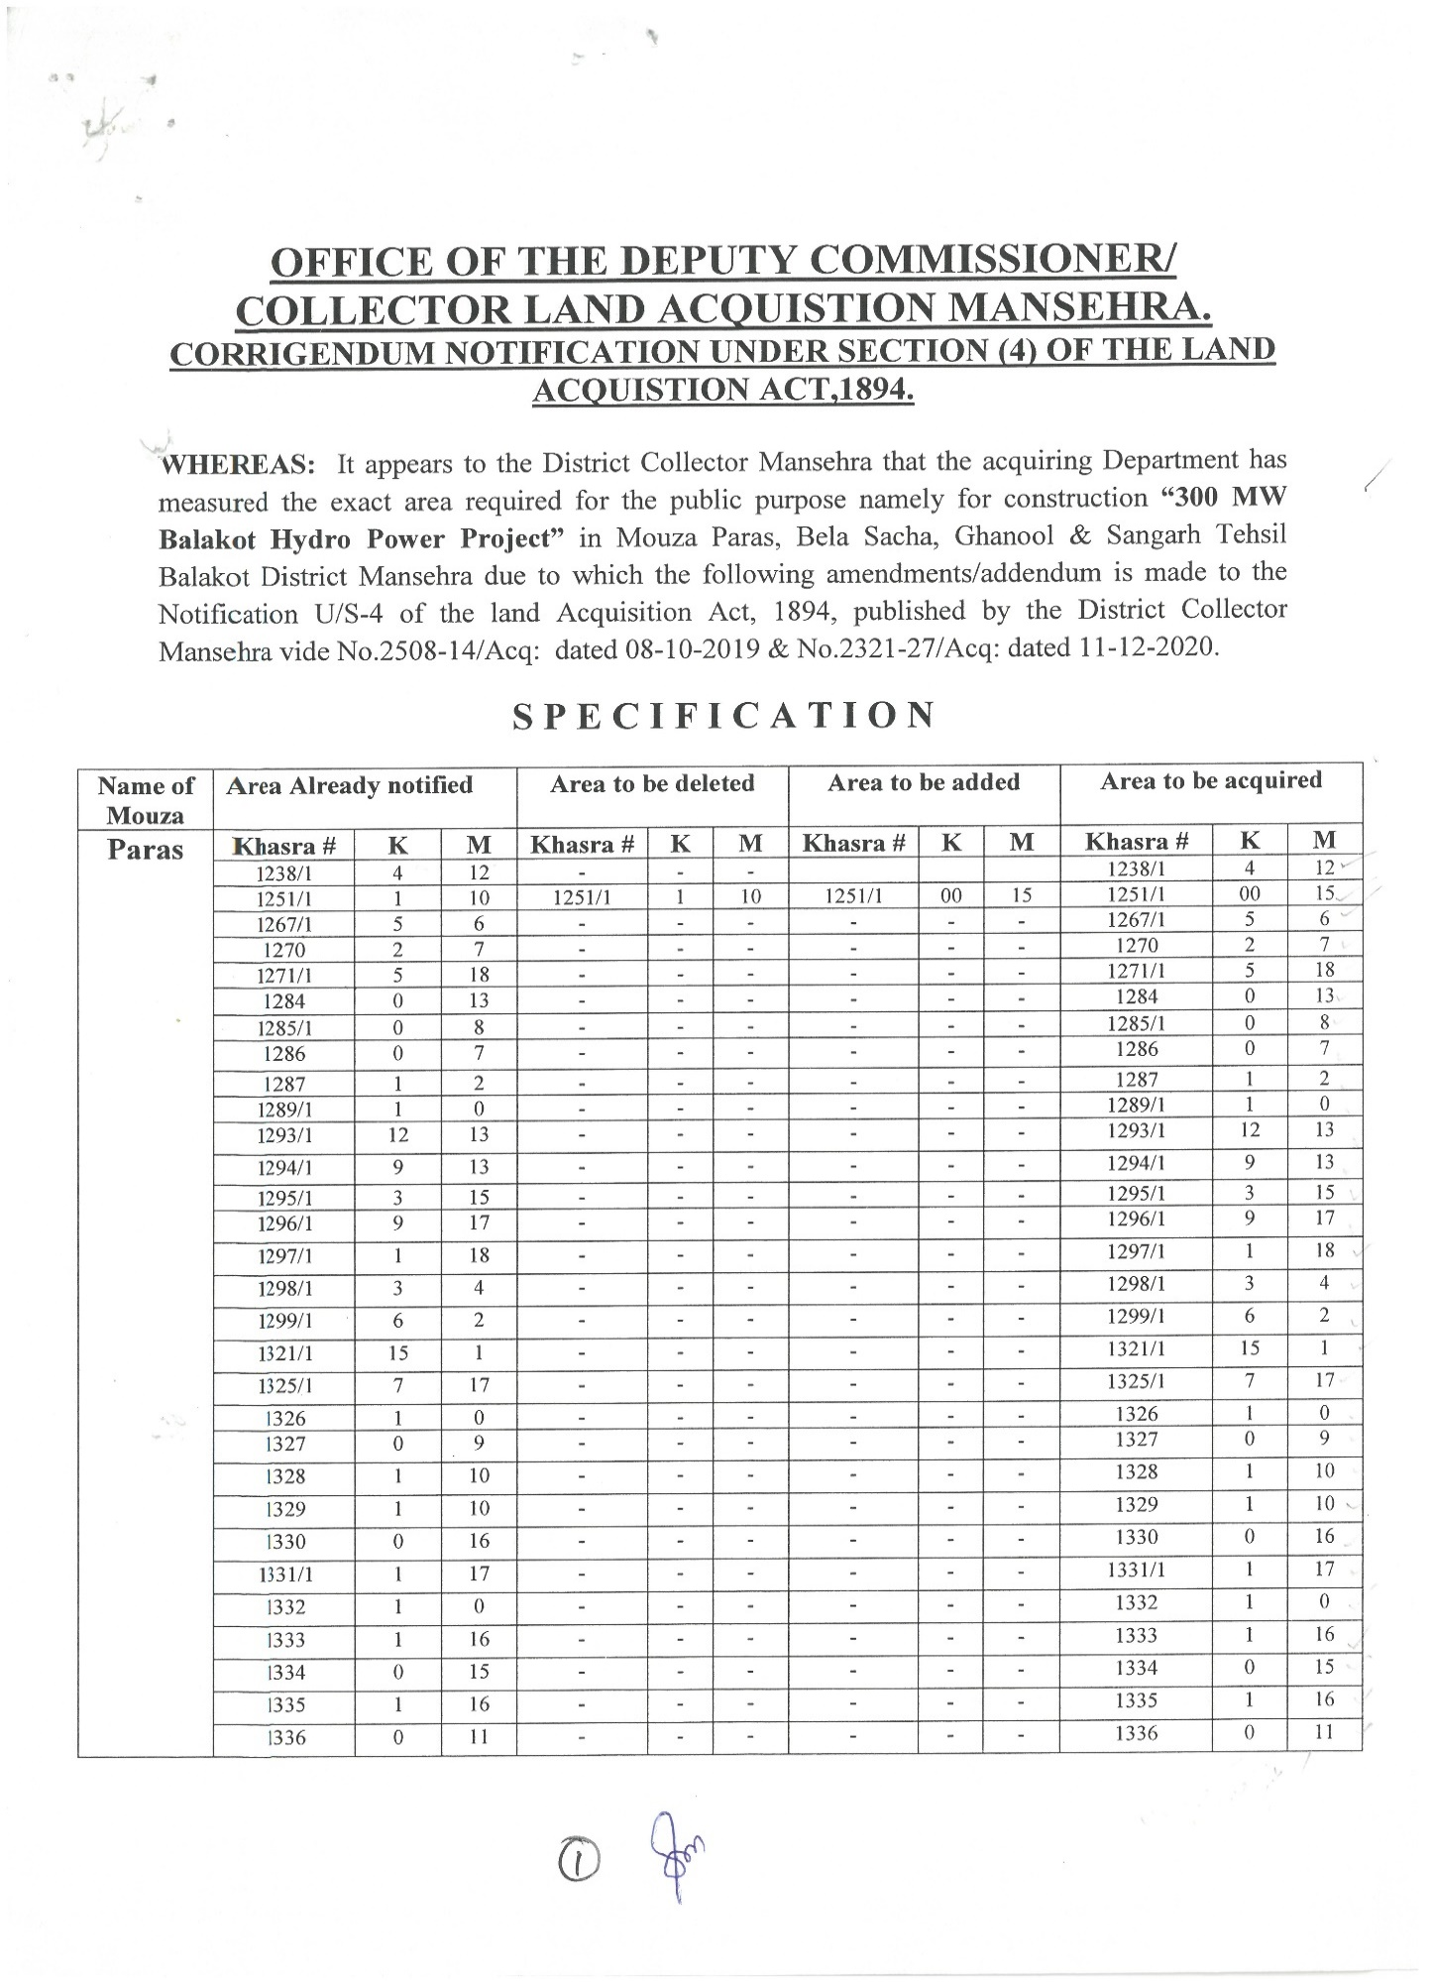
- Section 4
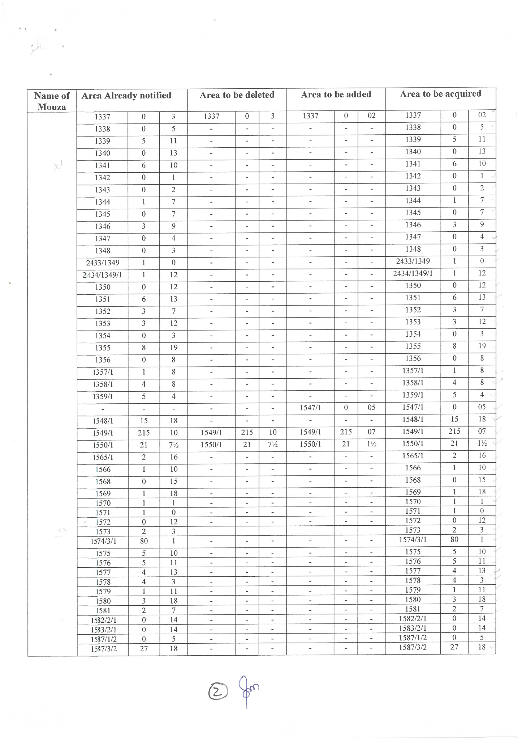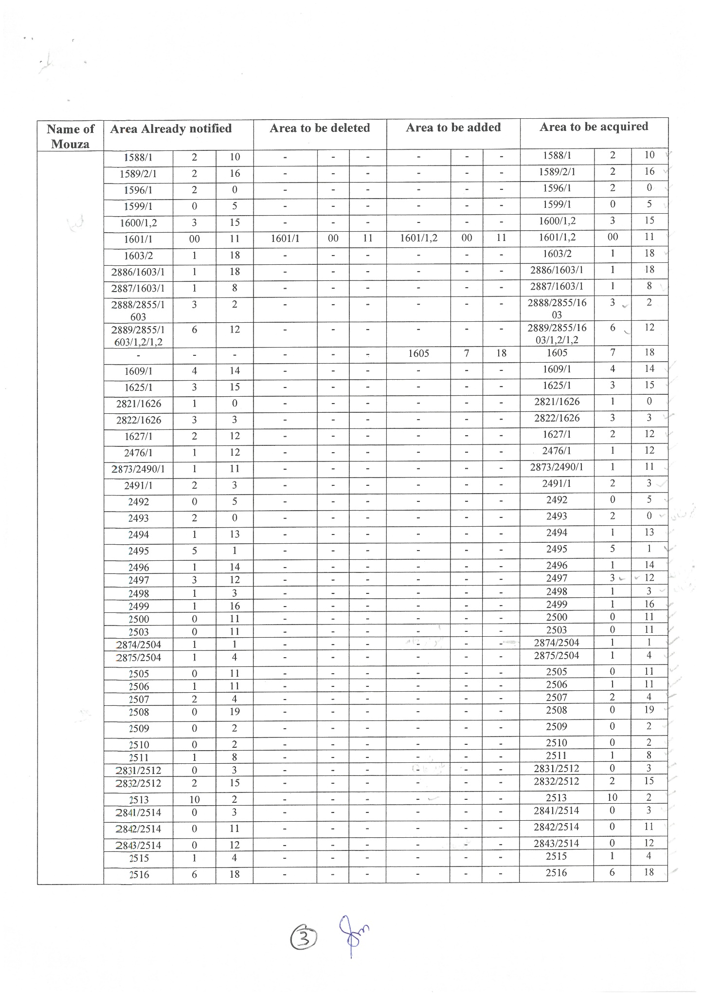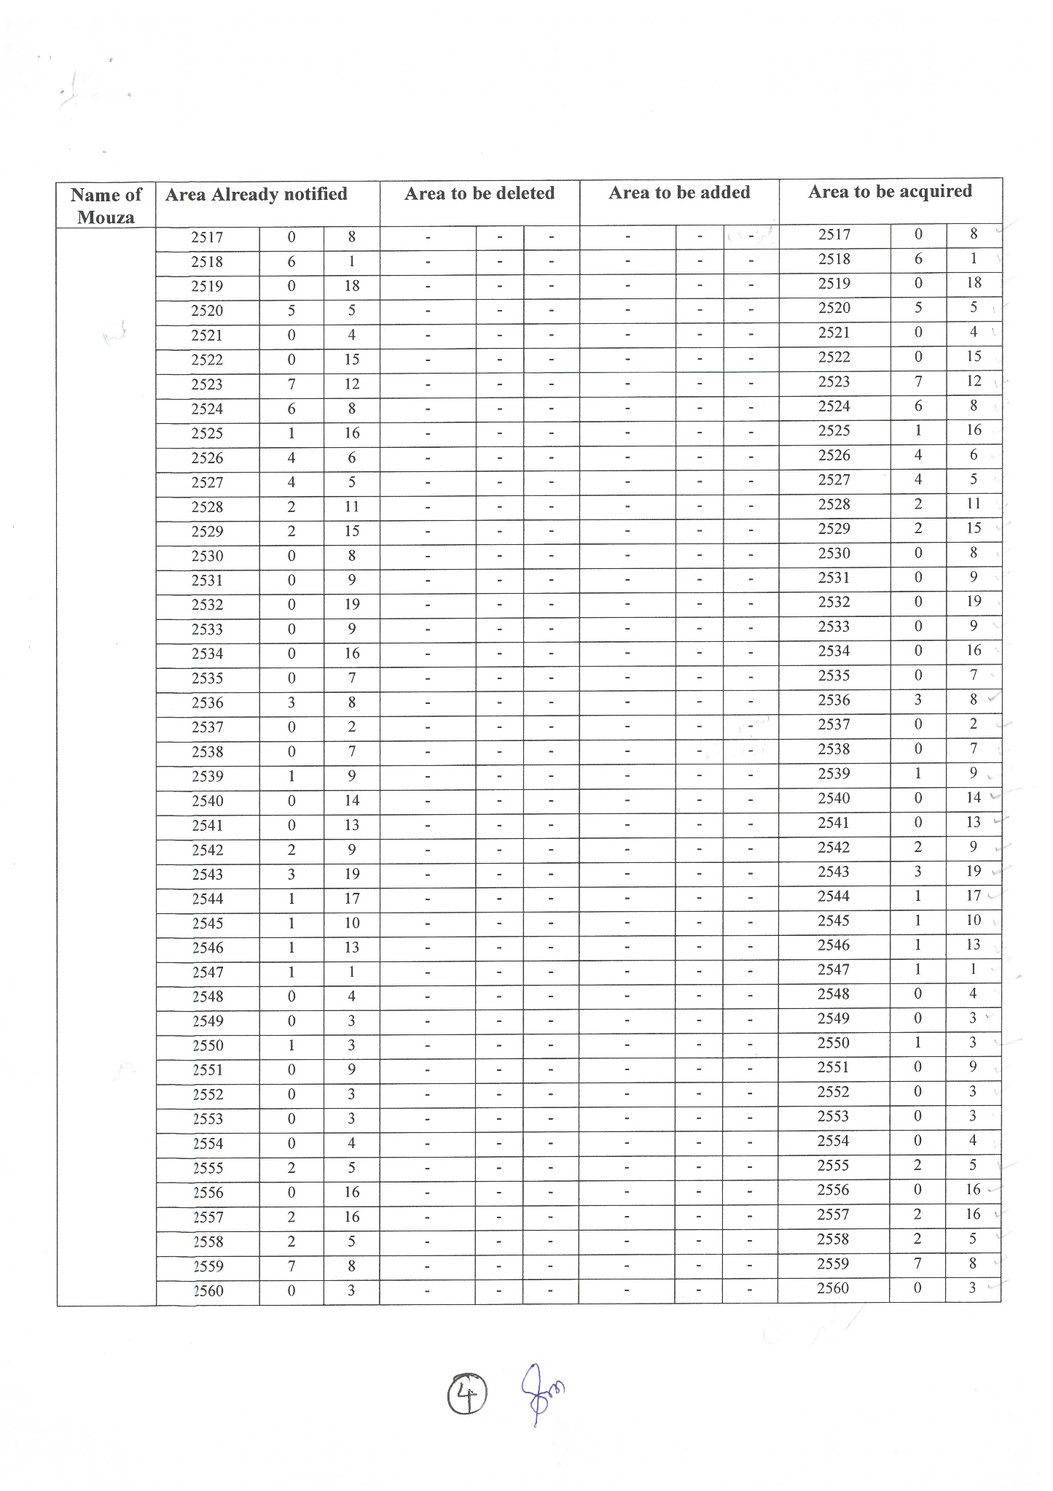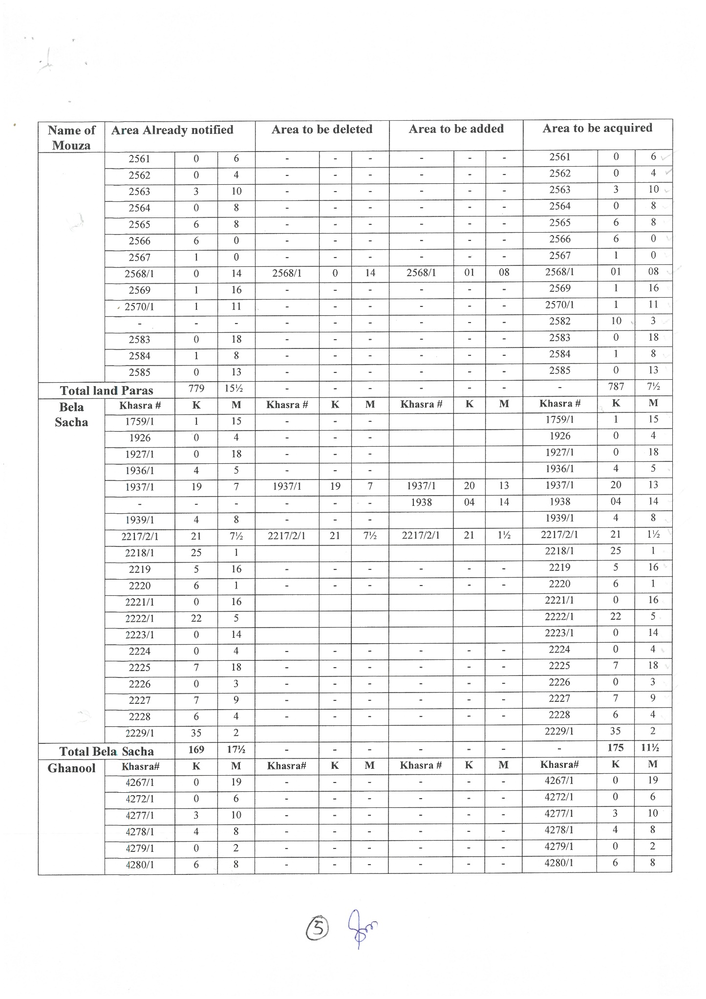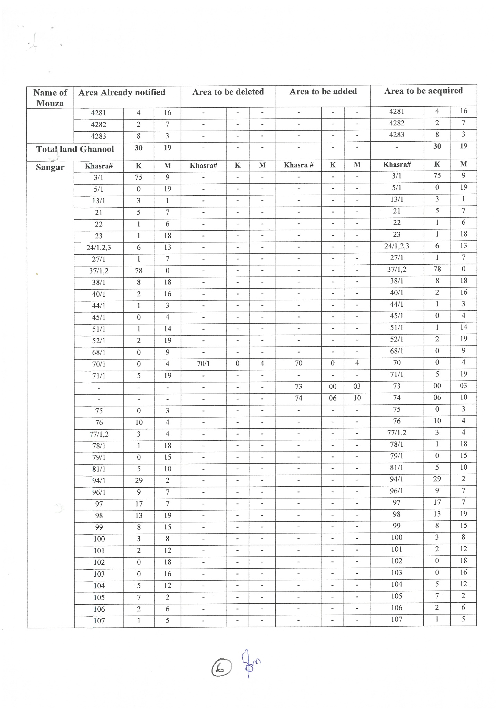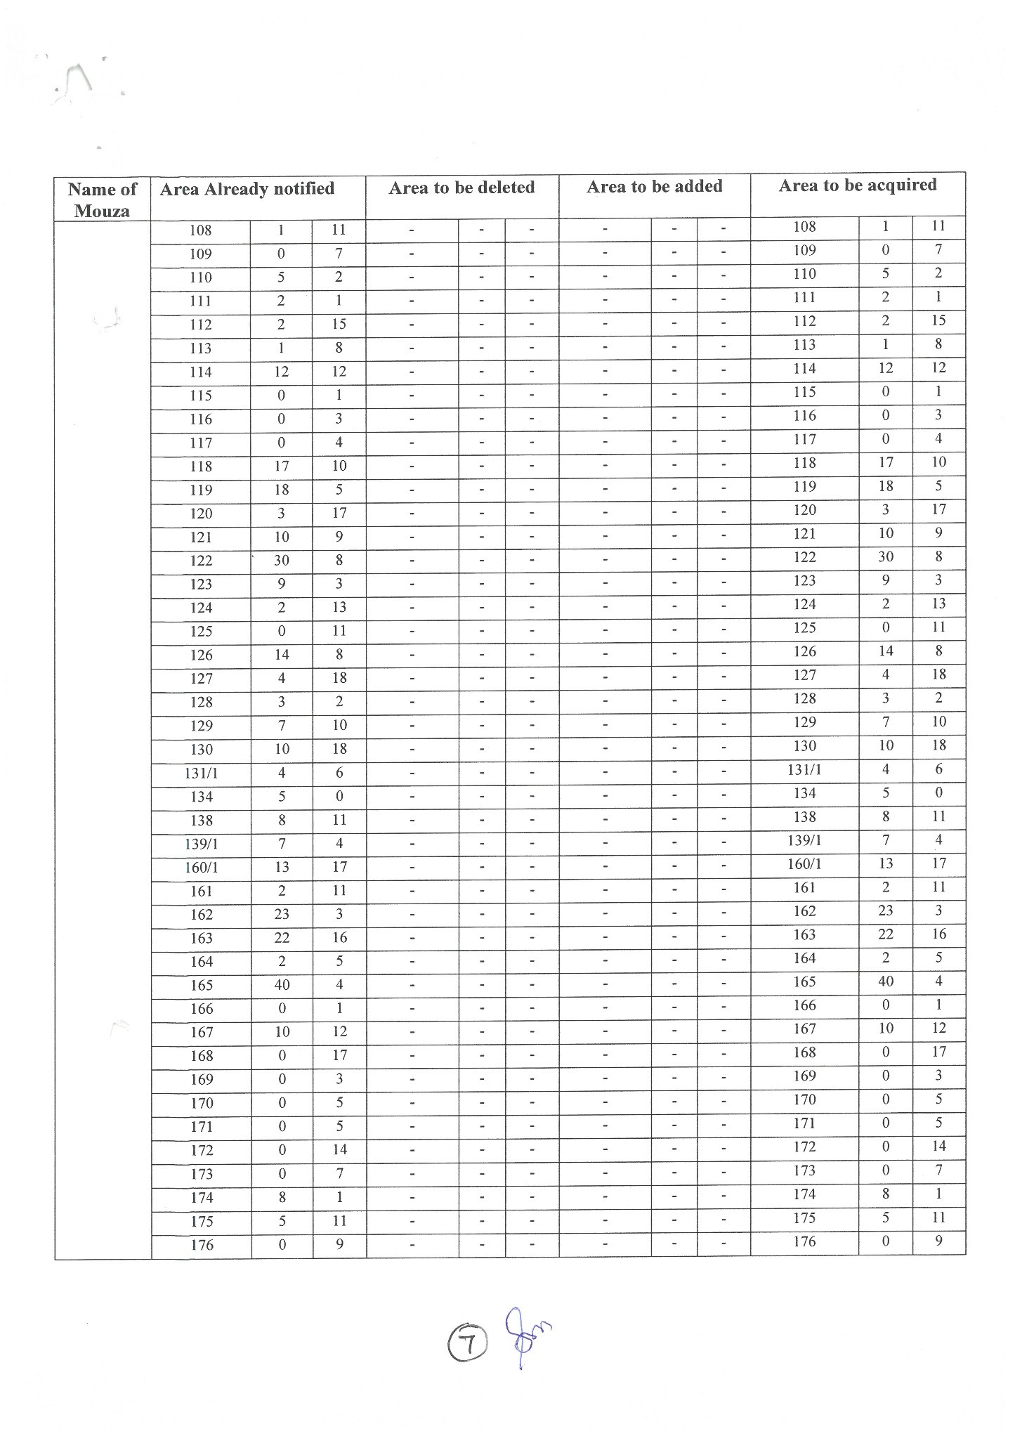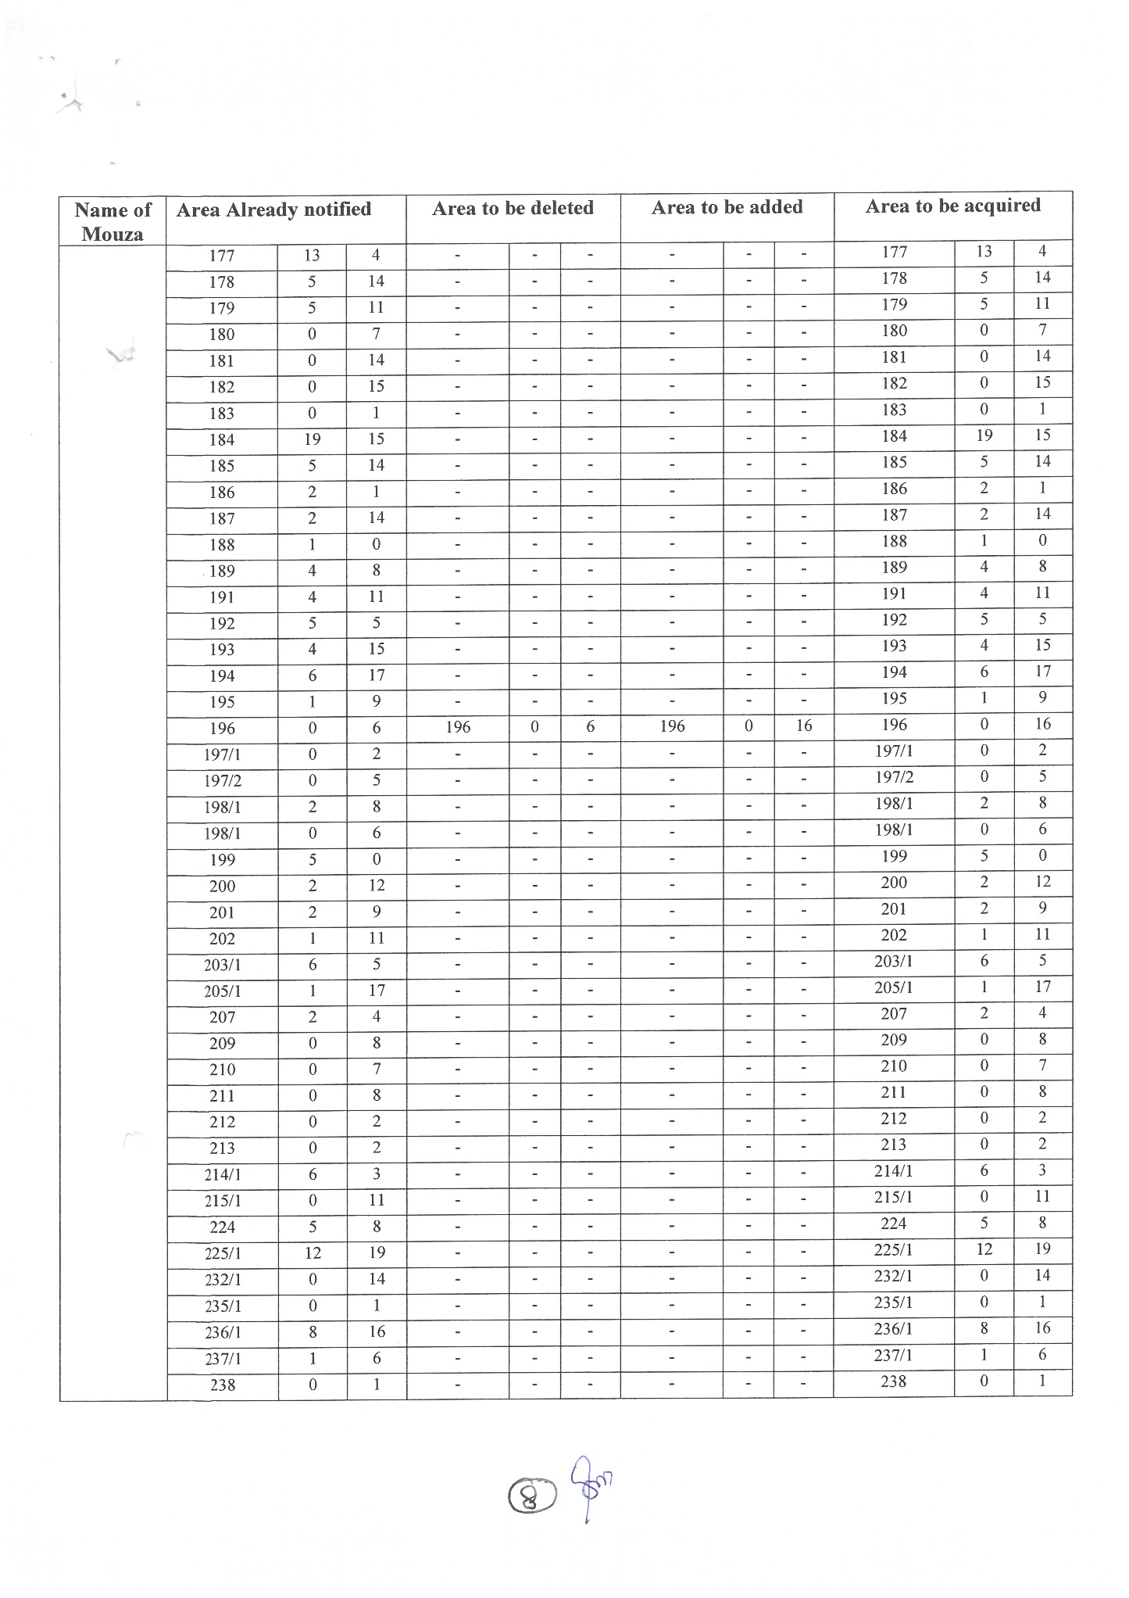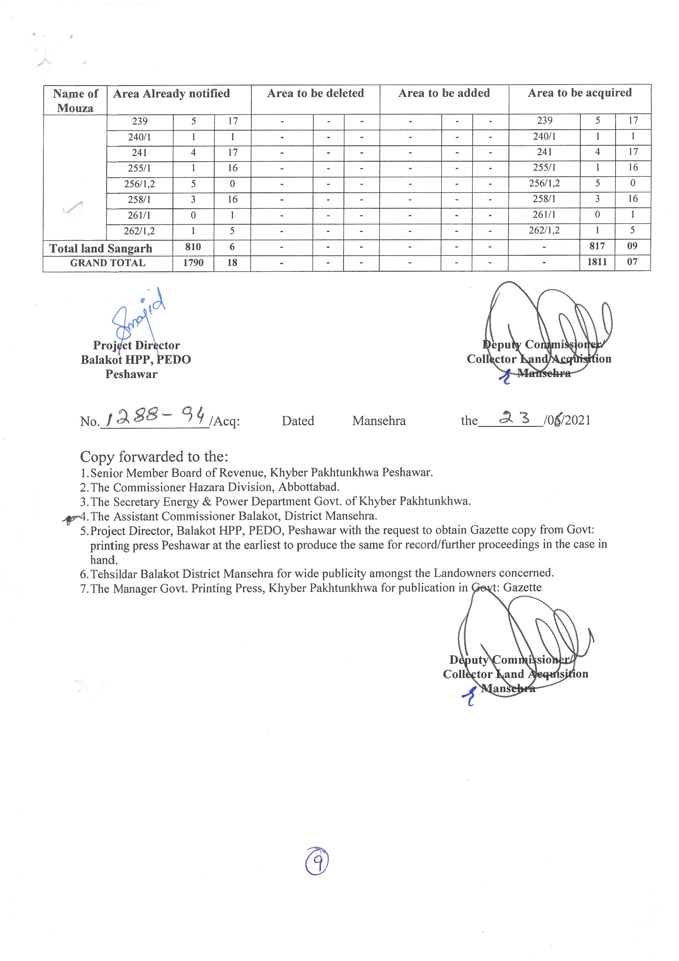

- Section 5
Mouza Paras
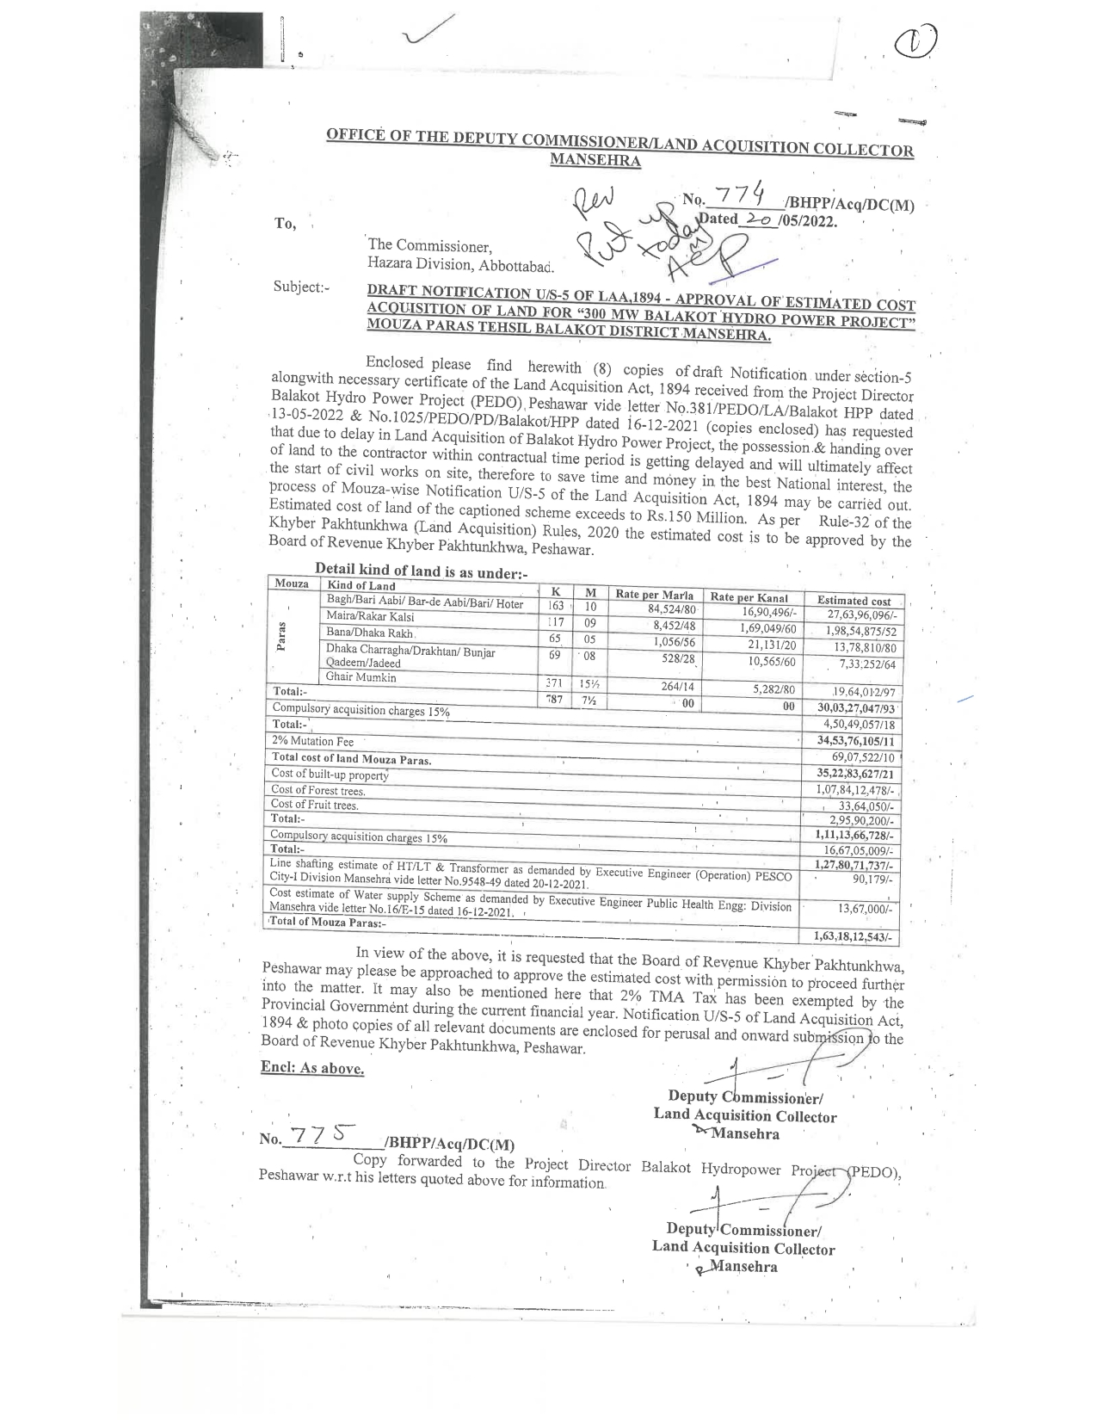

Mouza Bela Sacha

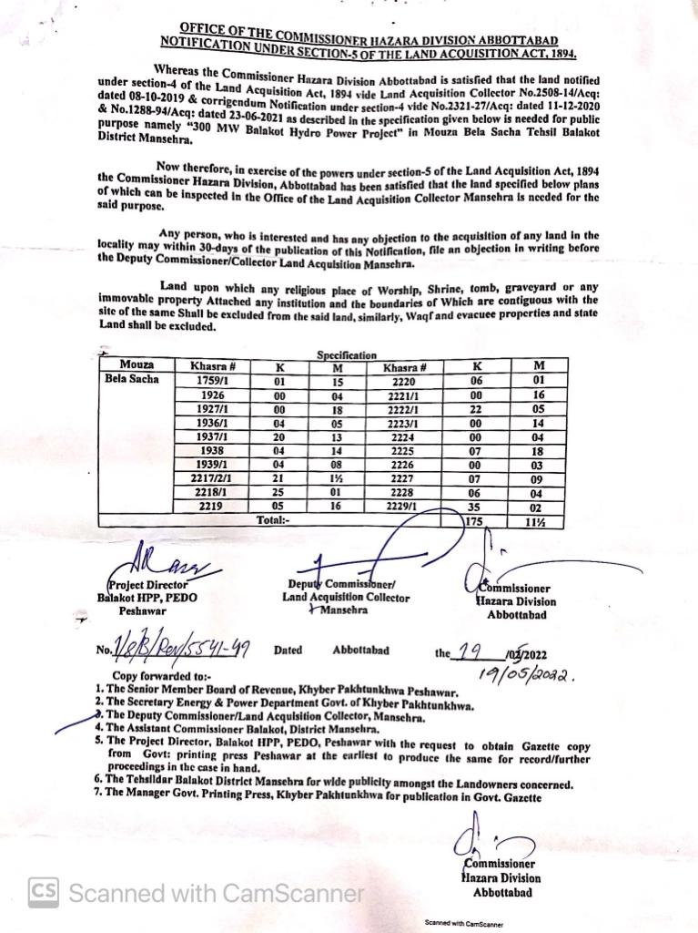
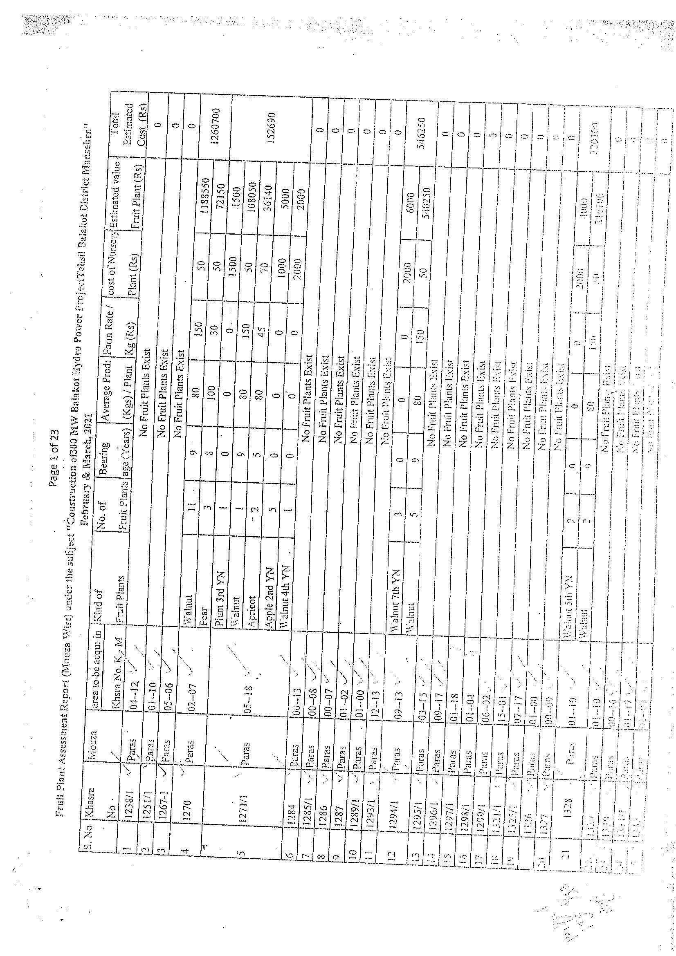
- Assessment of Agriculture Department

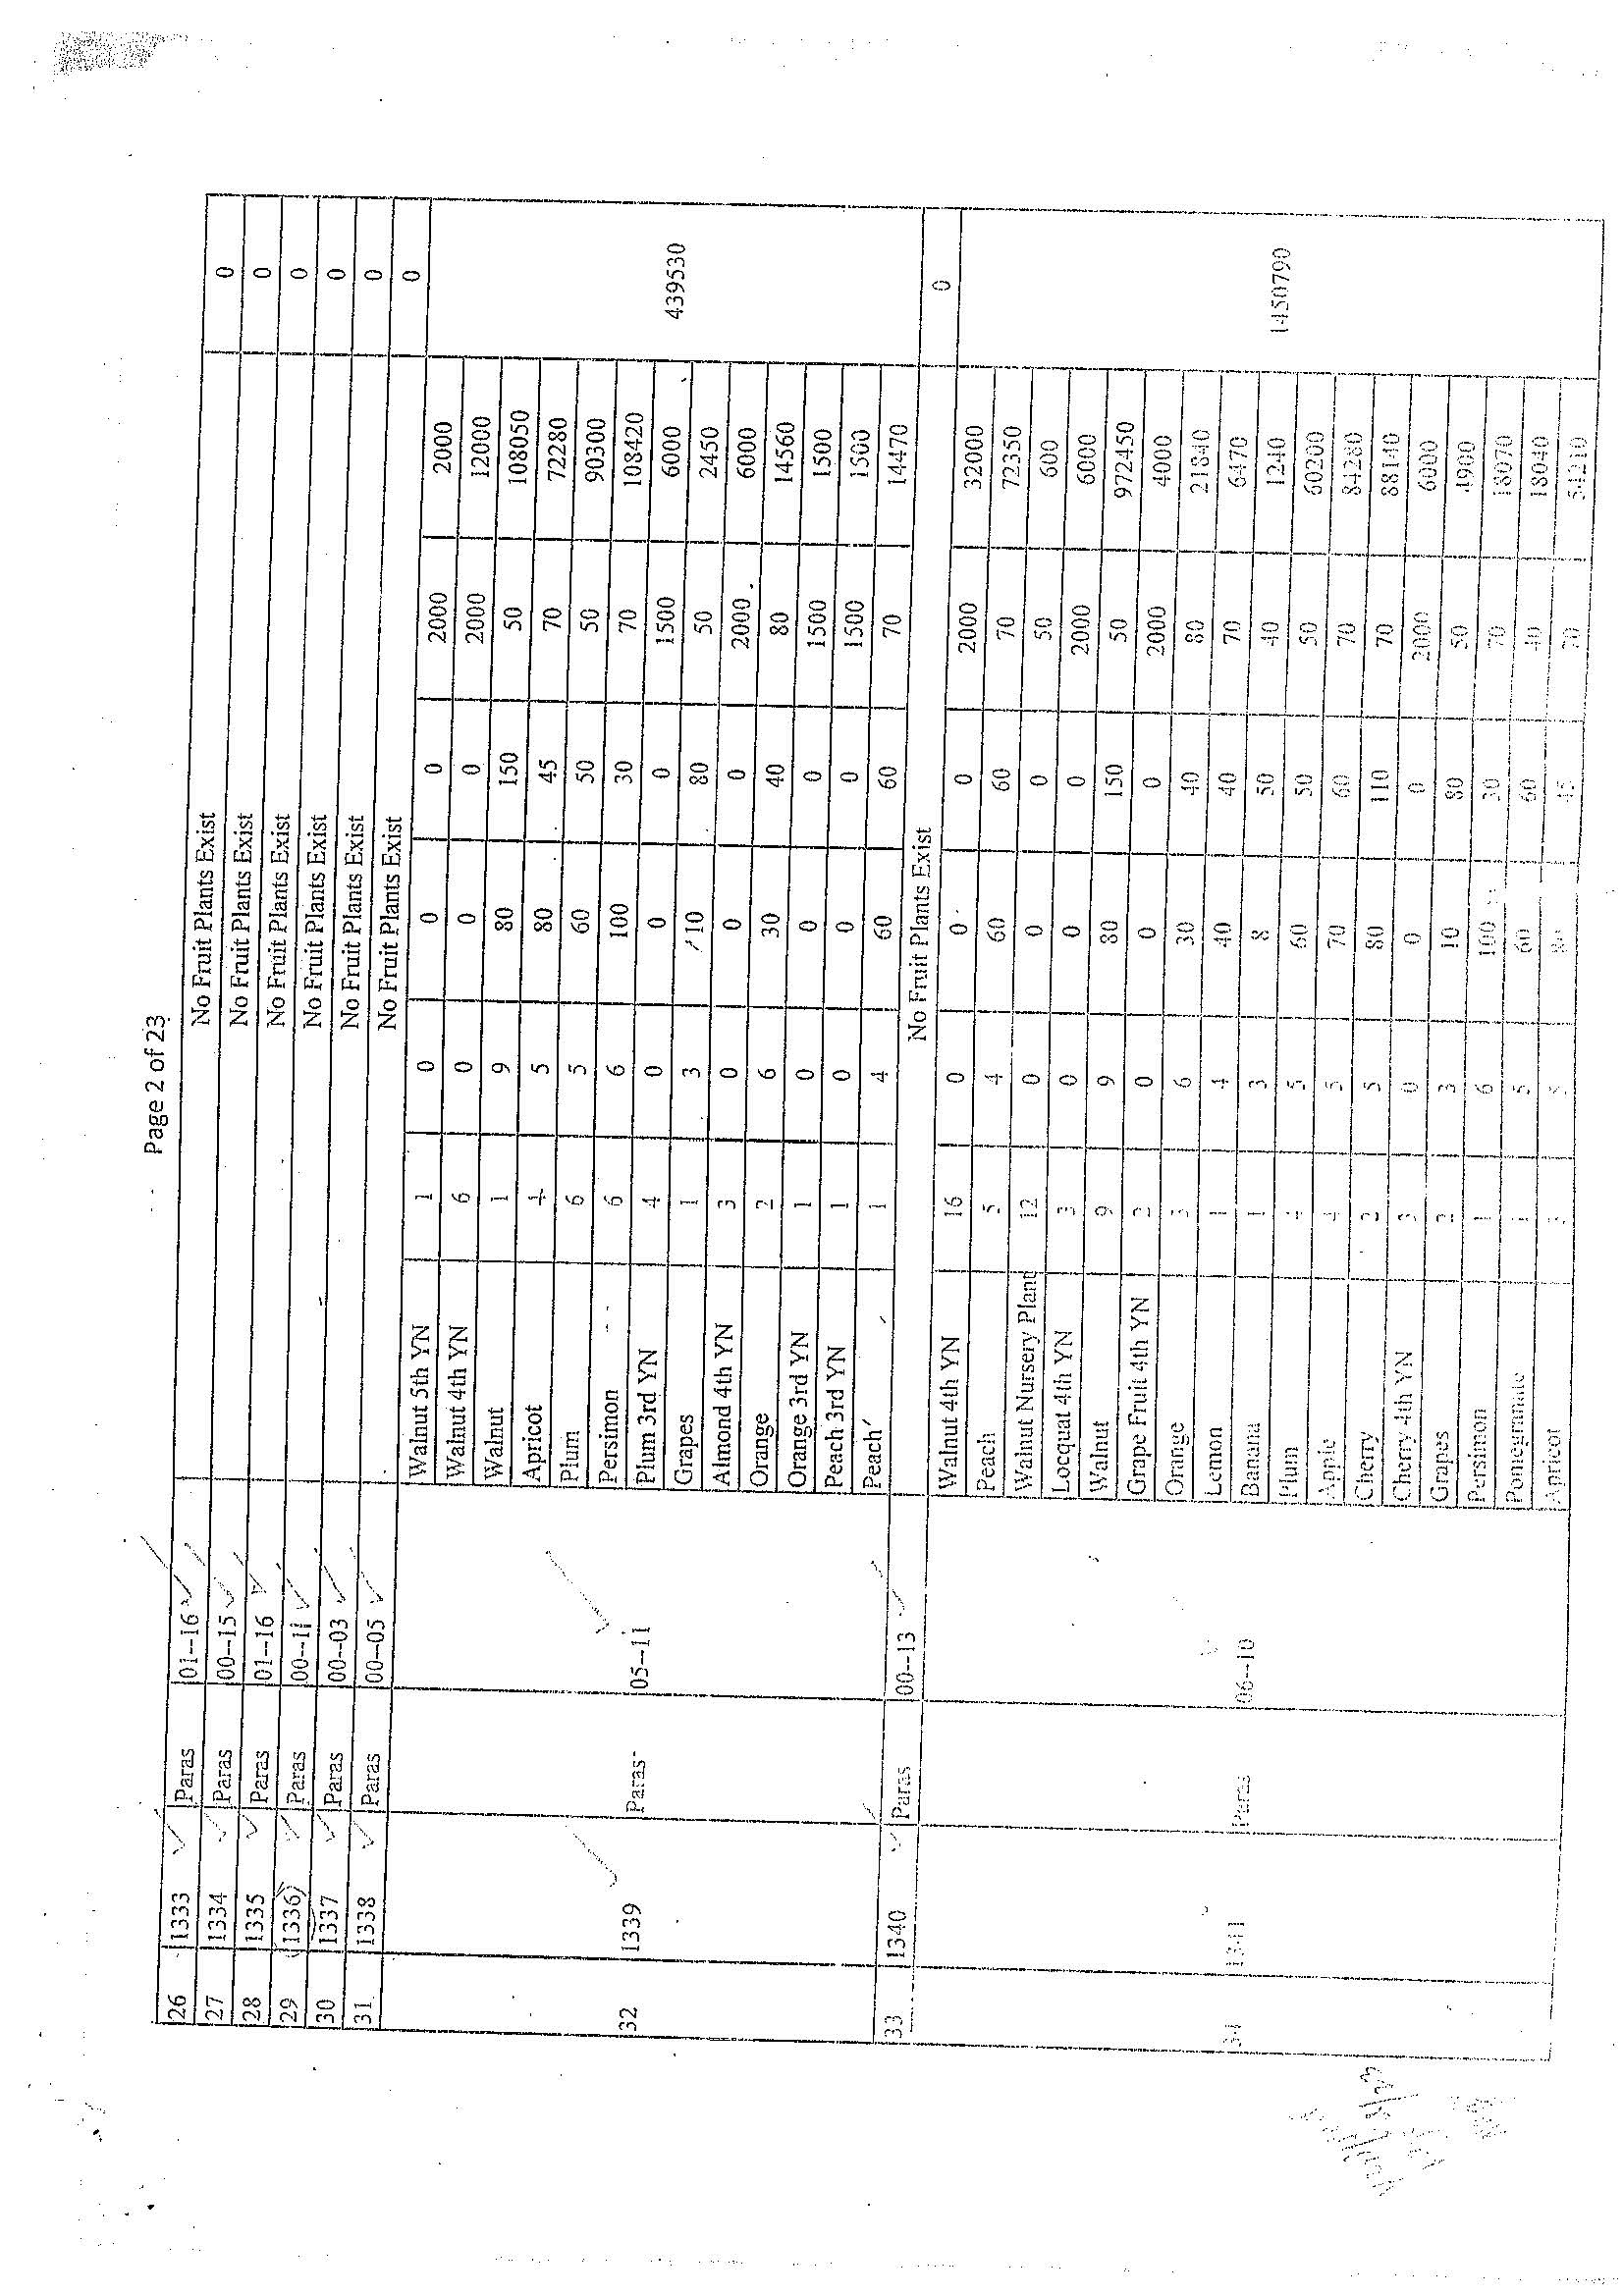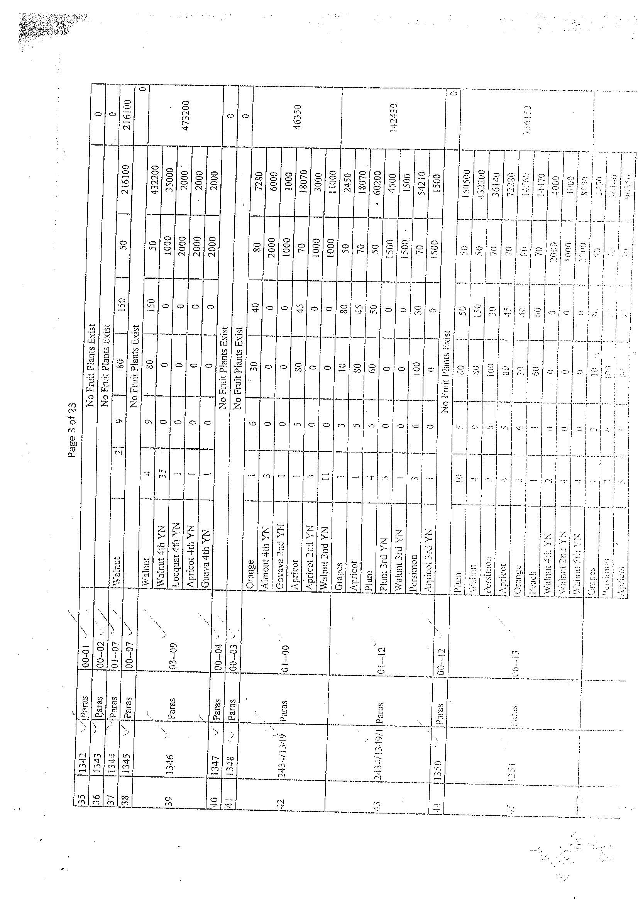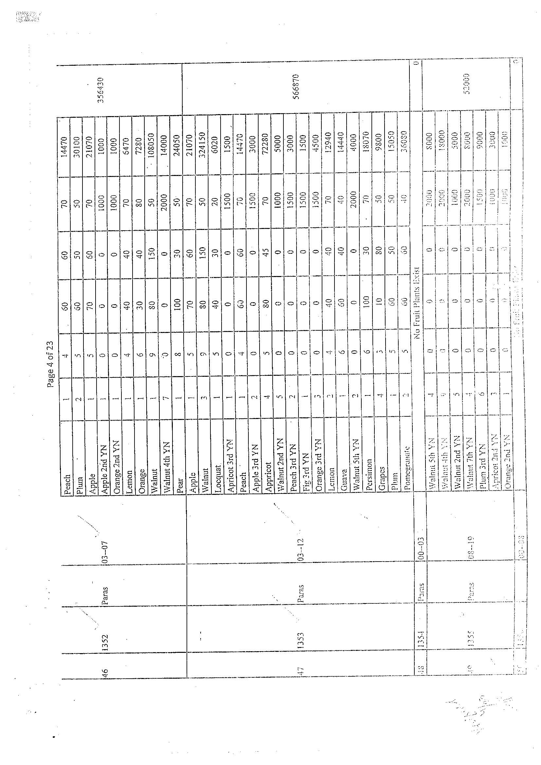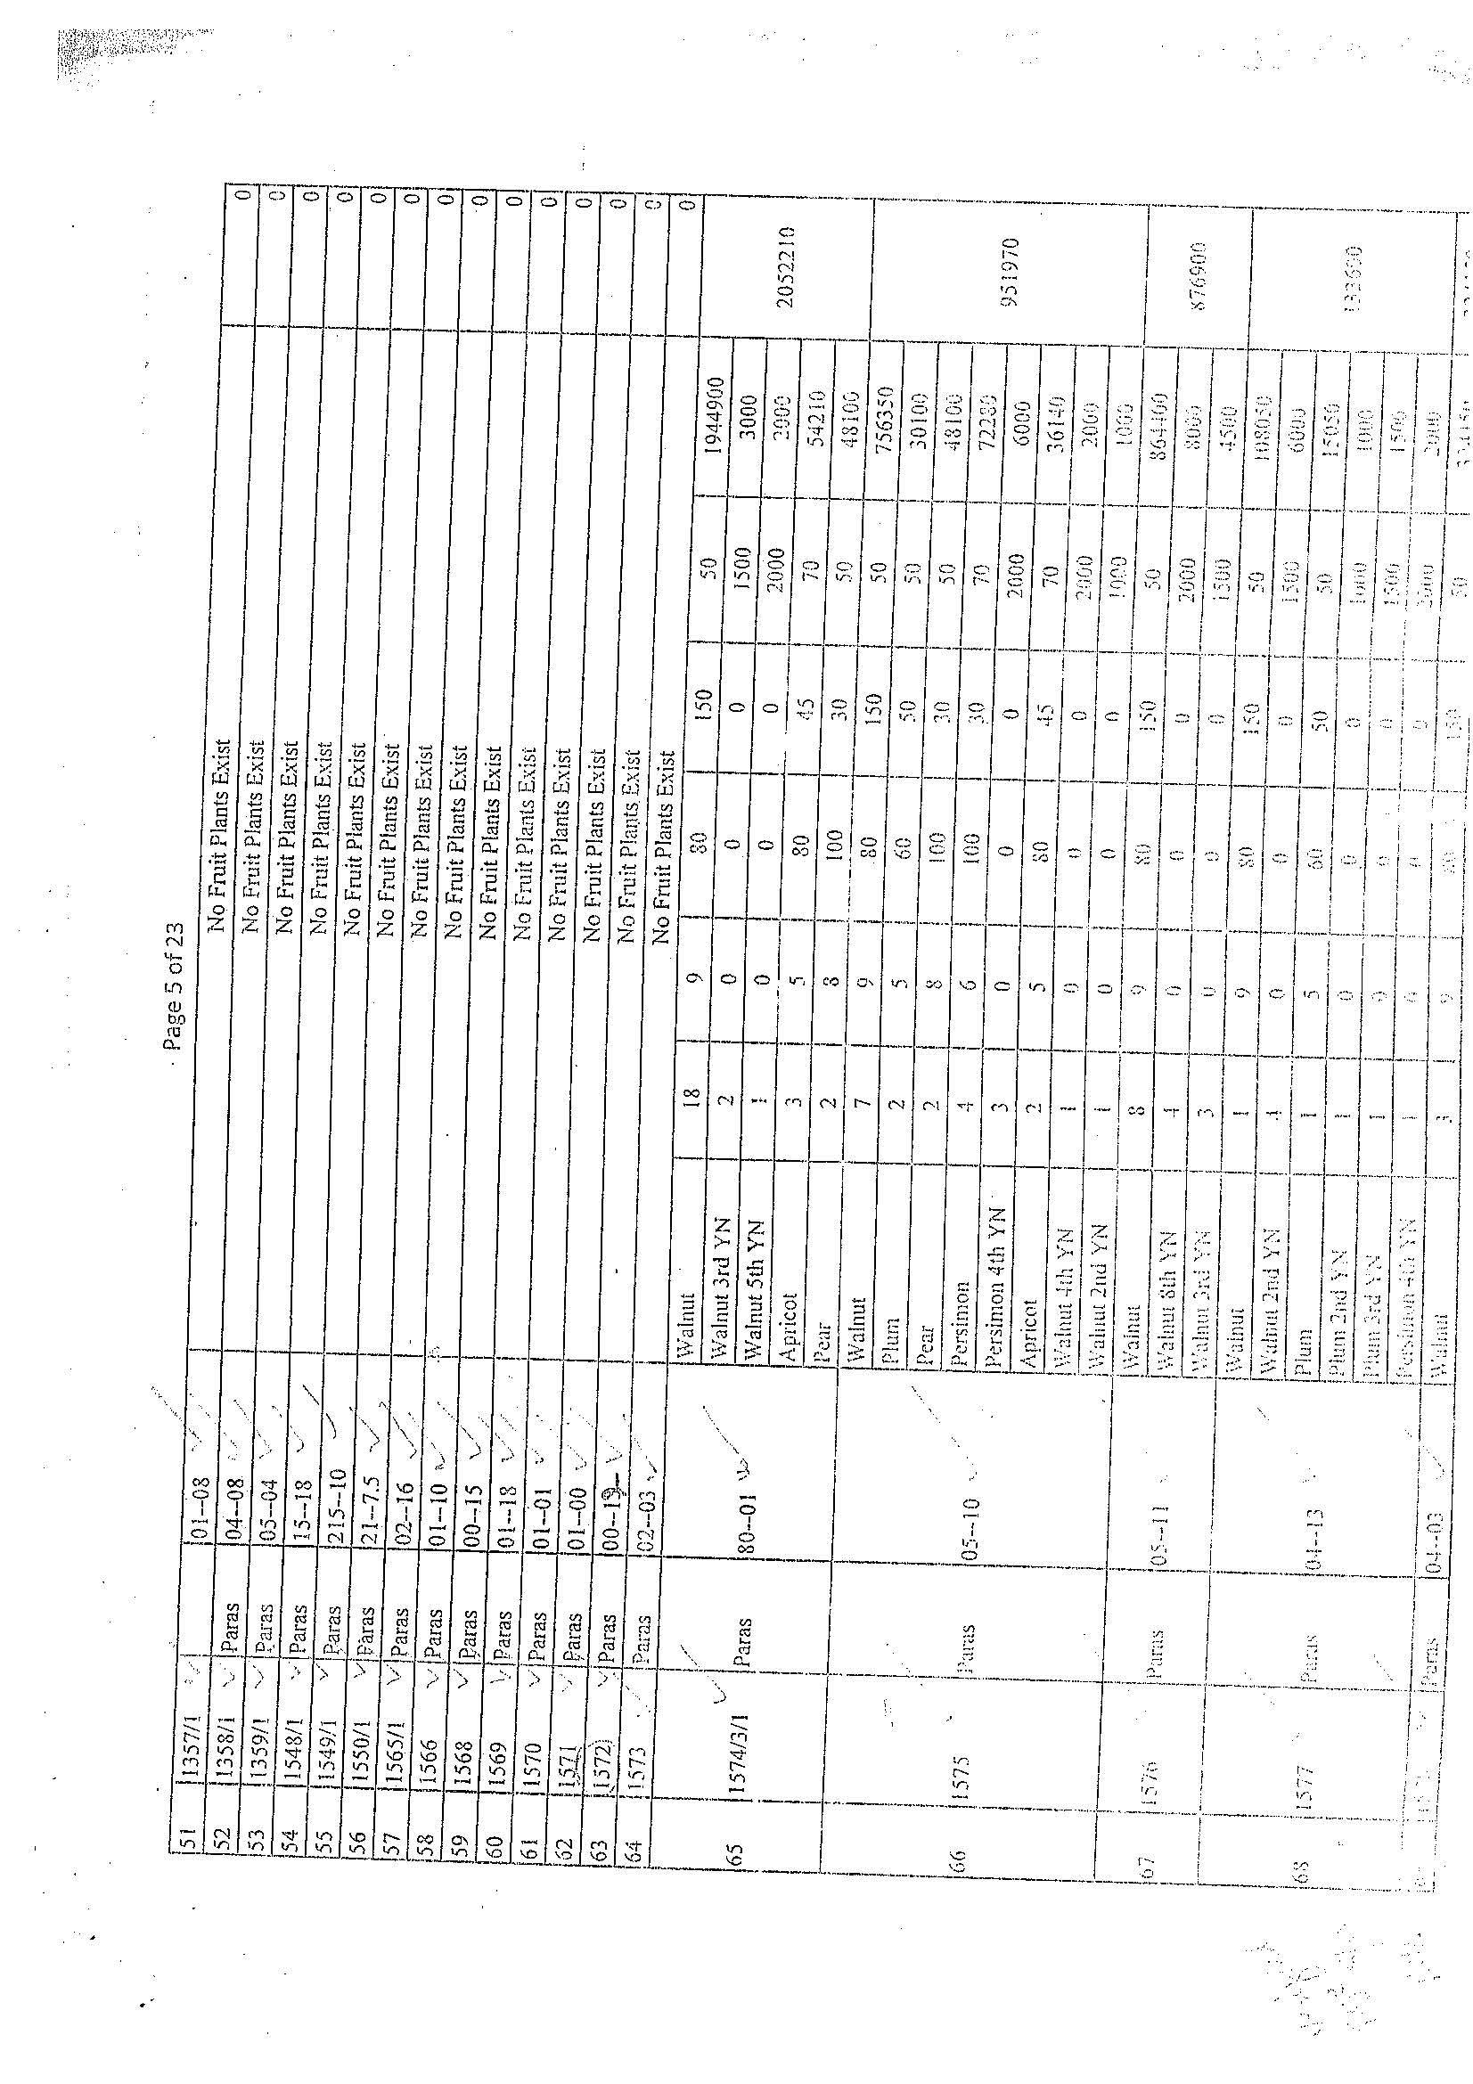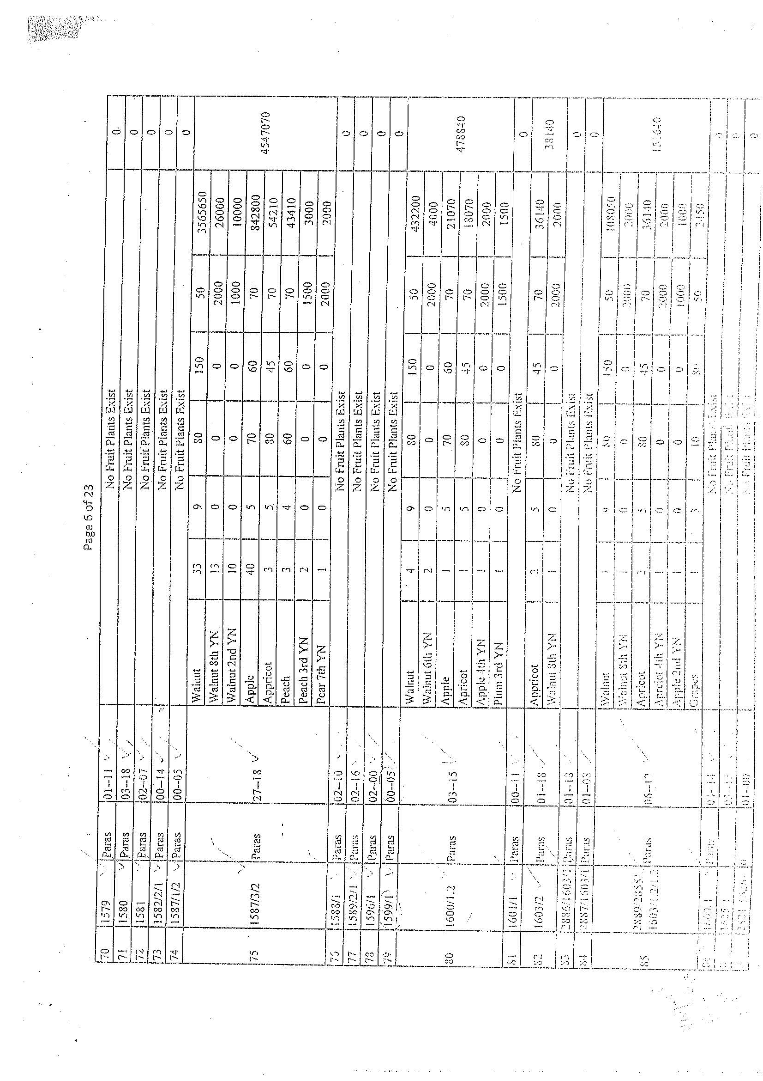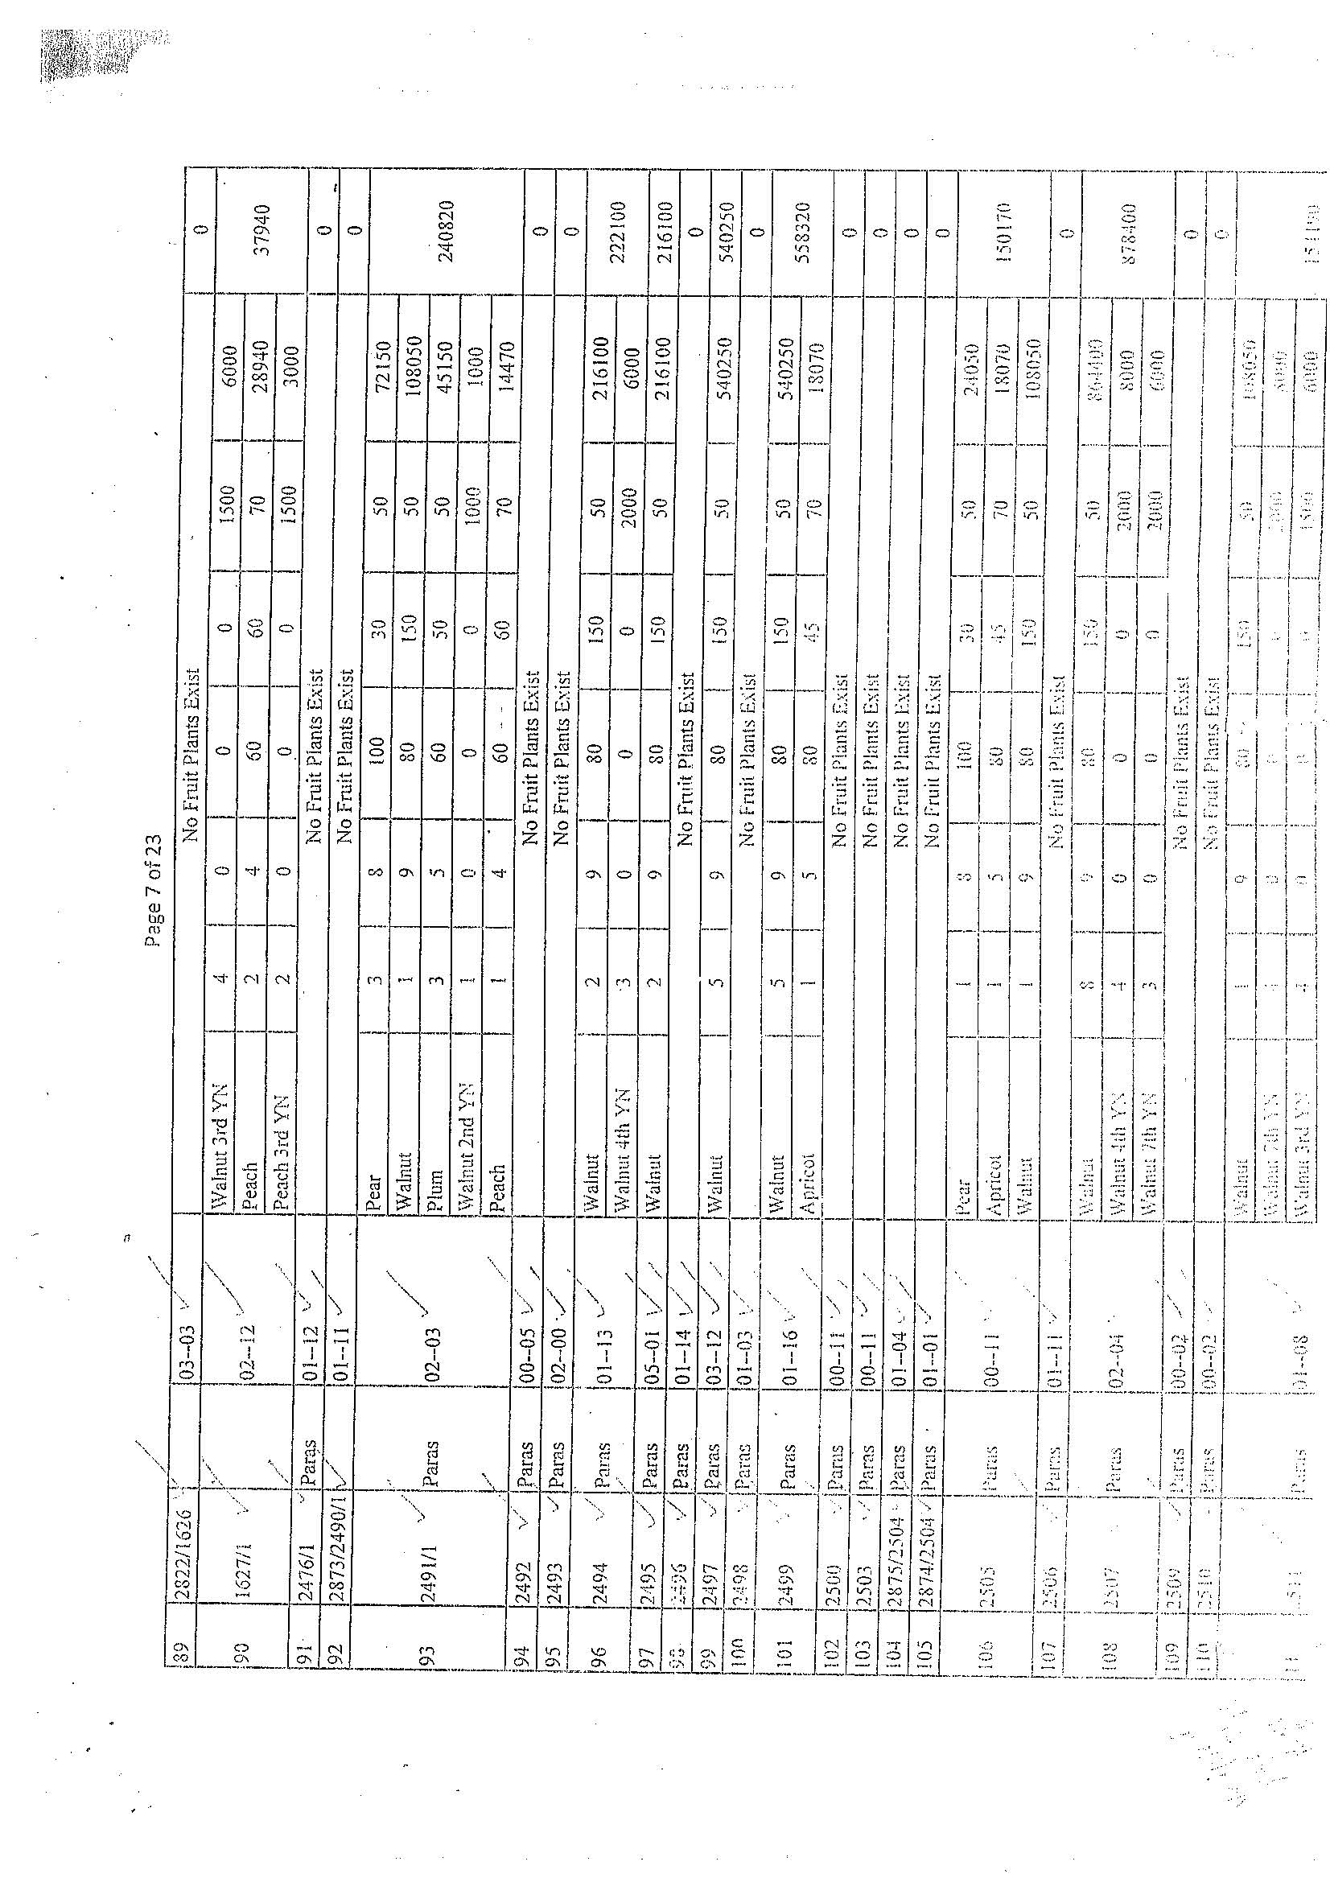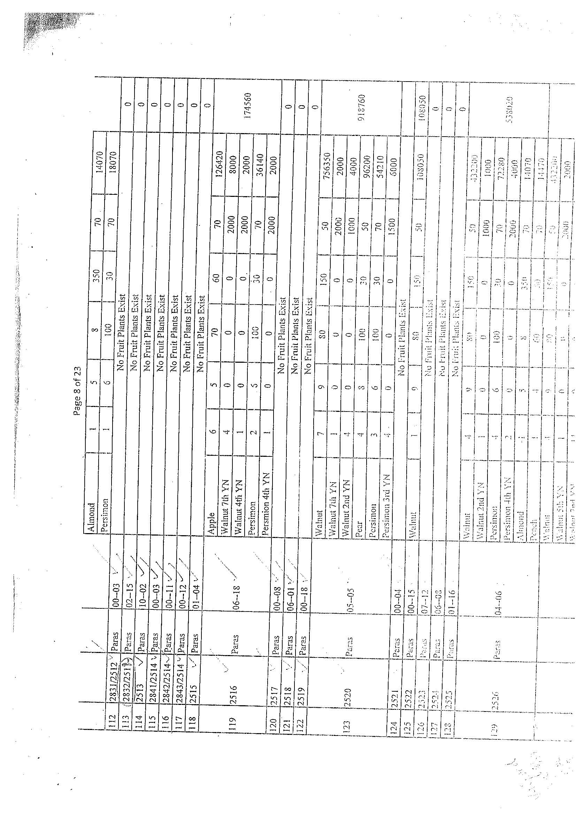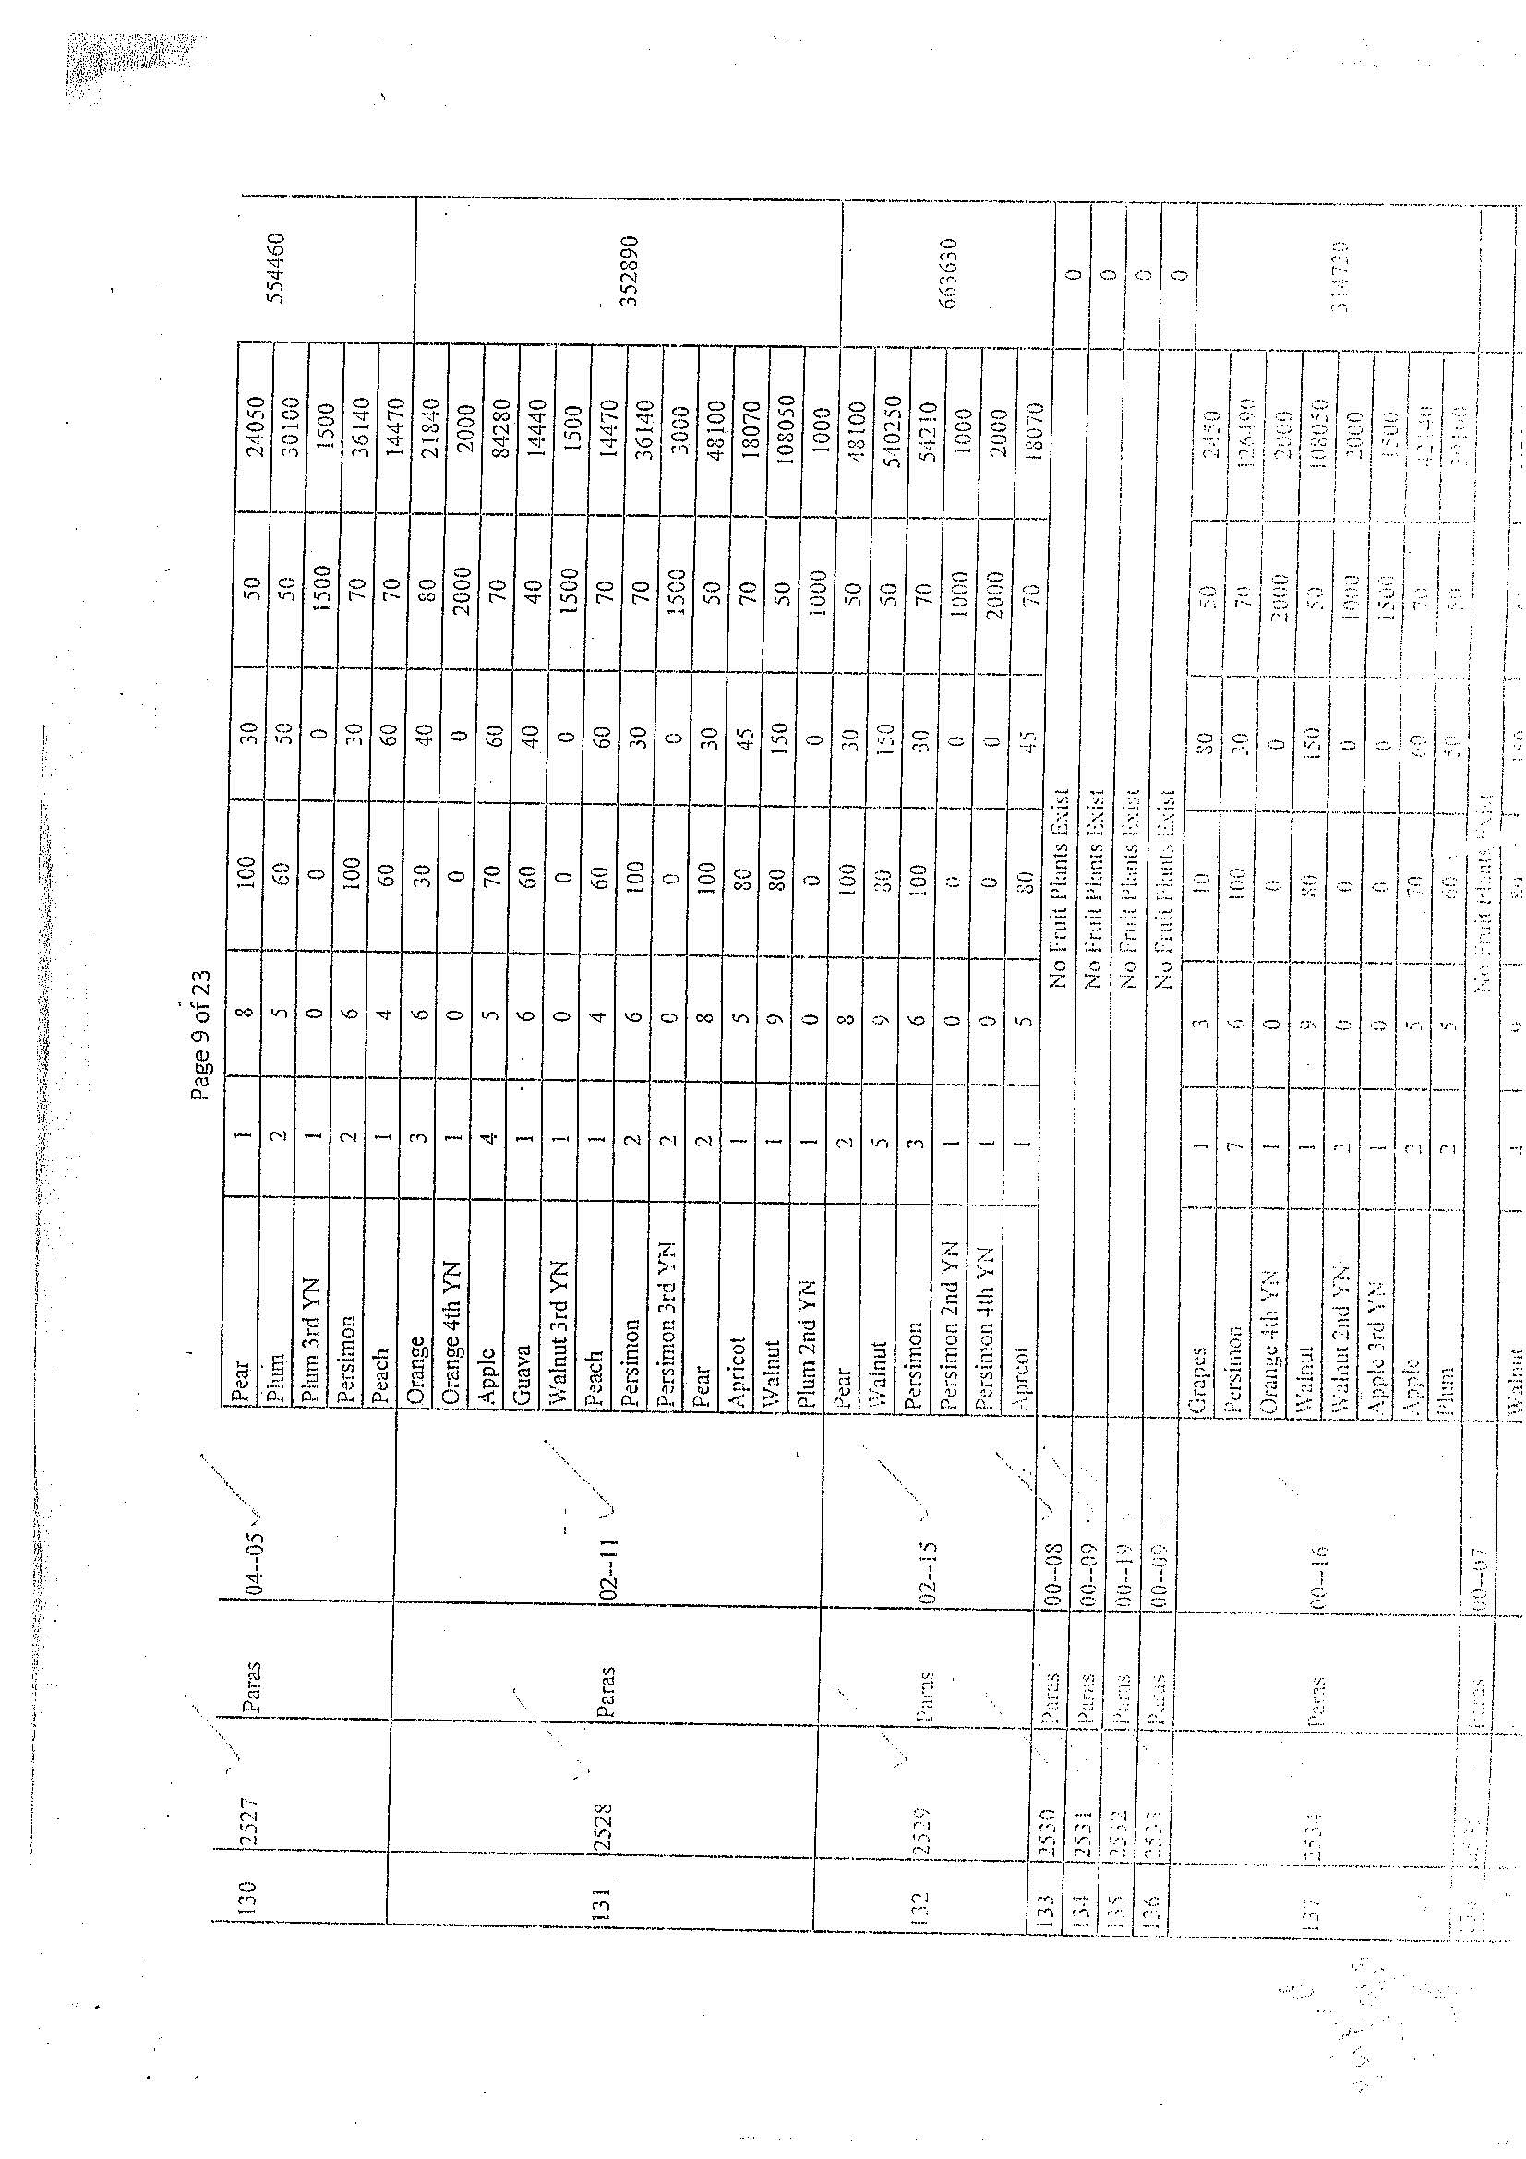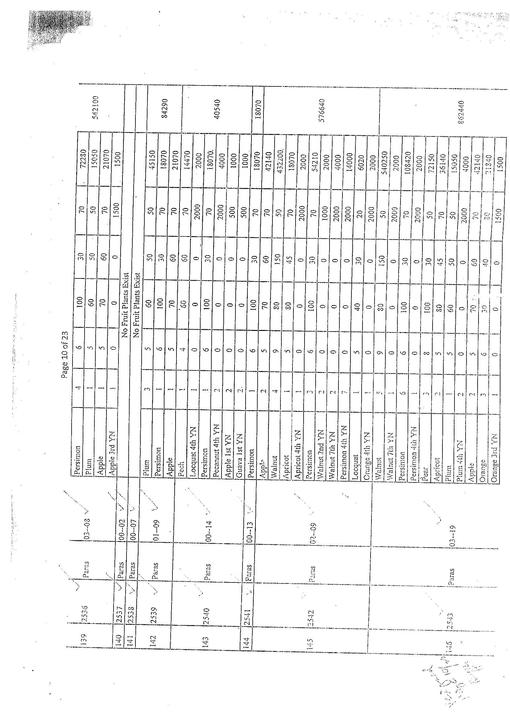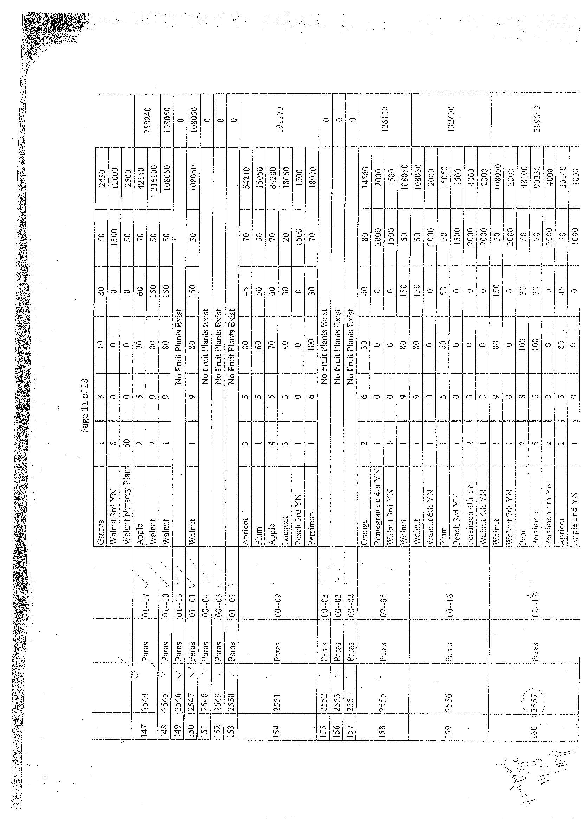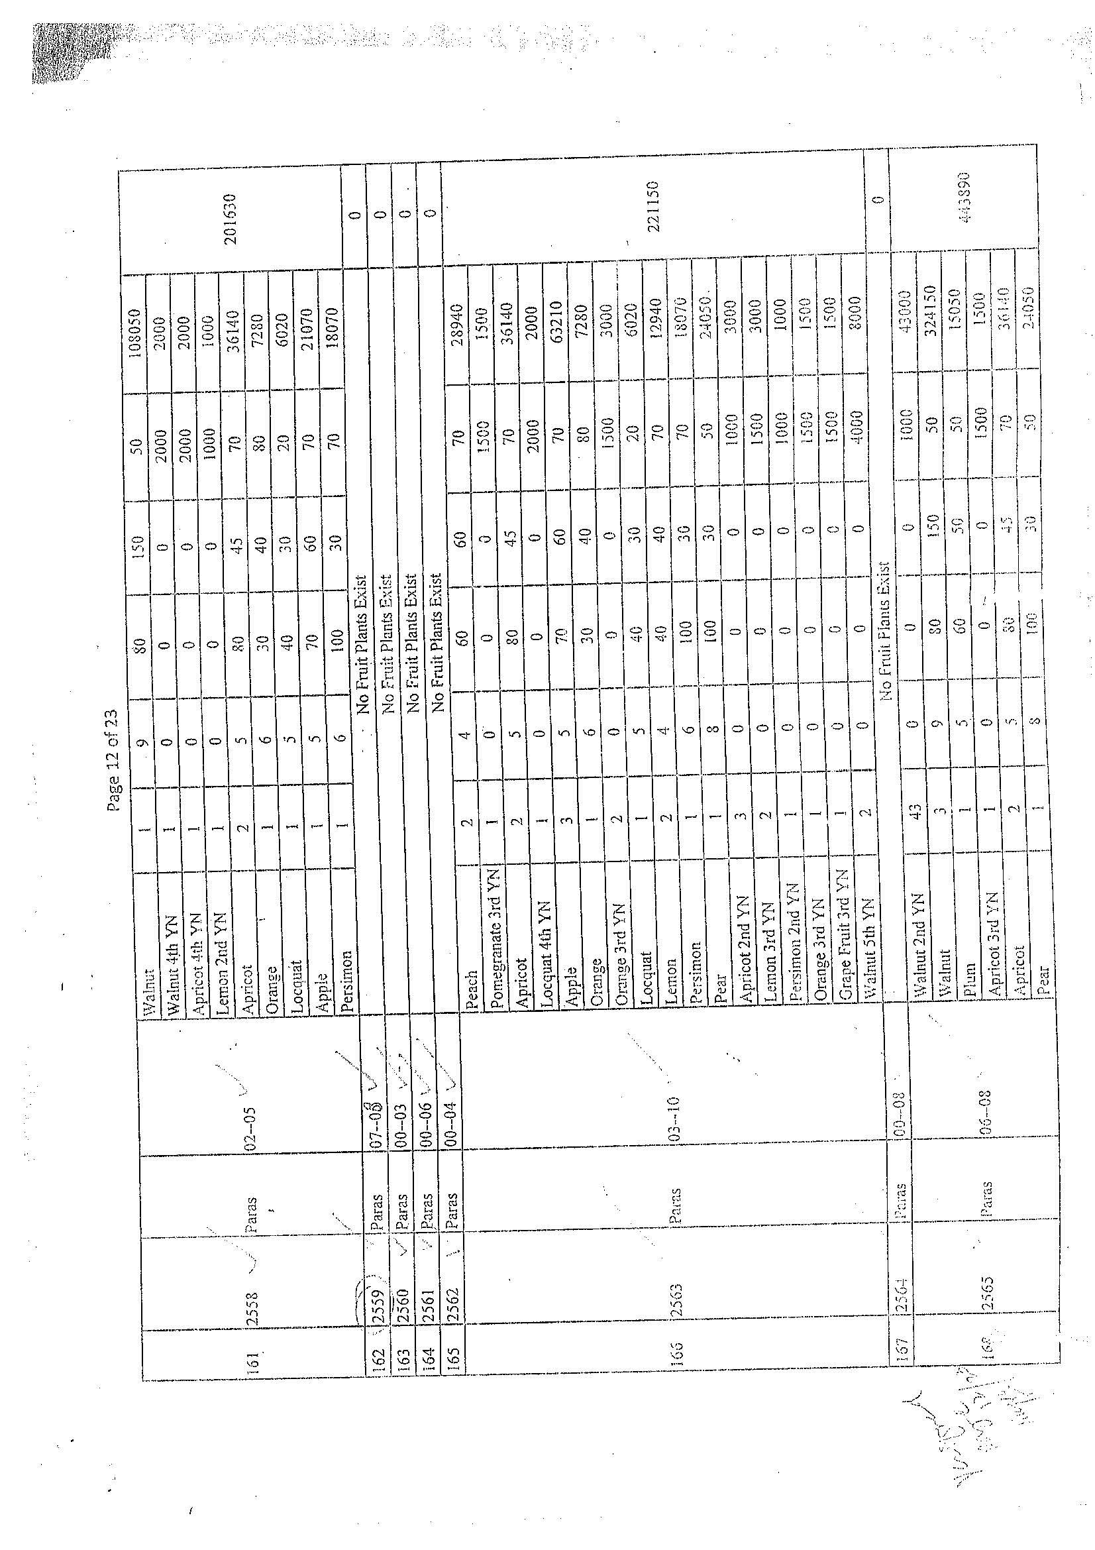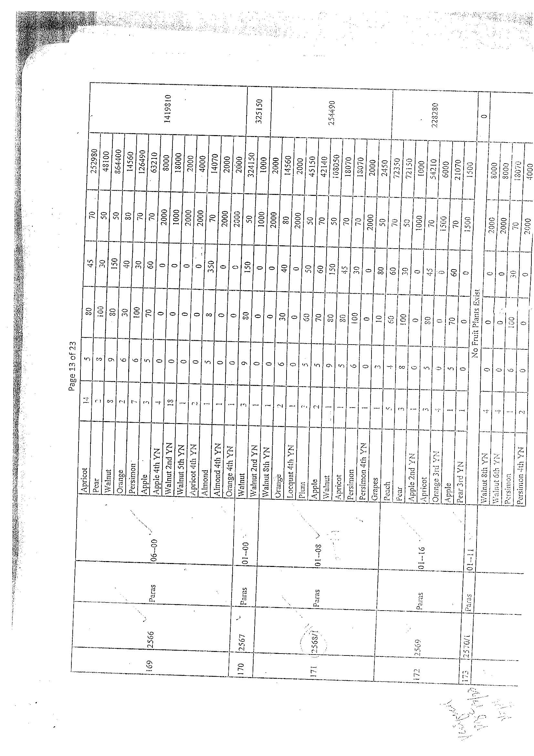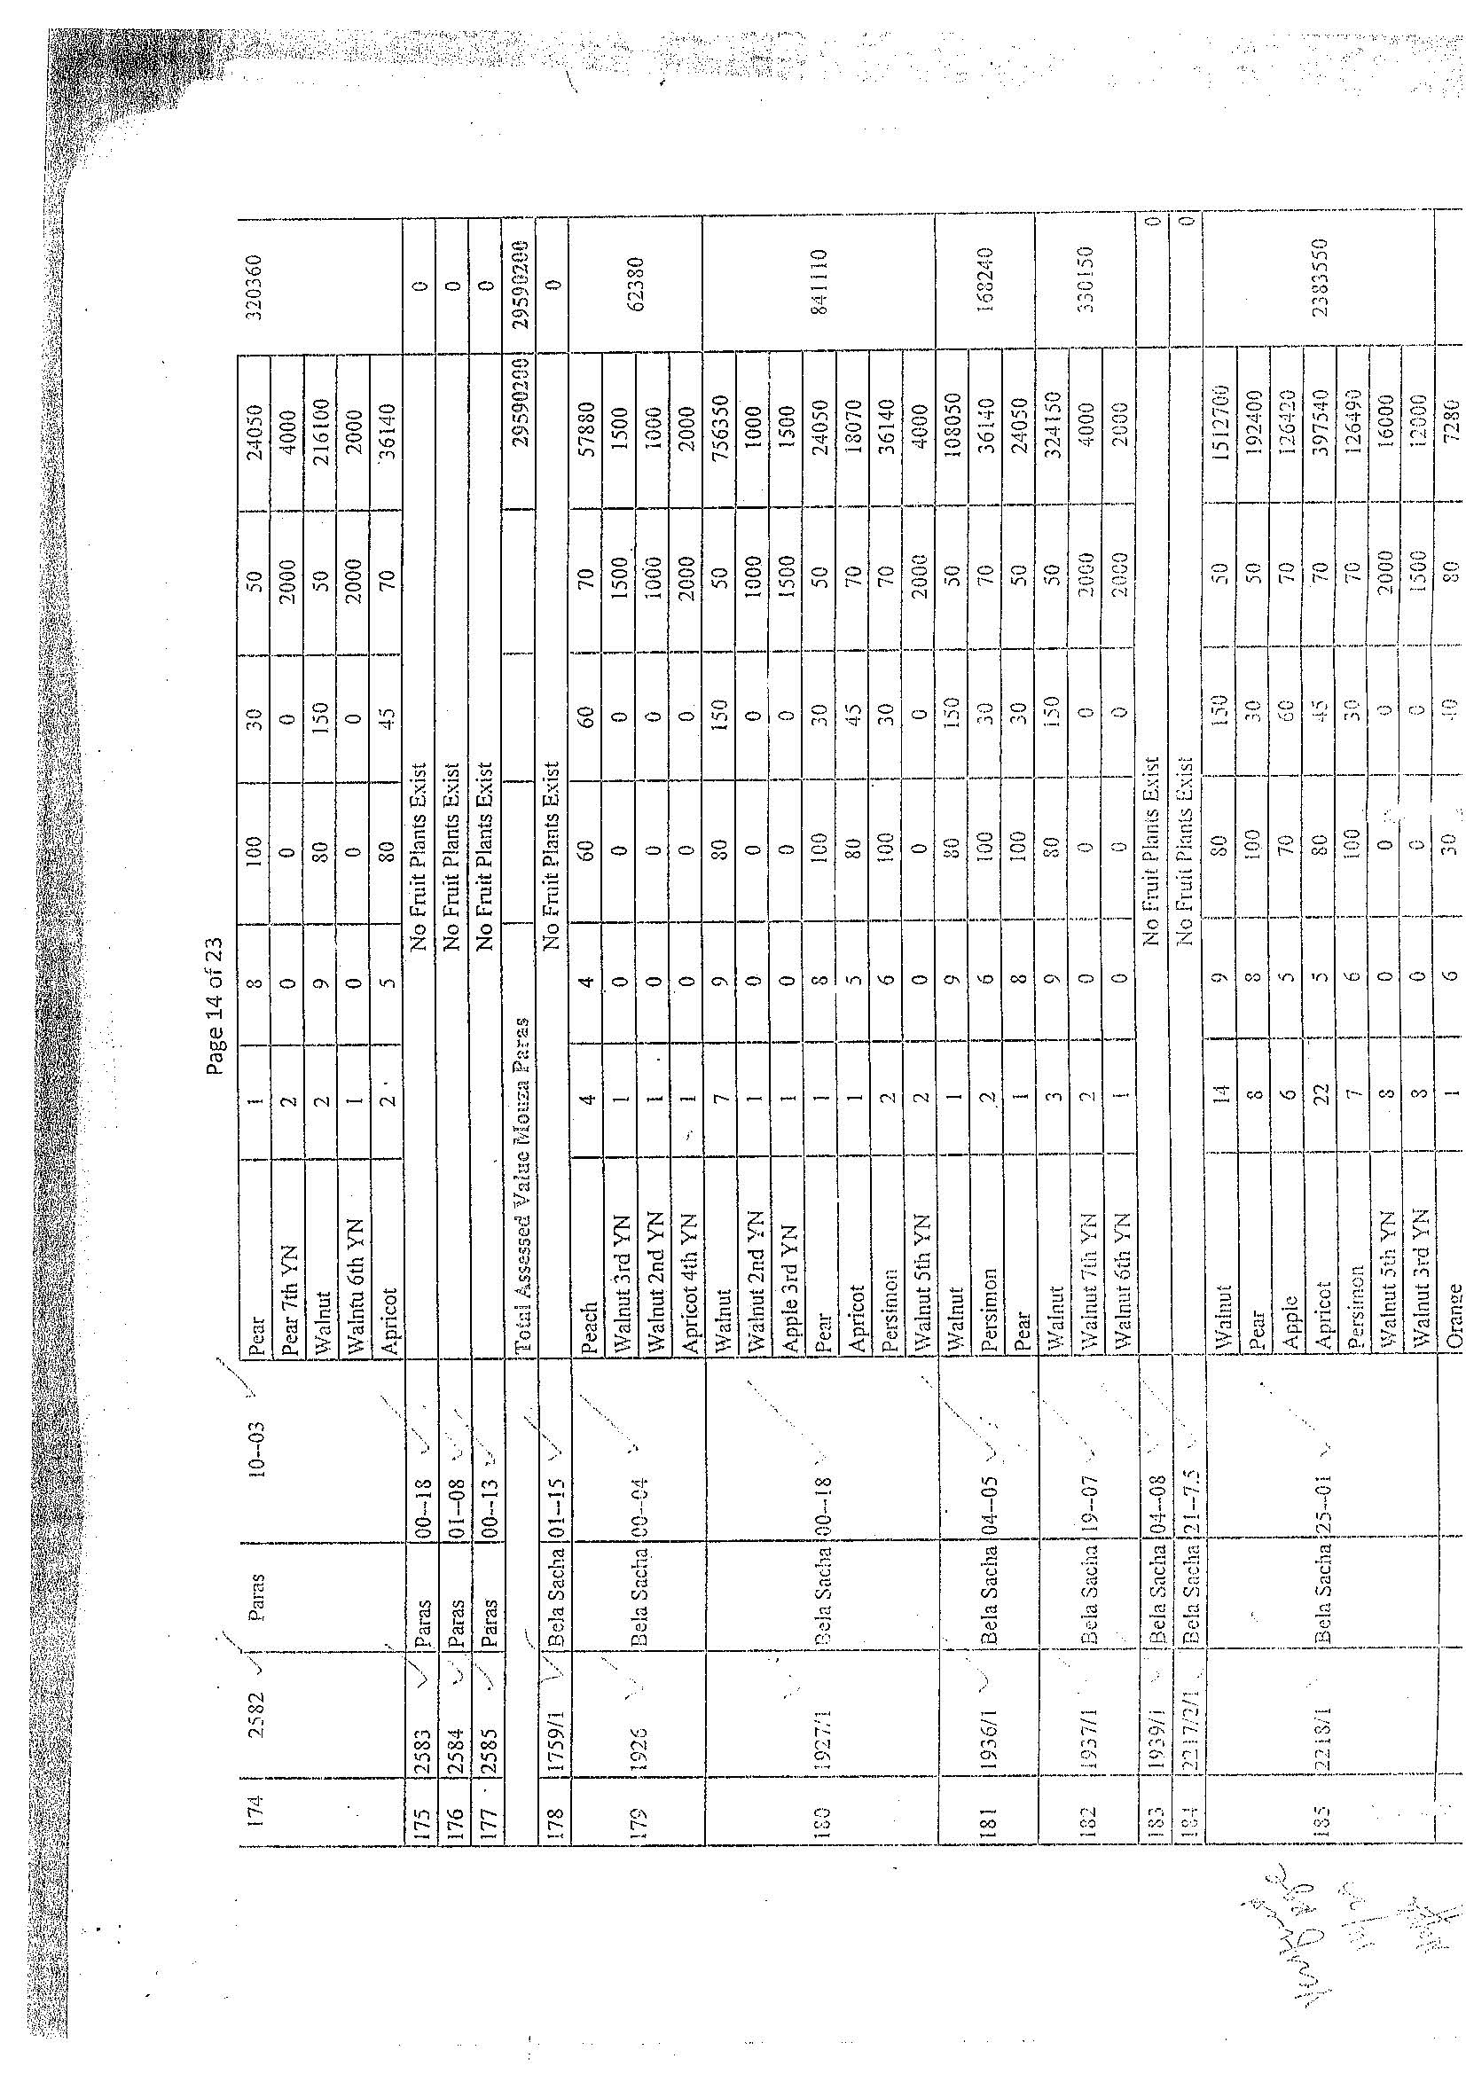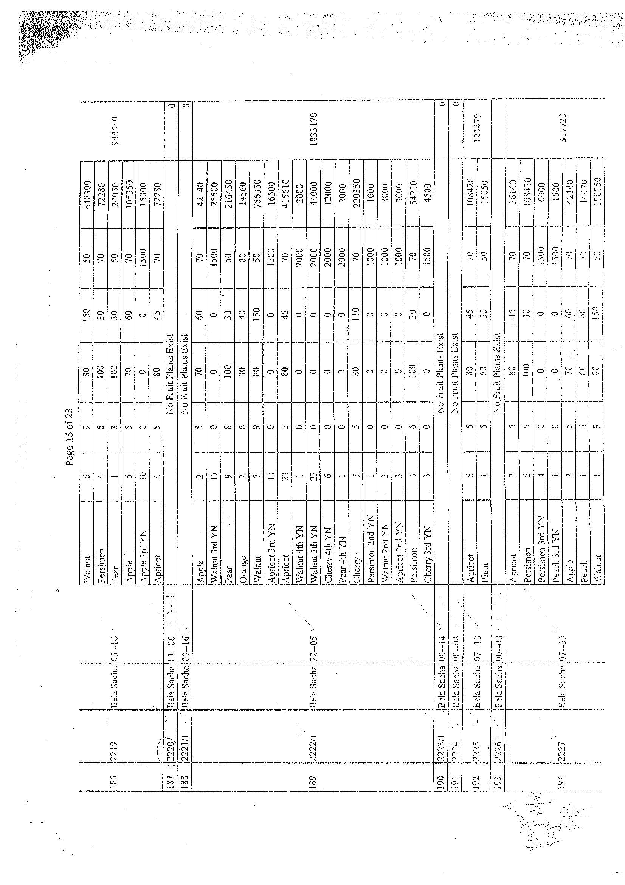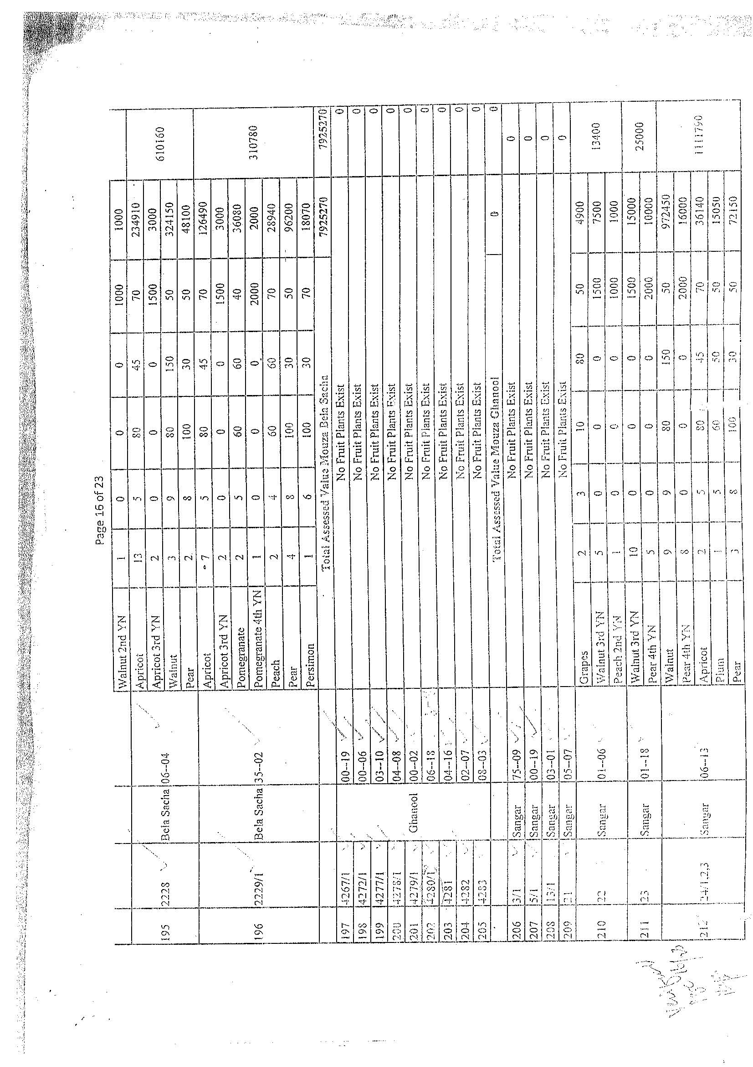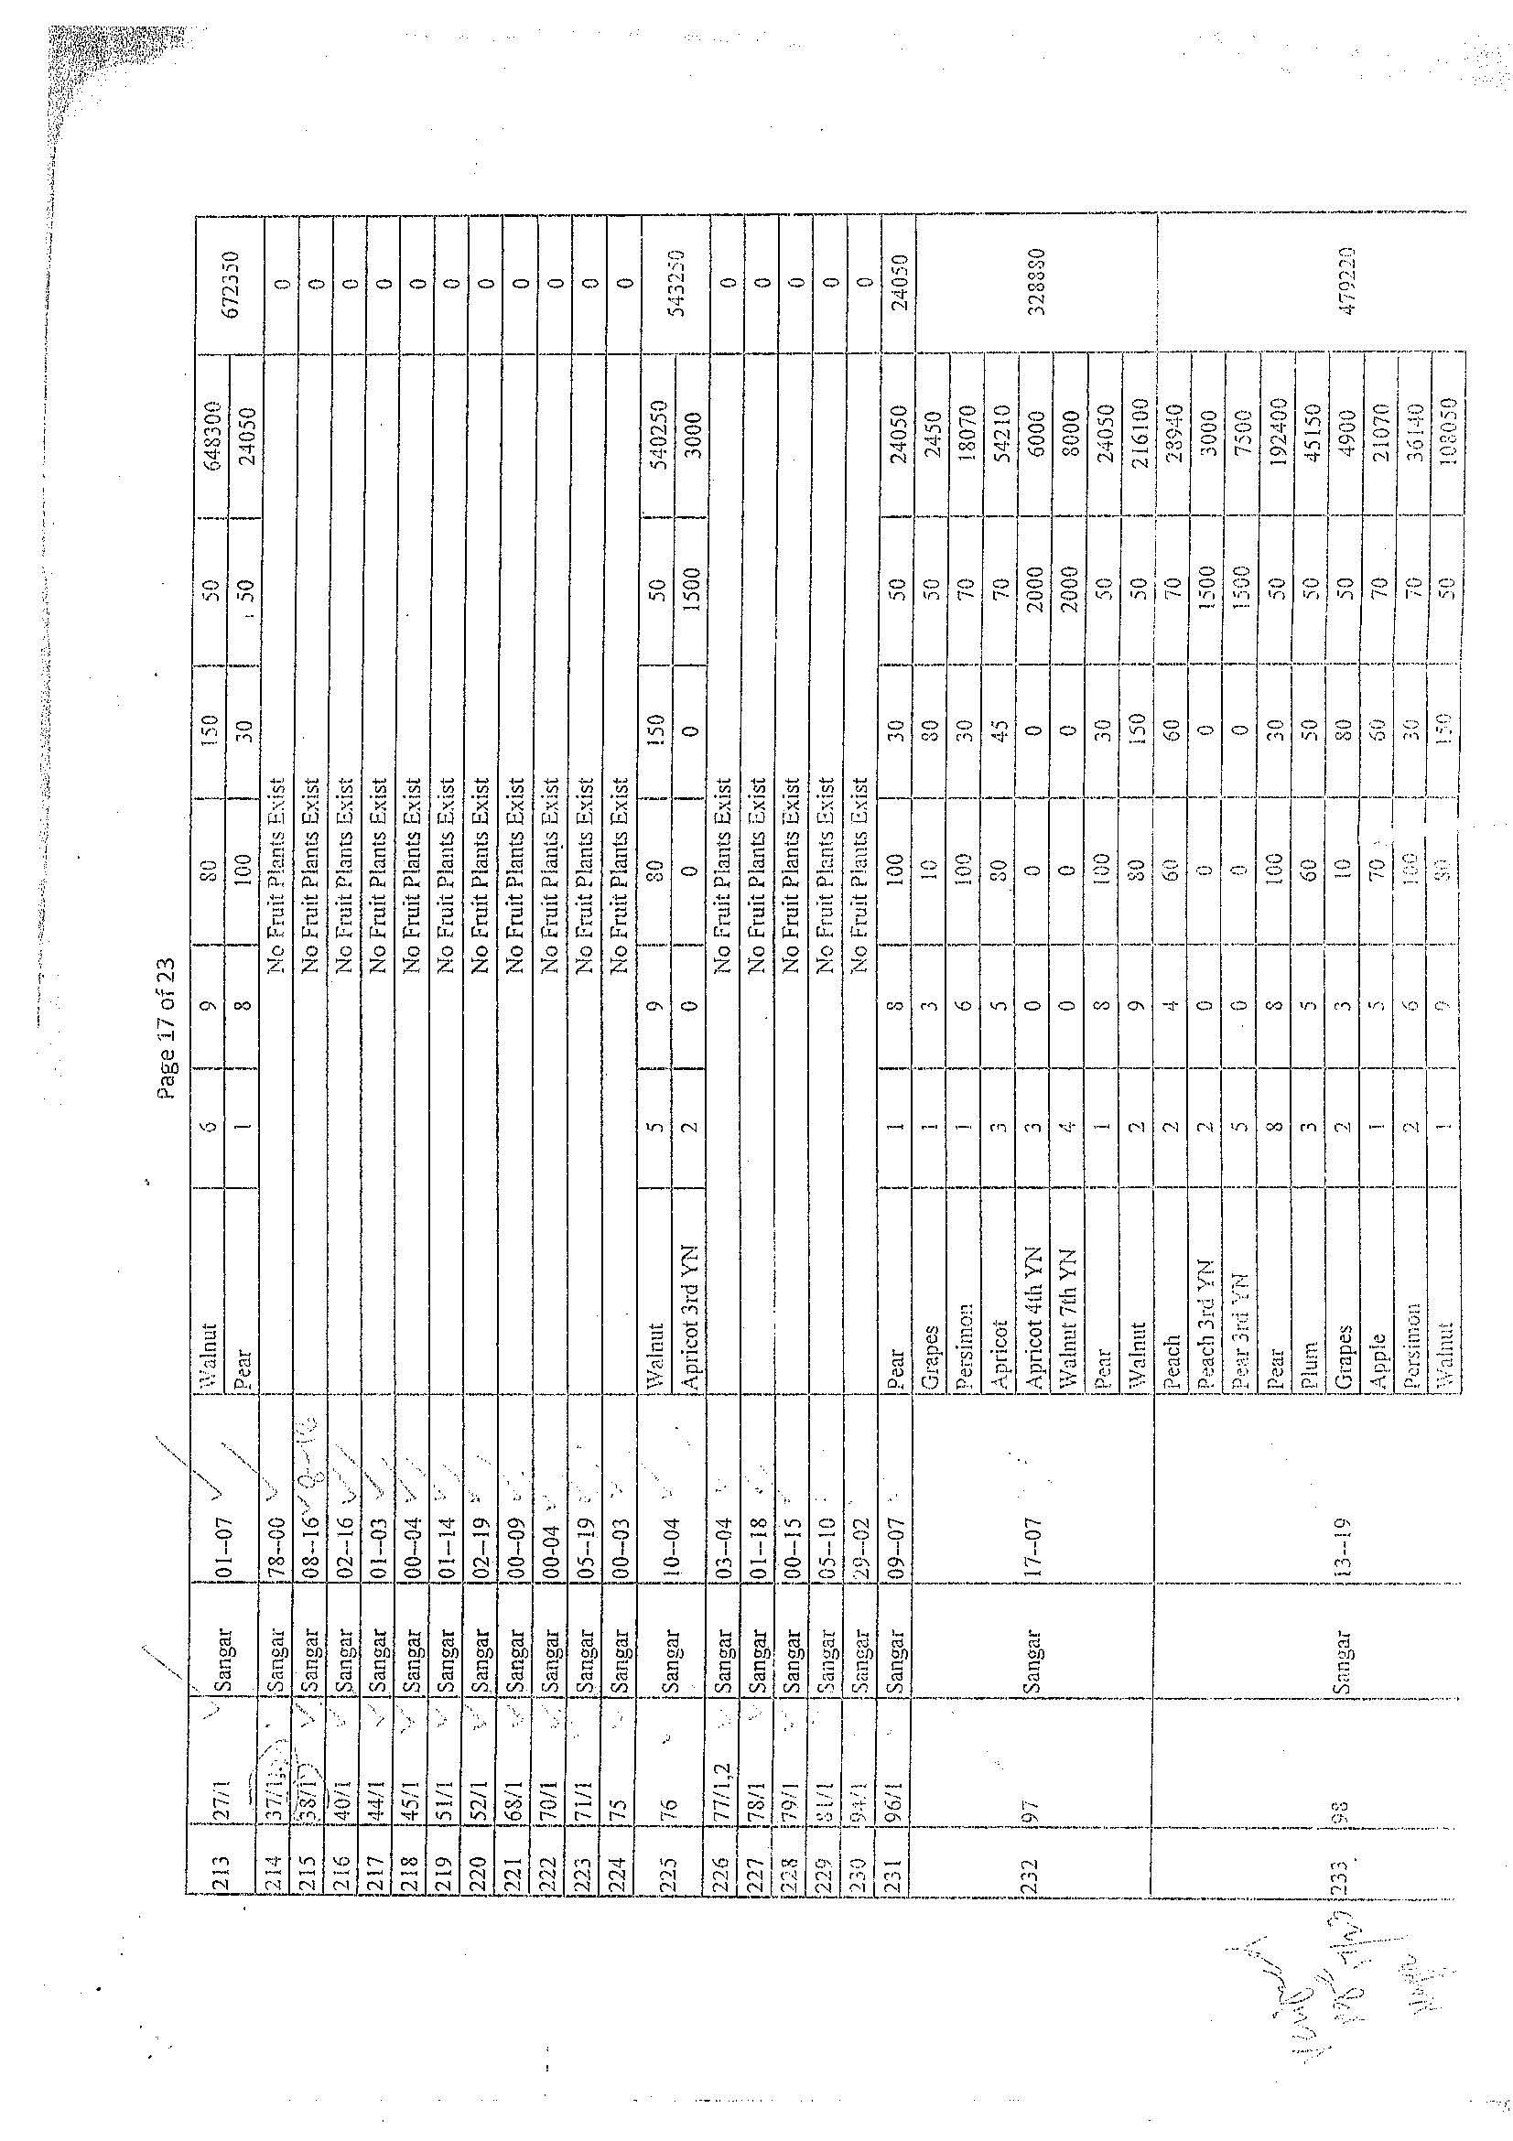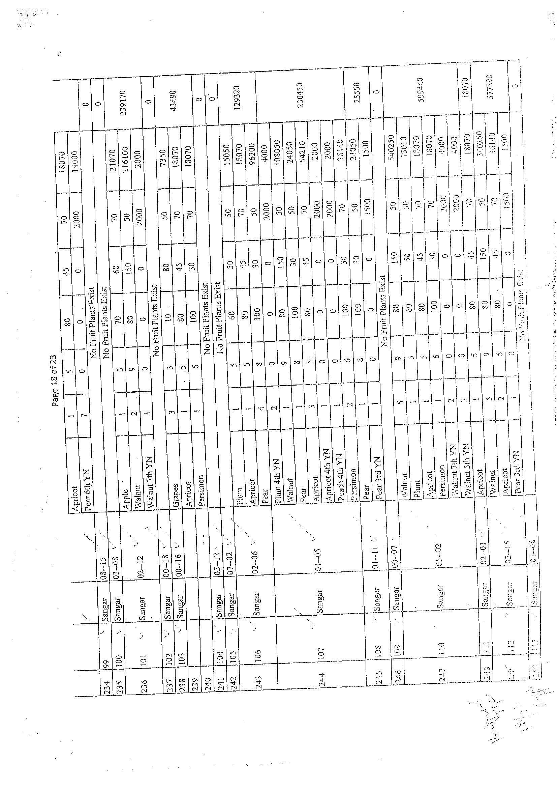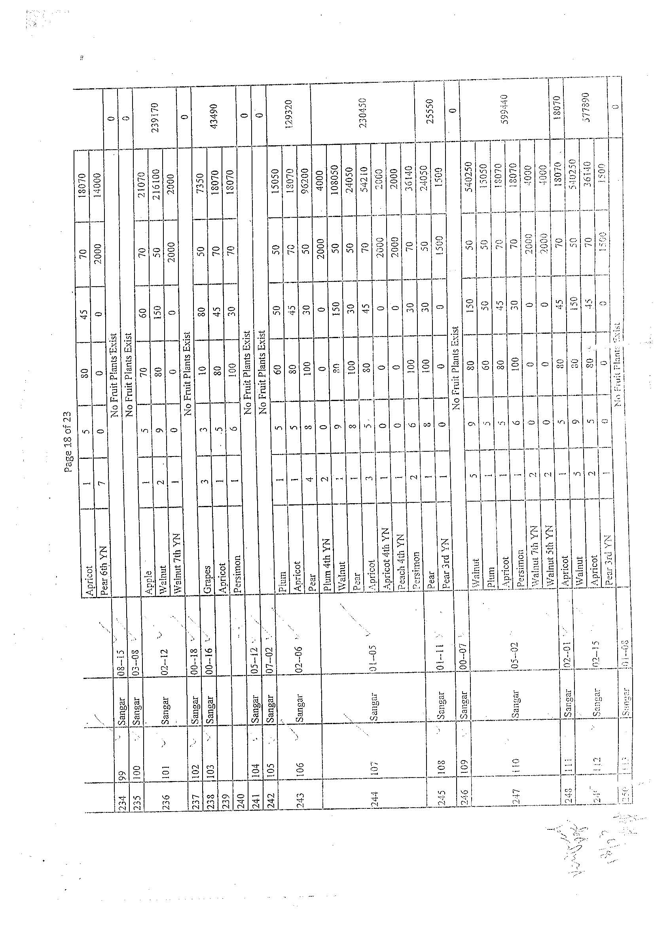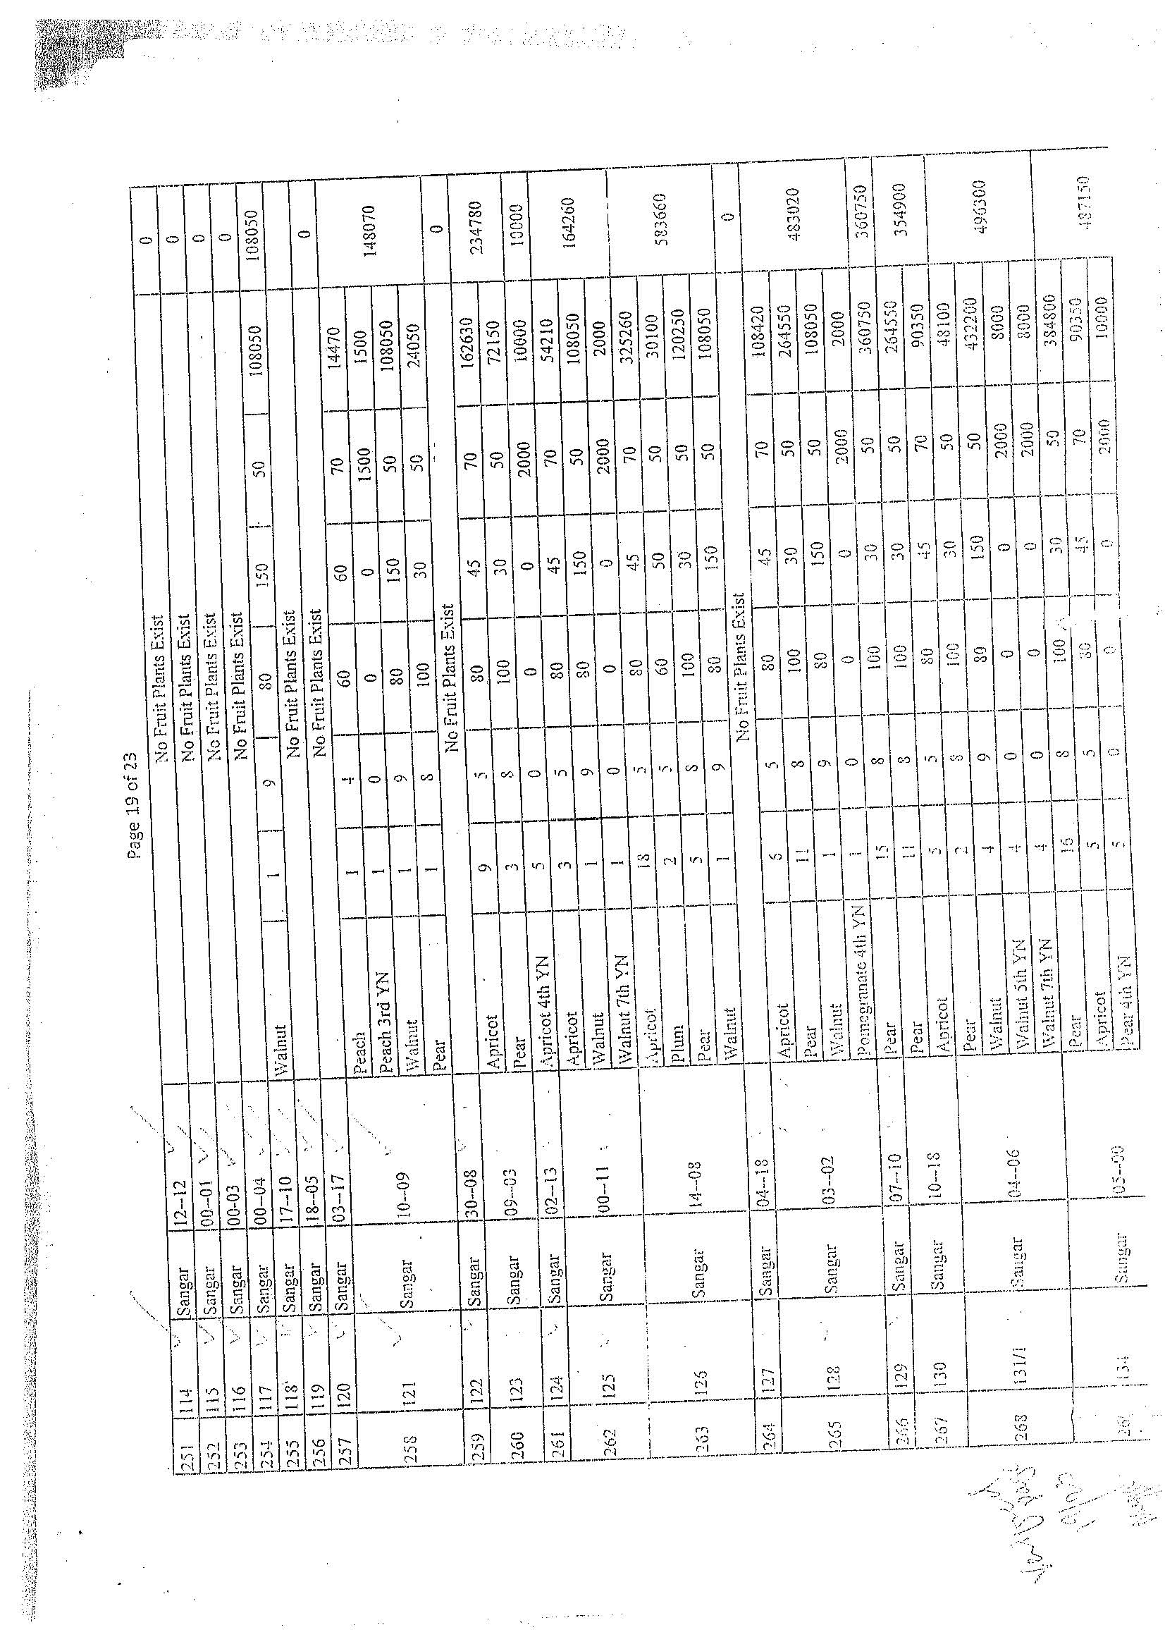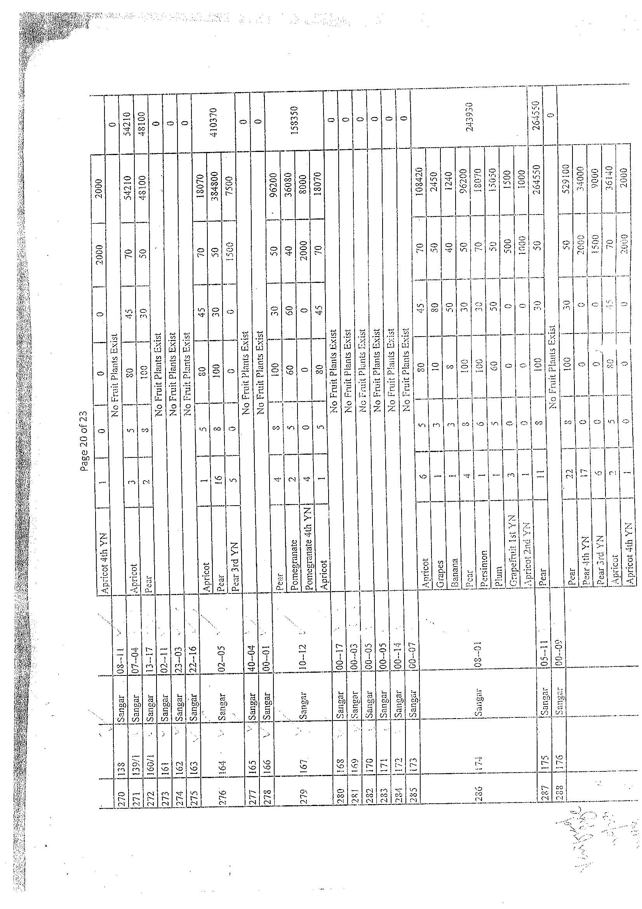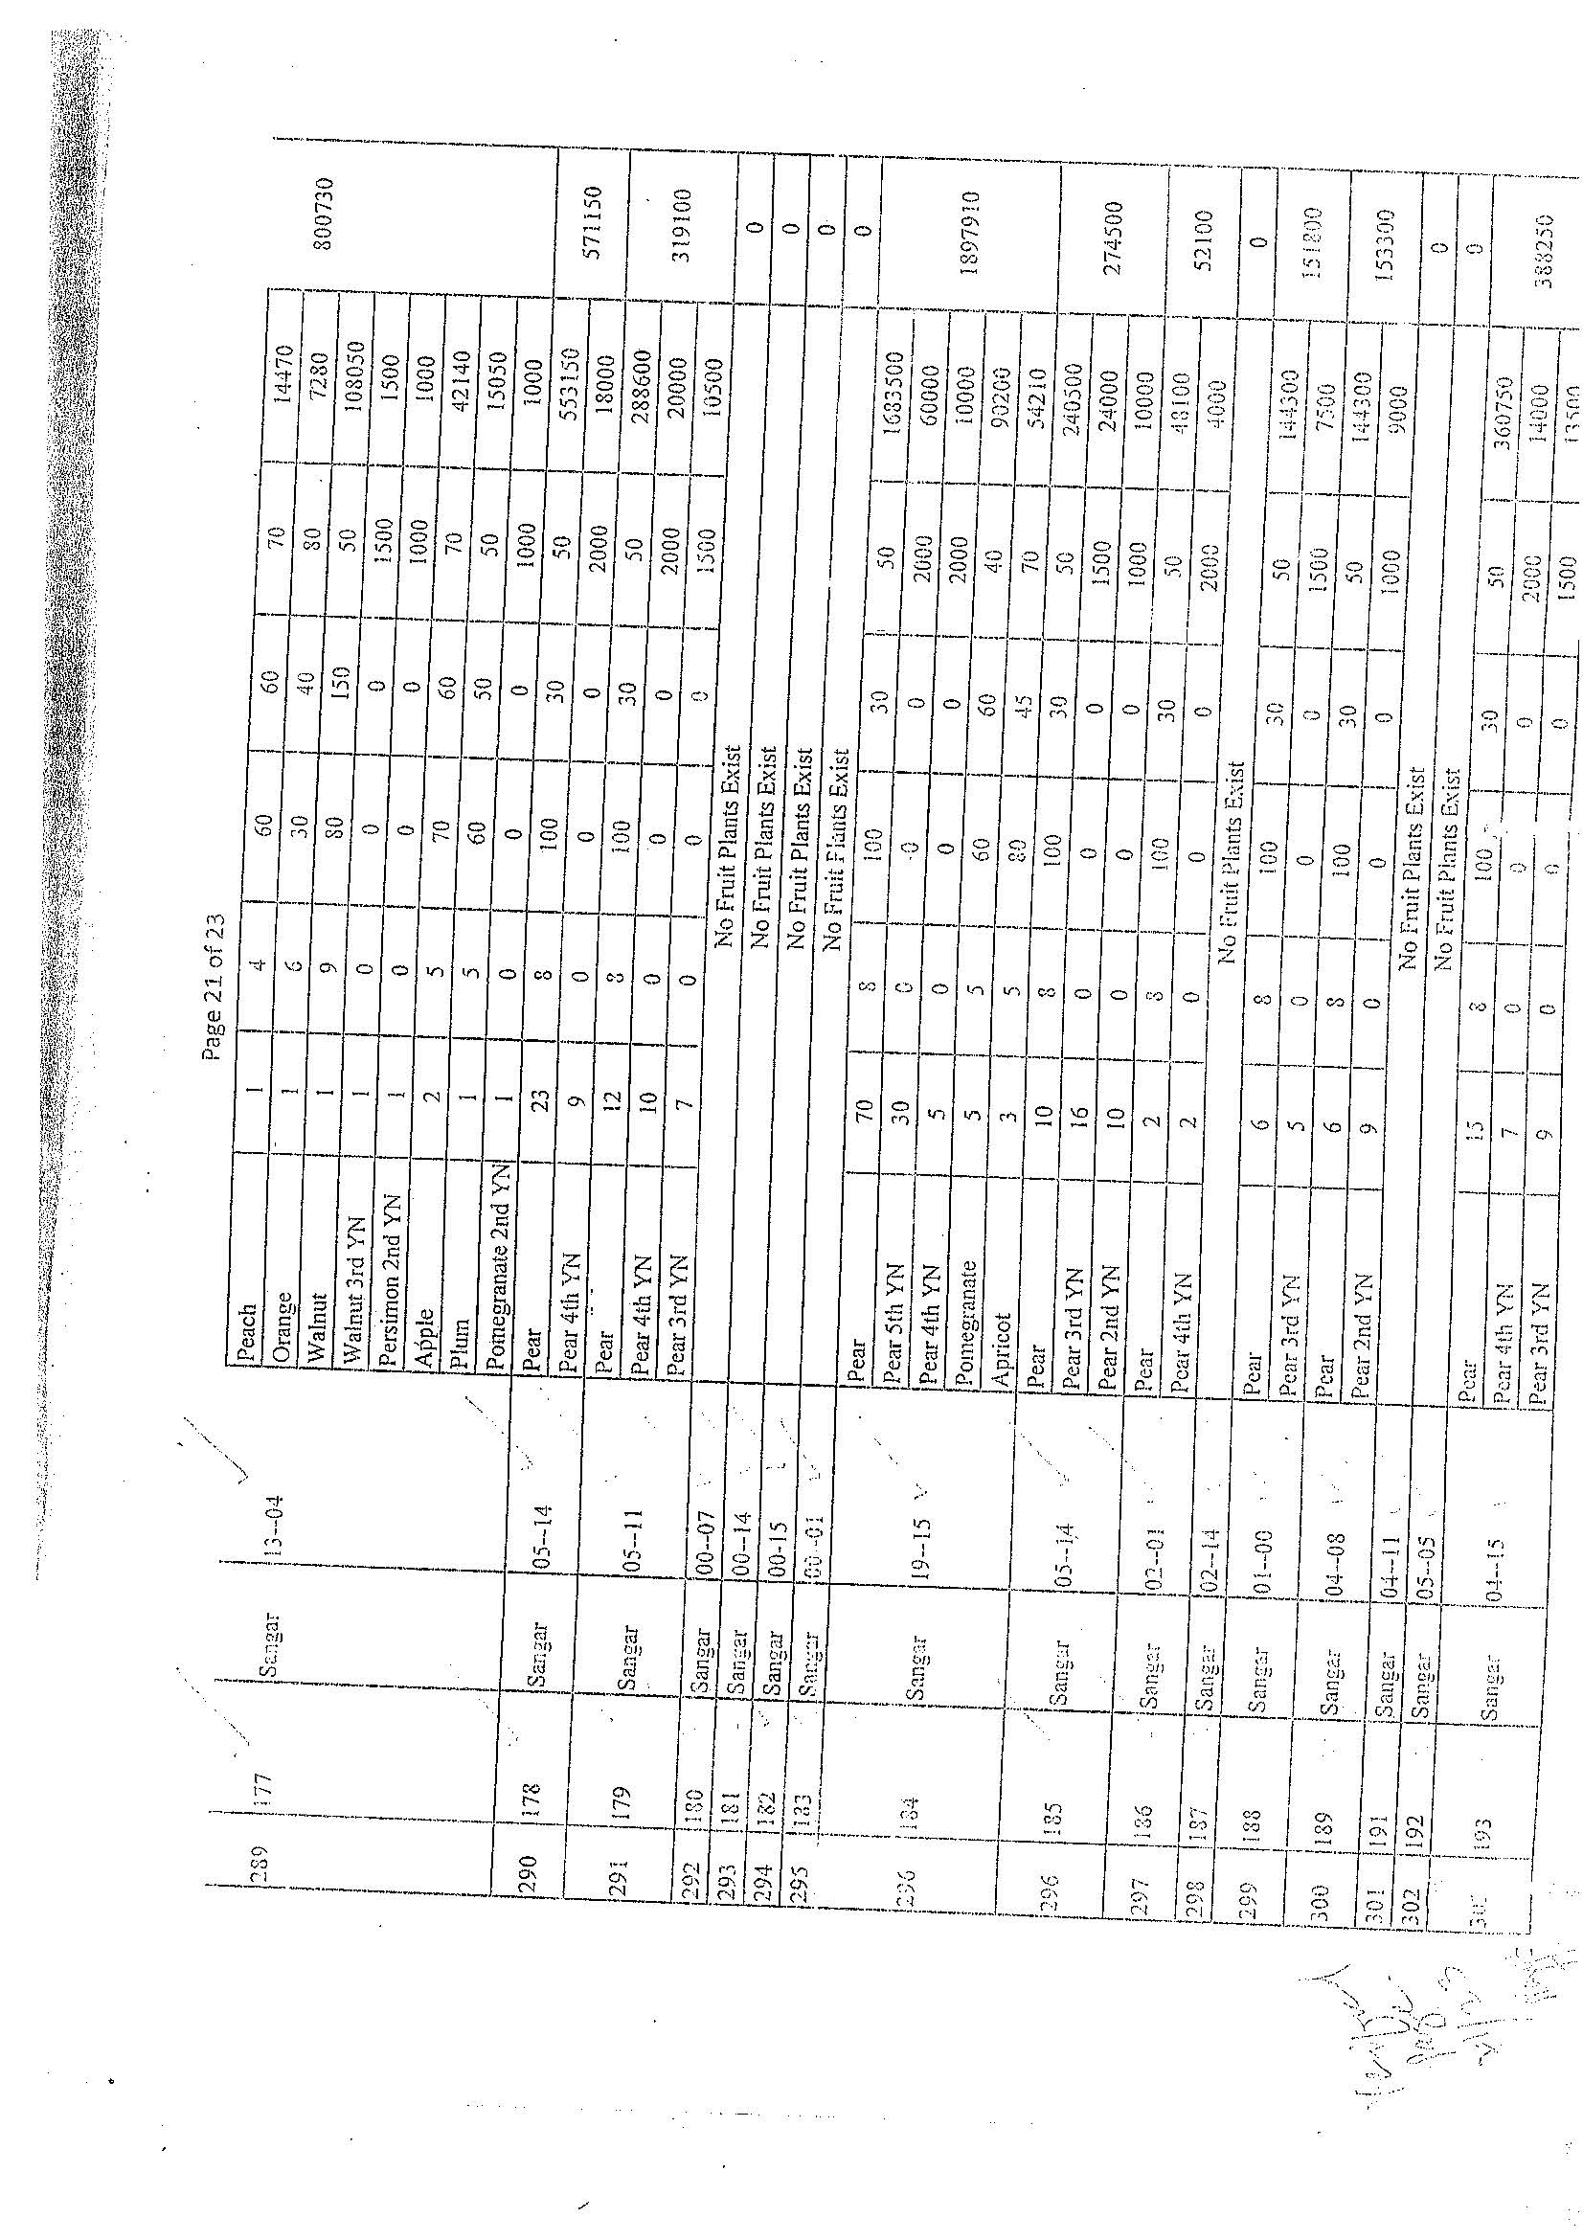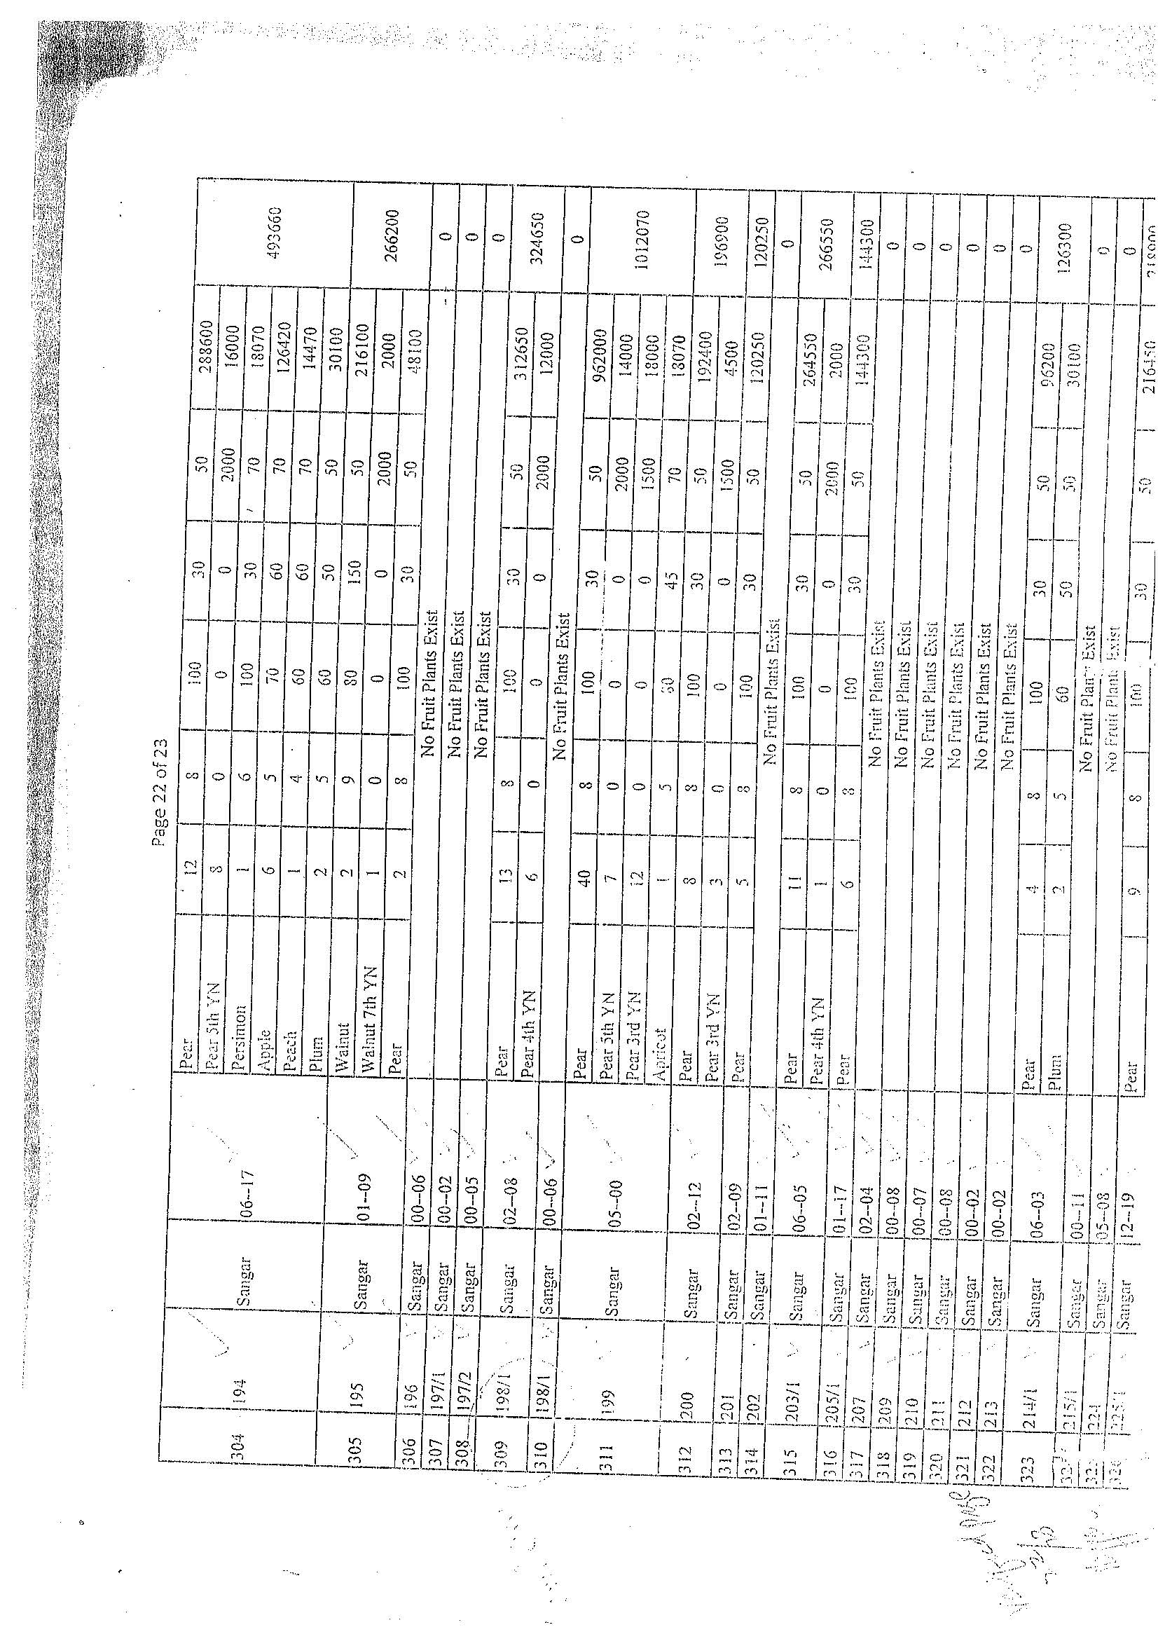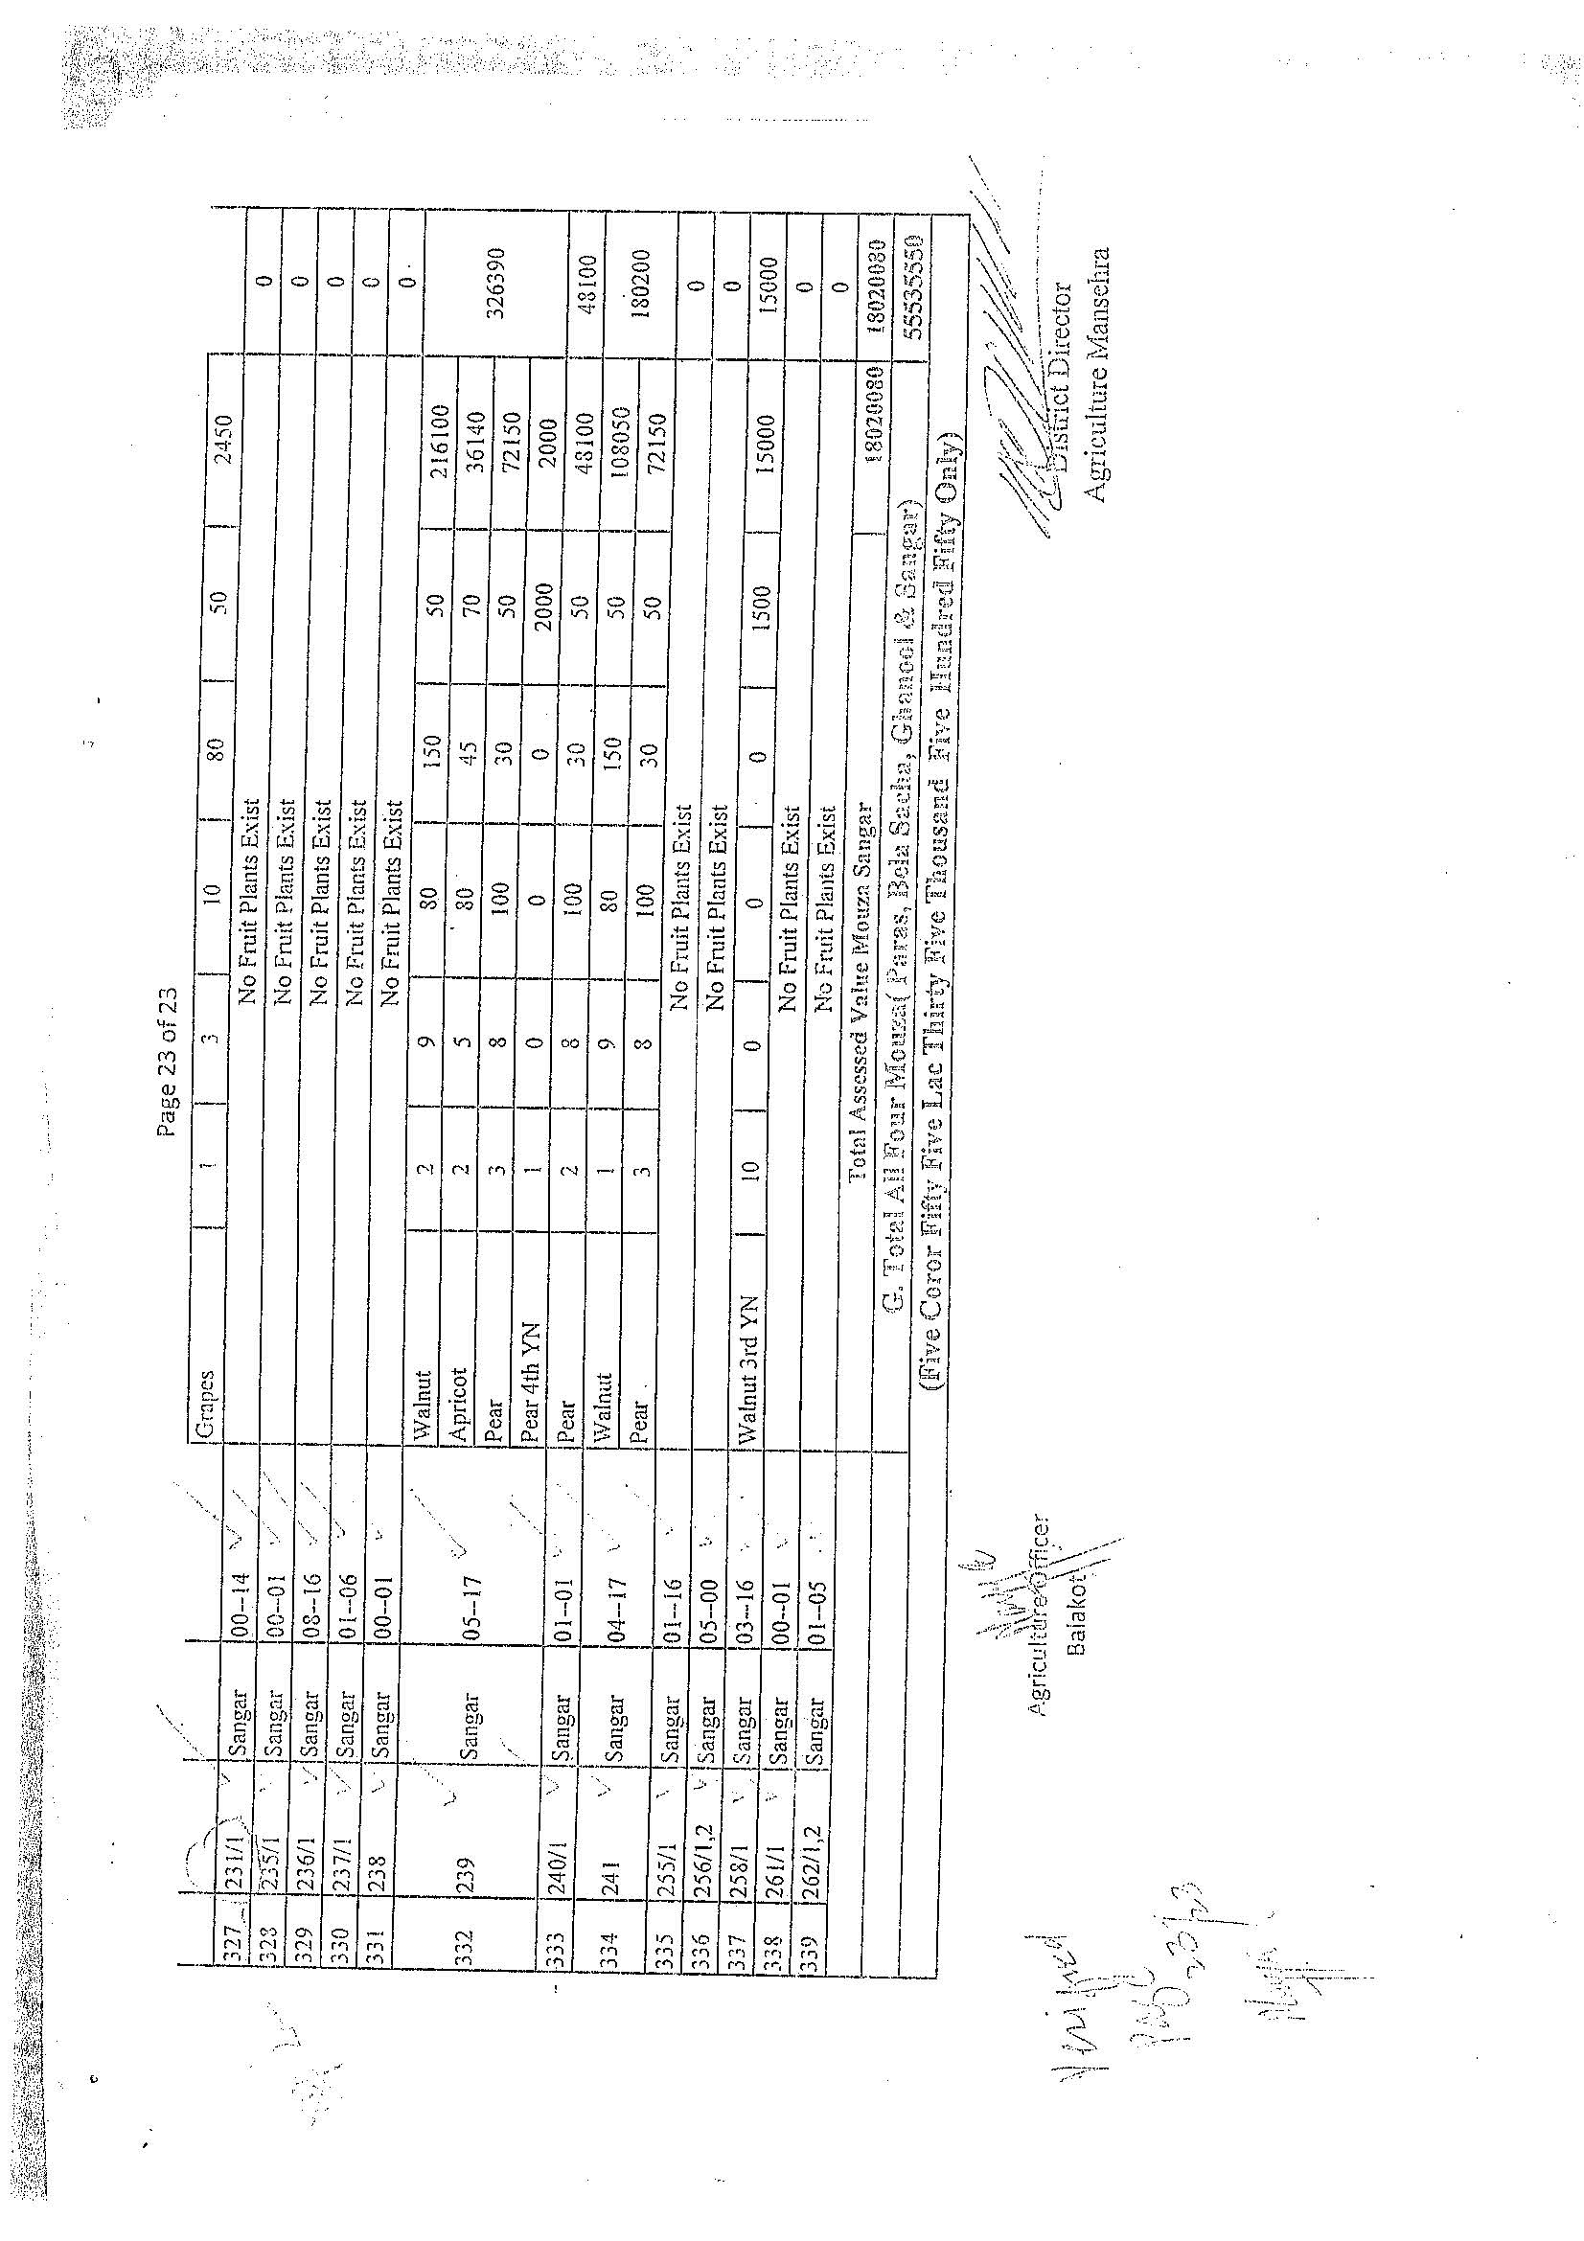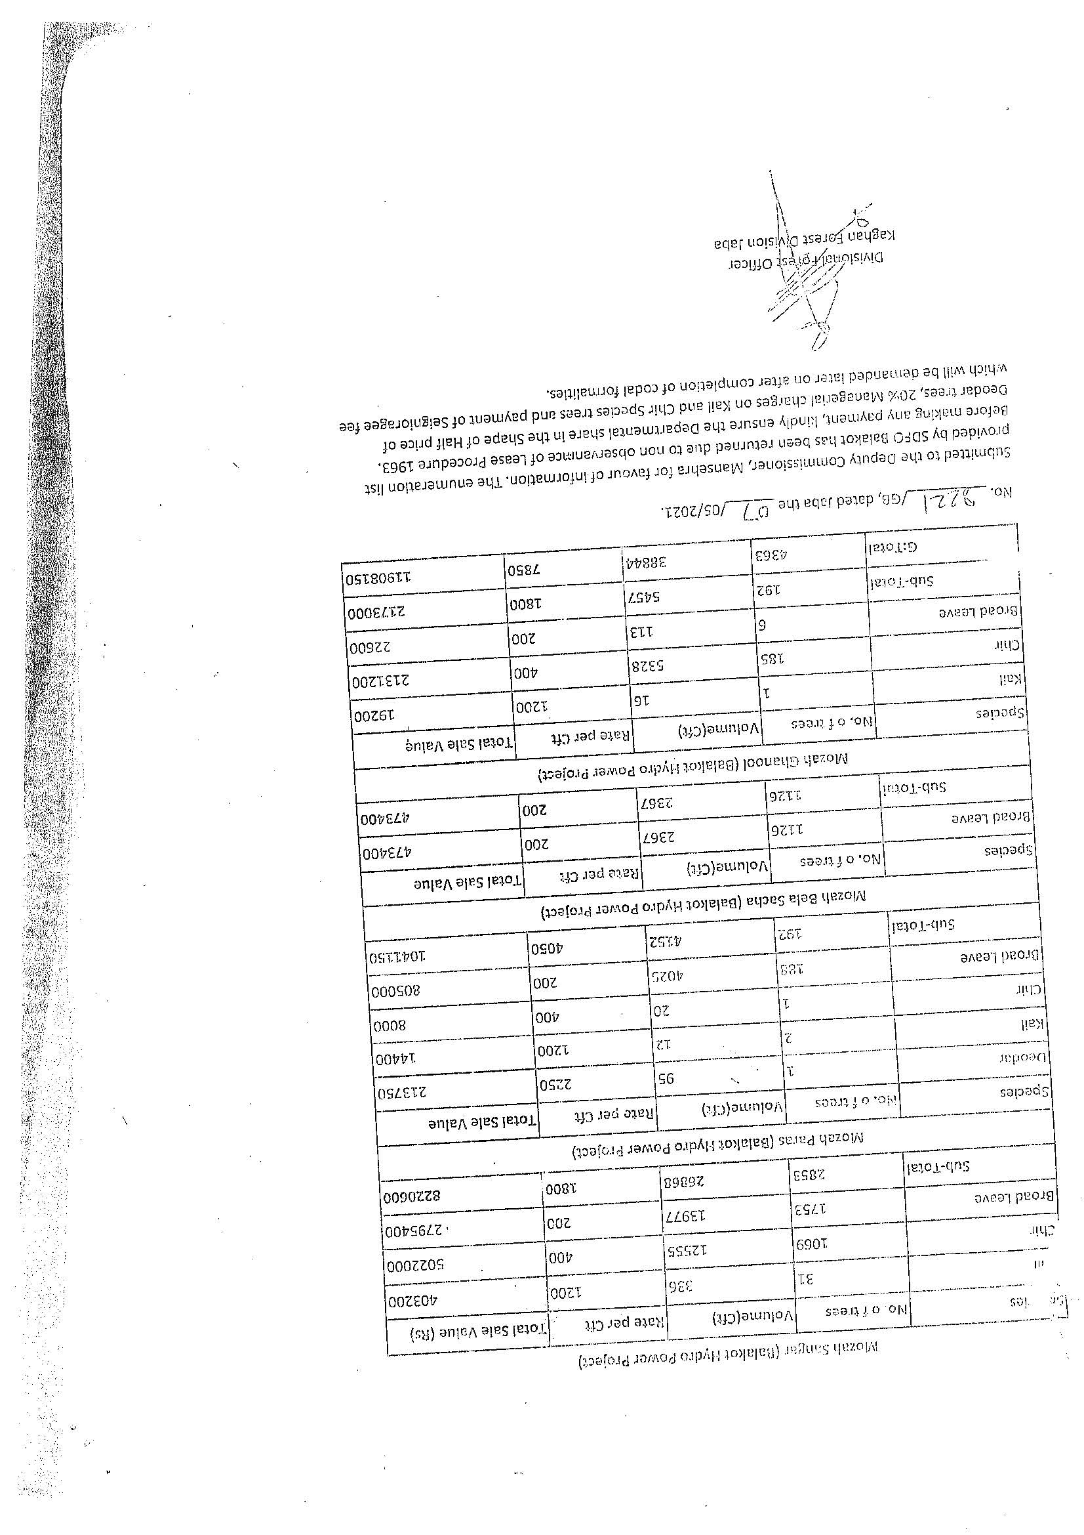

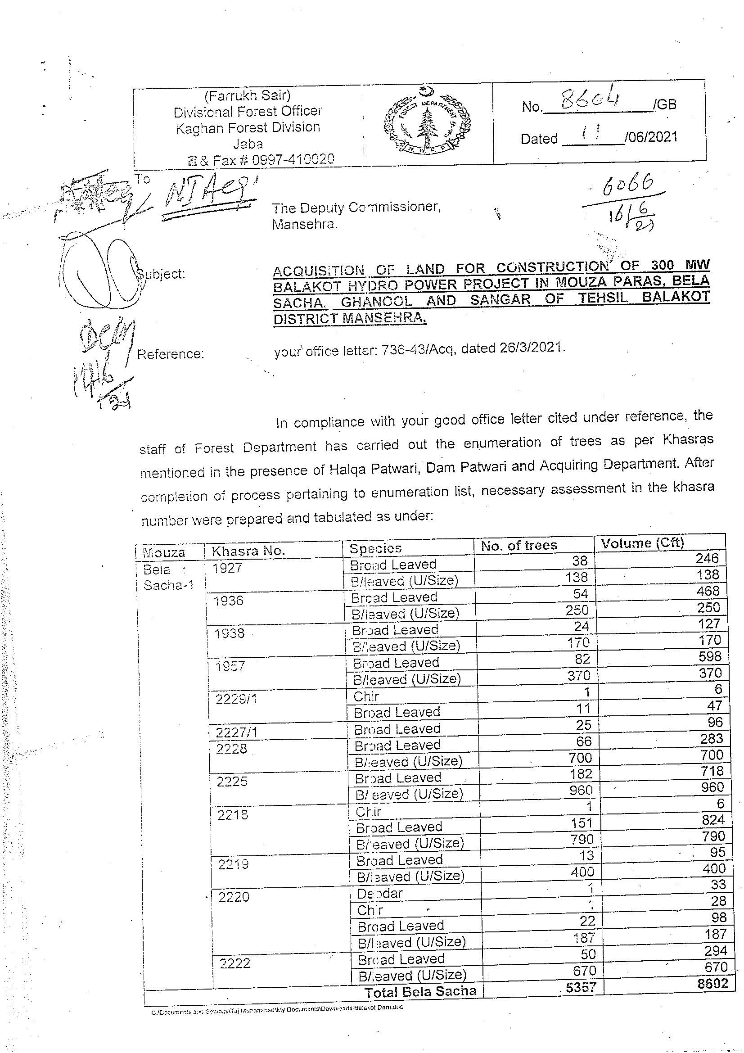
- Forest Department Assessment

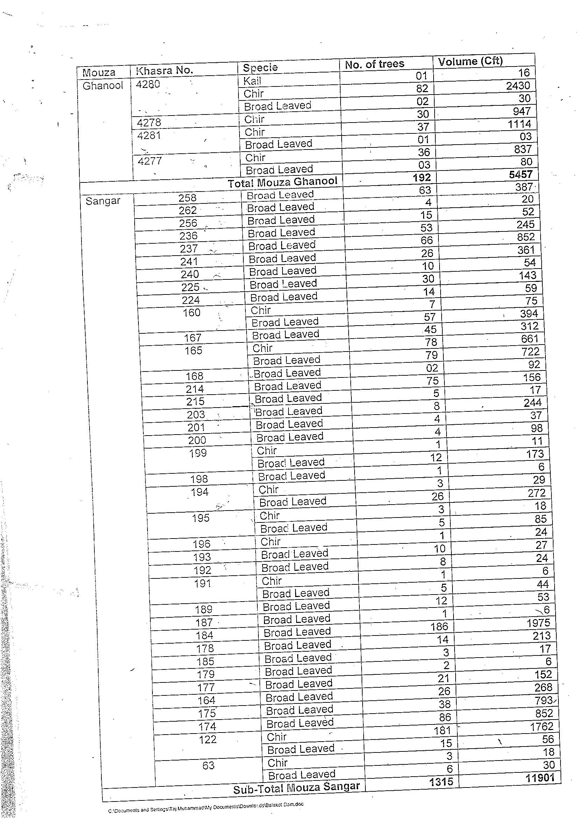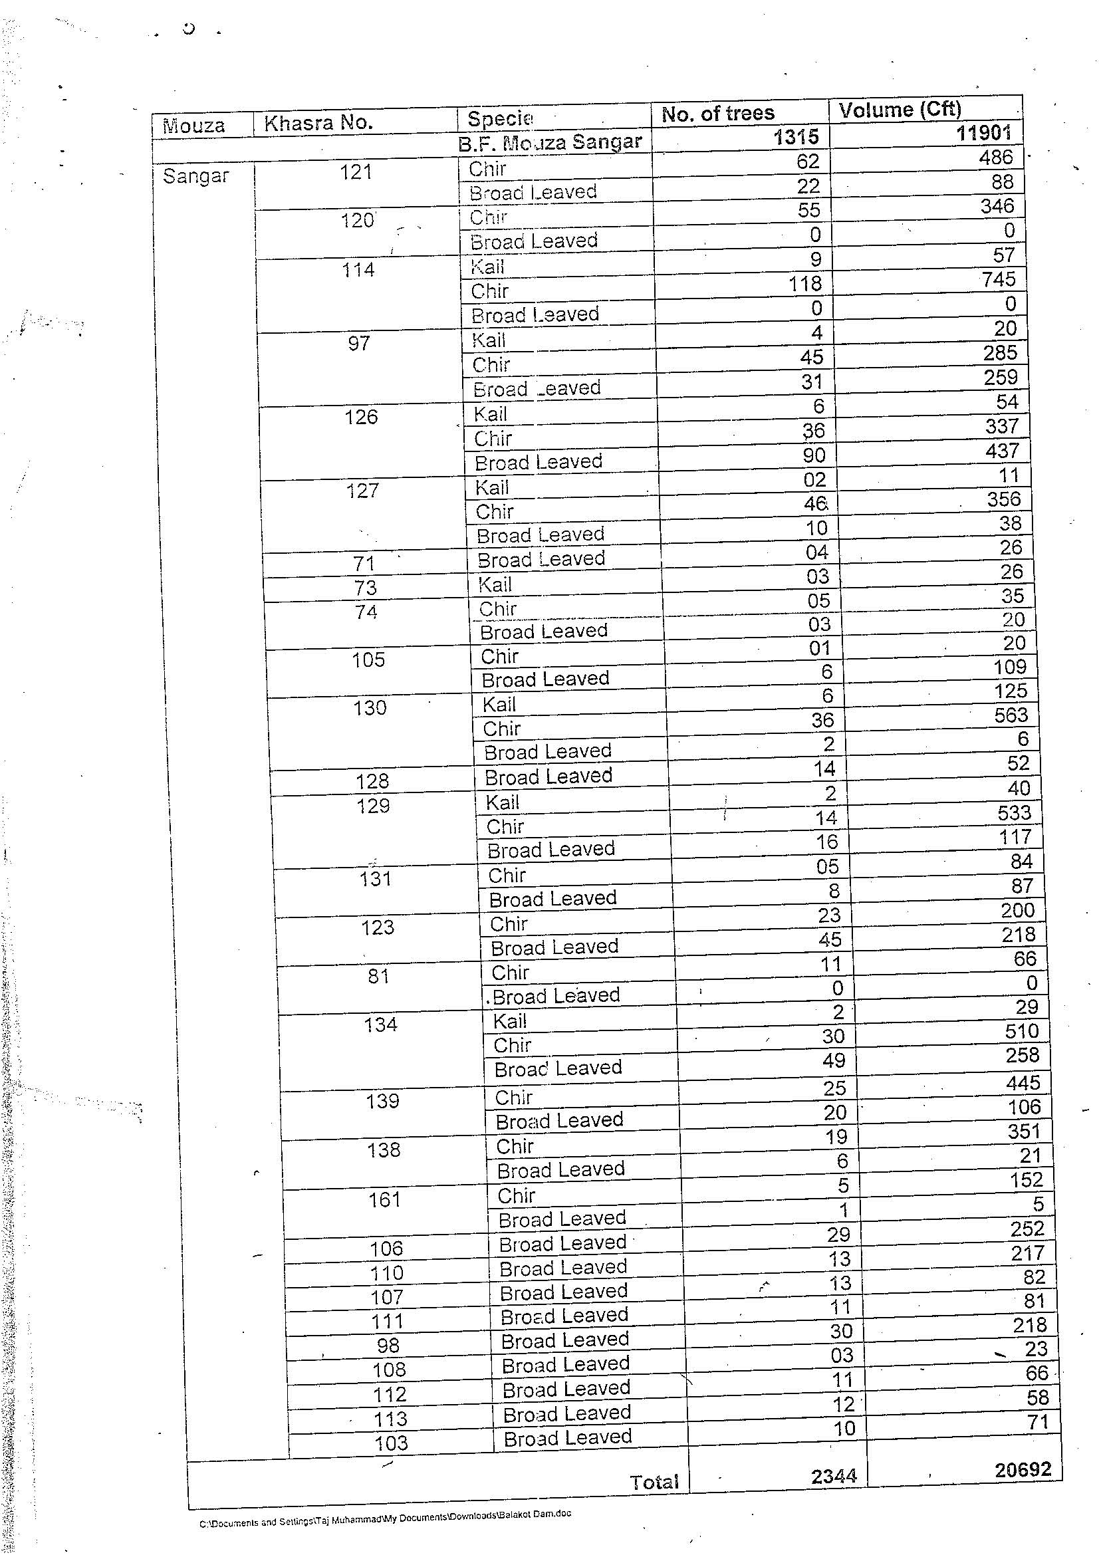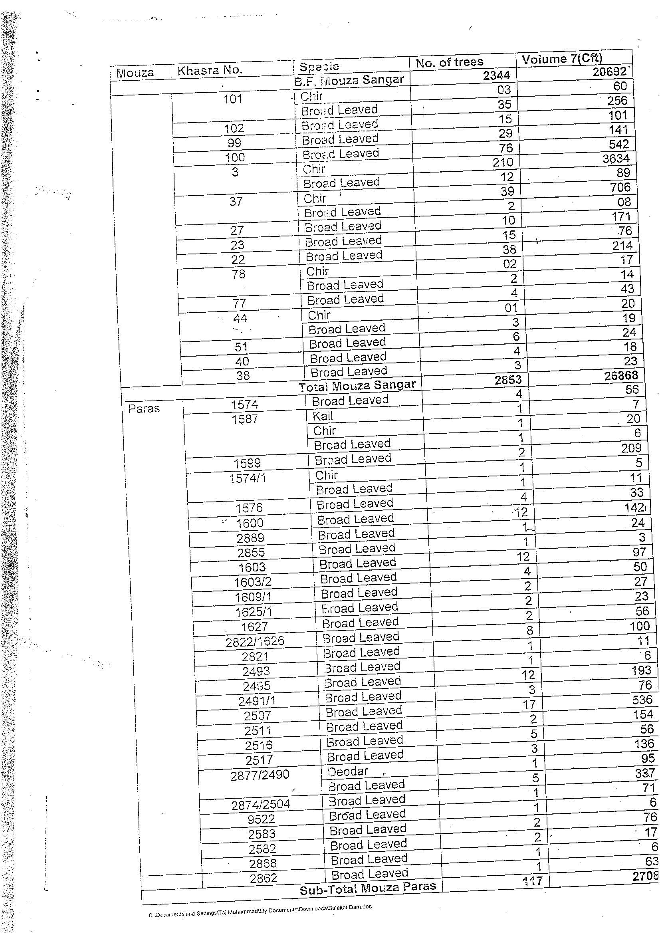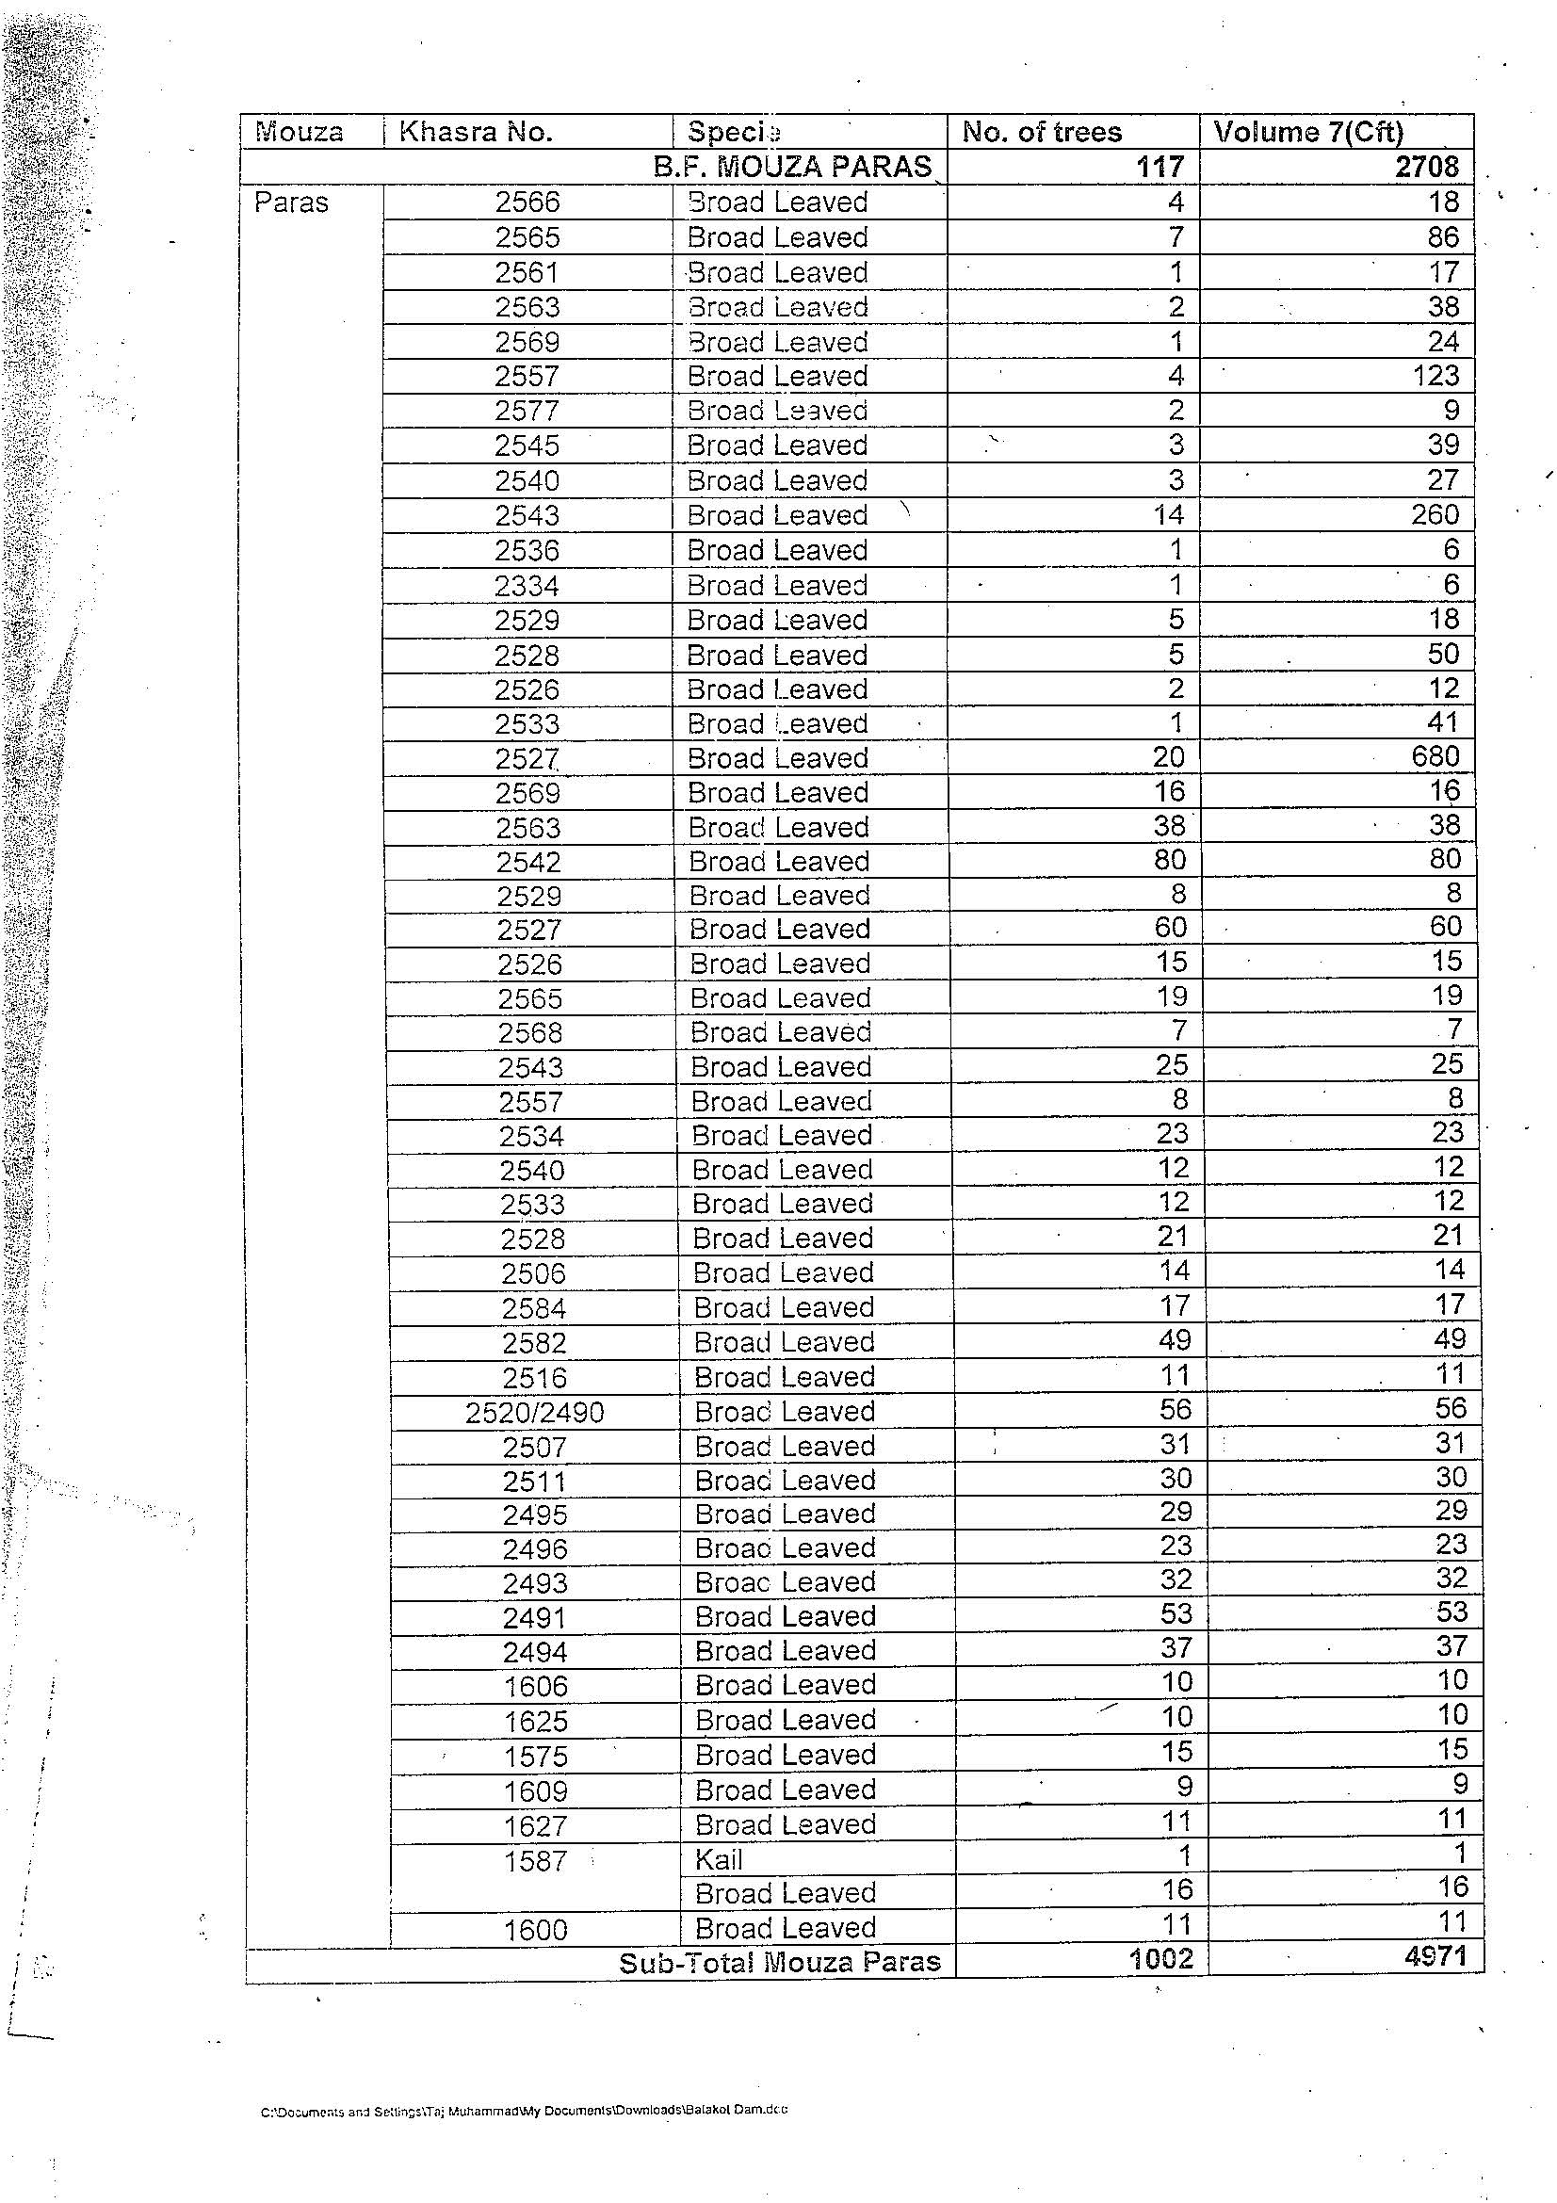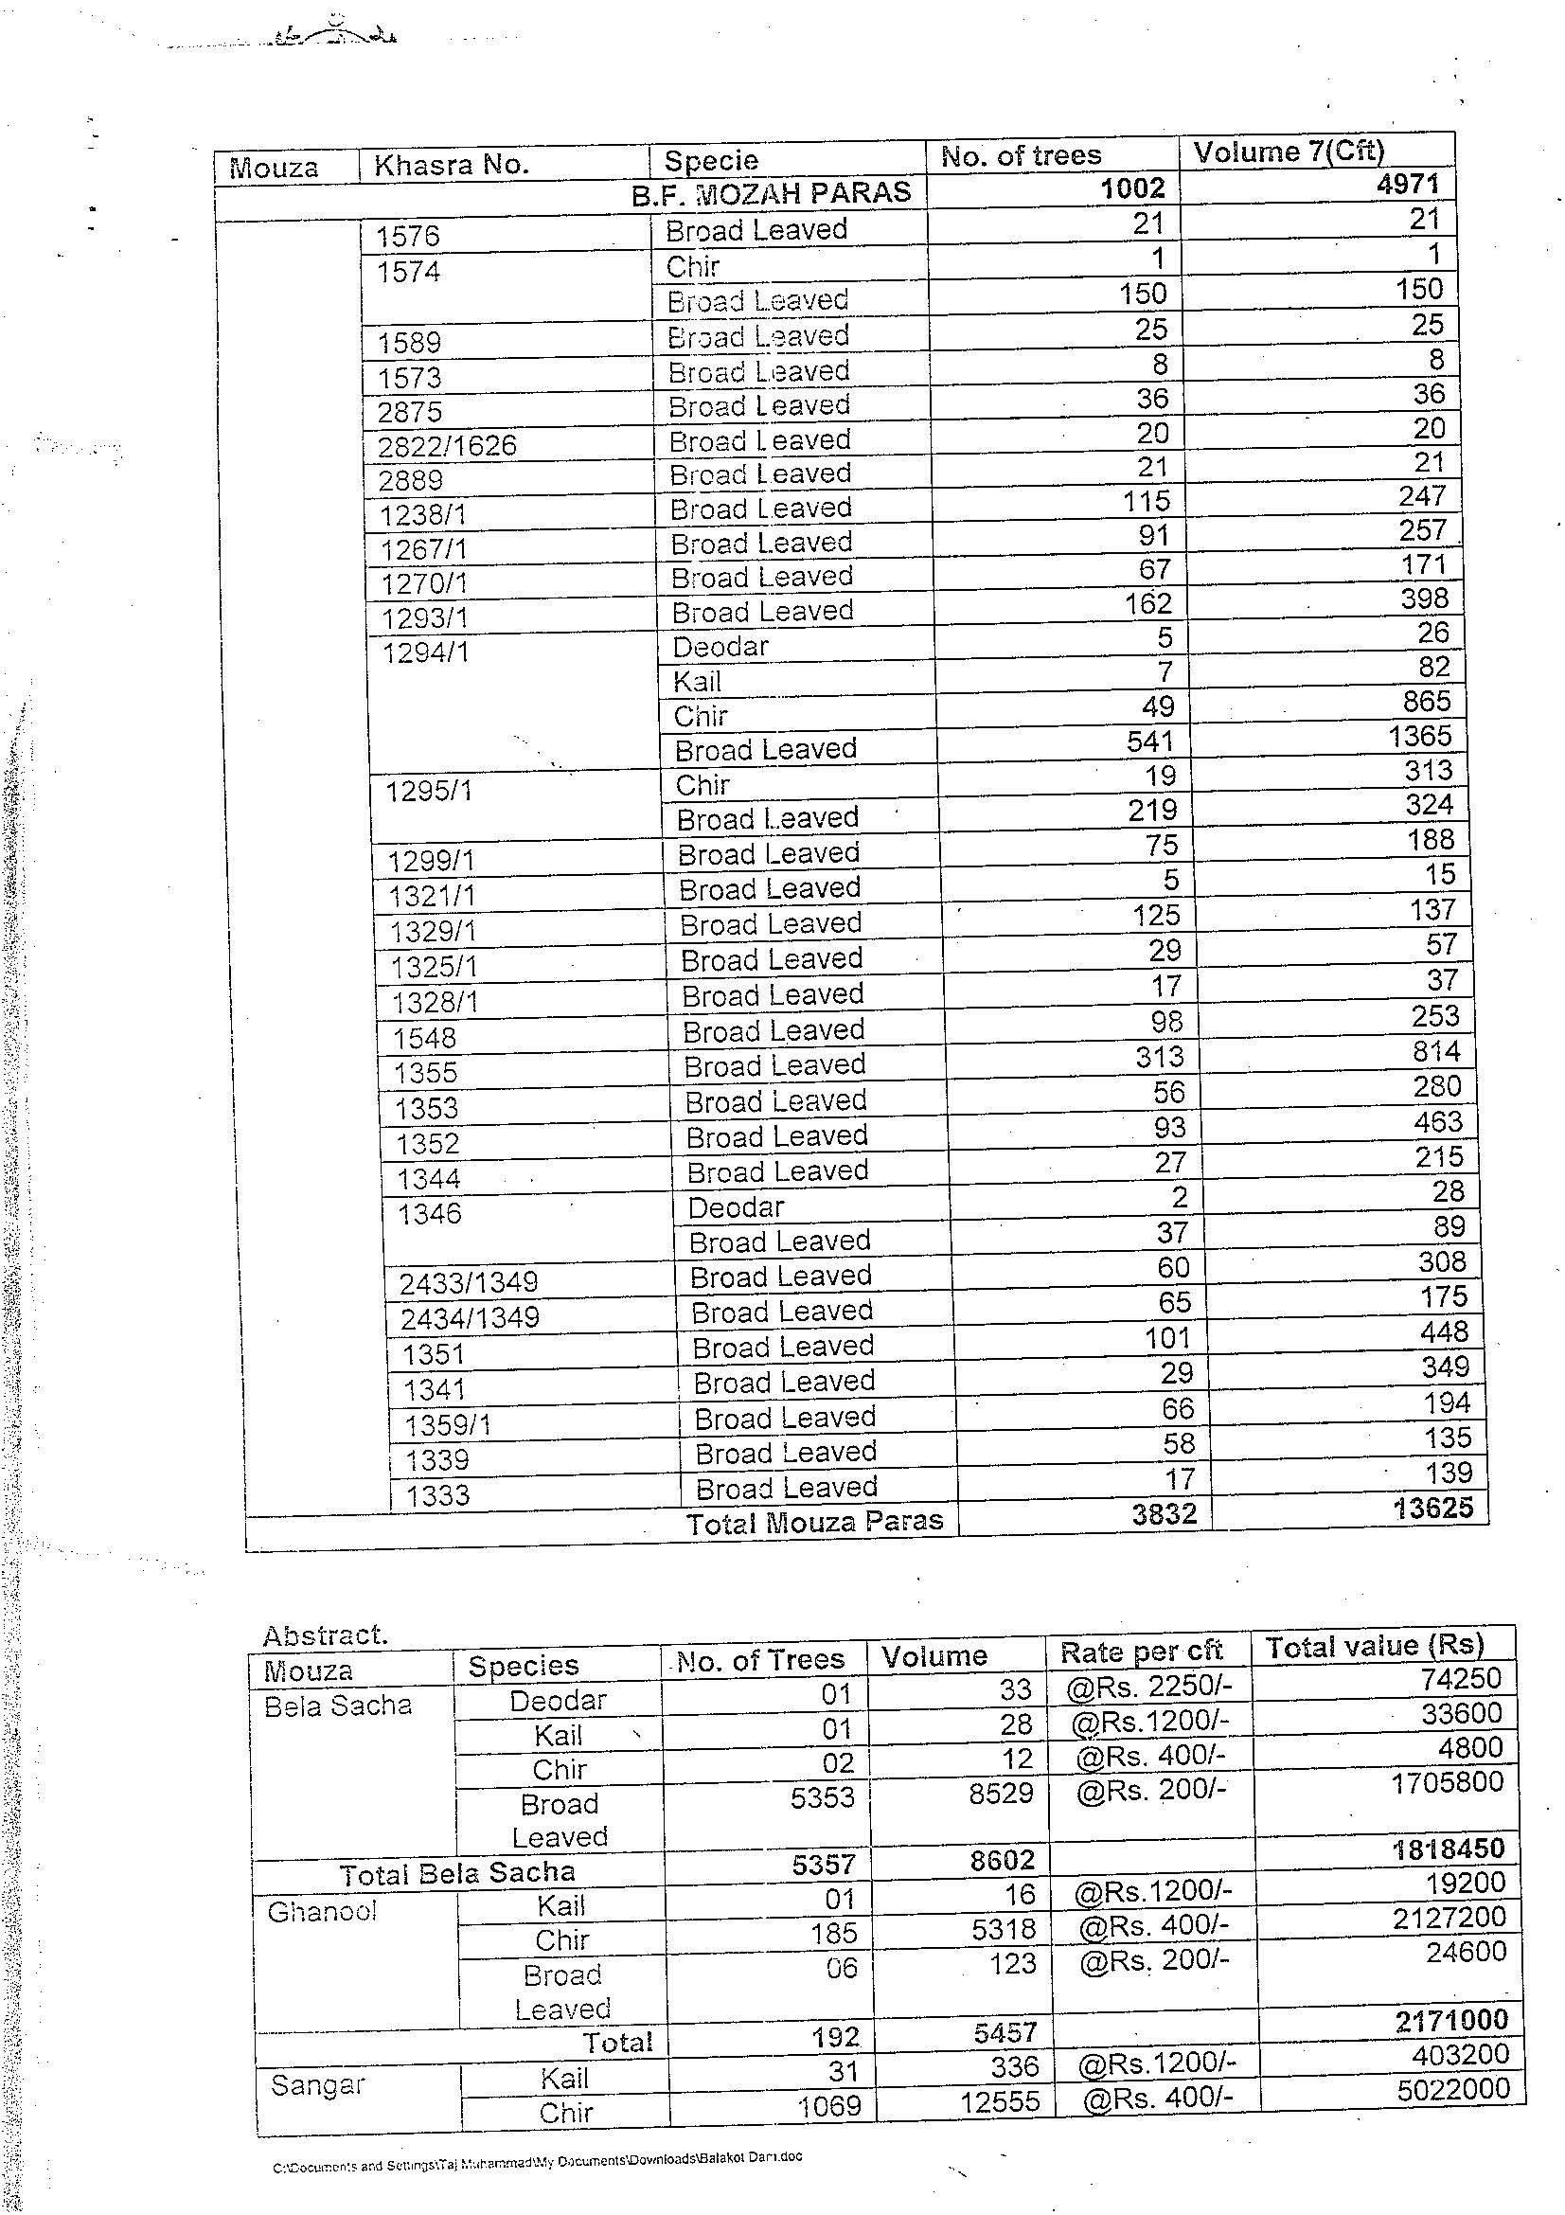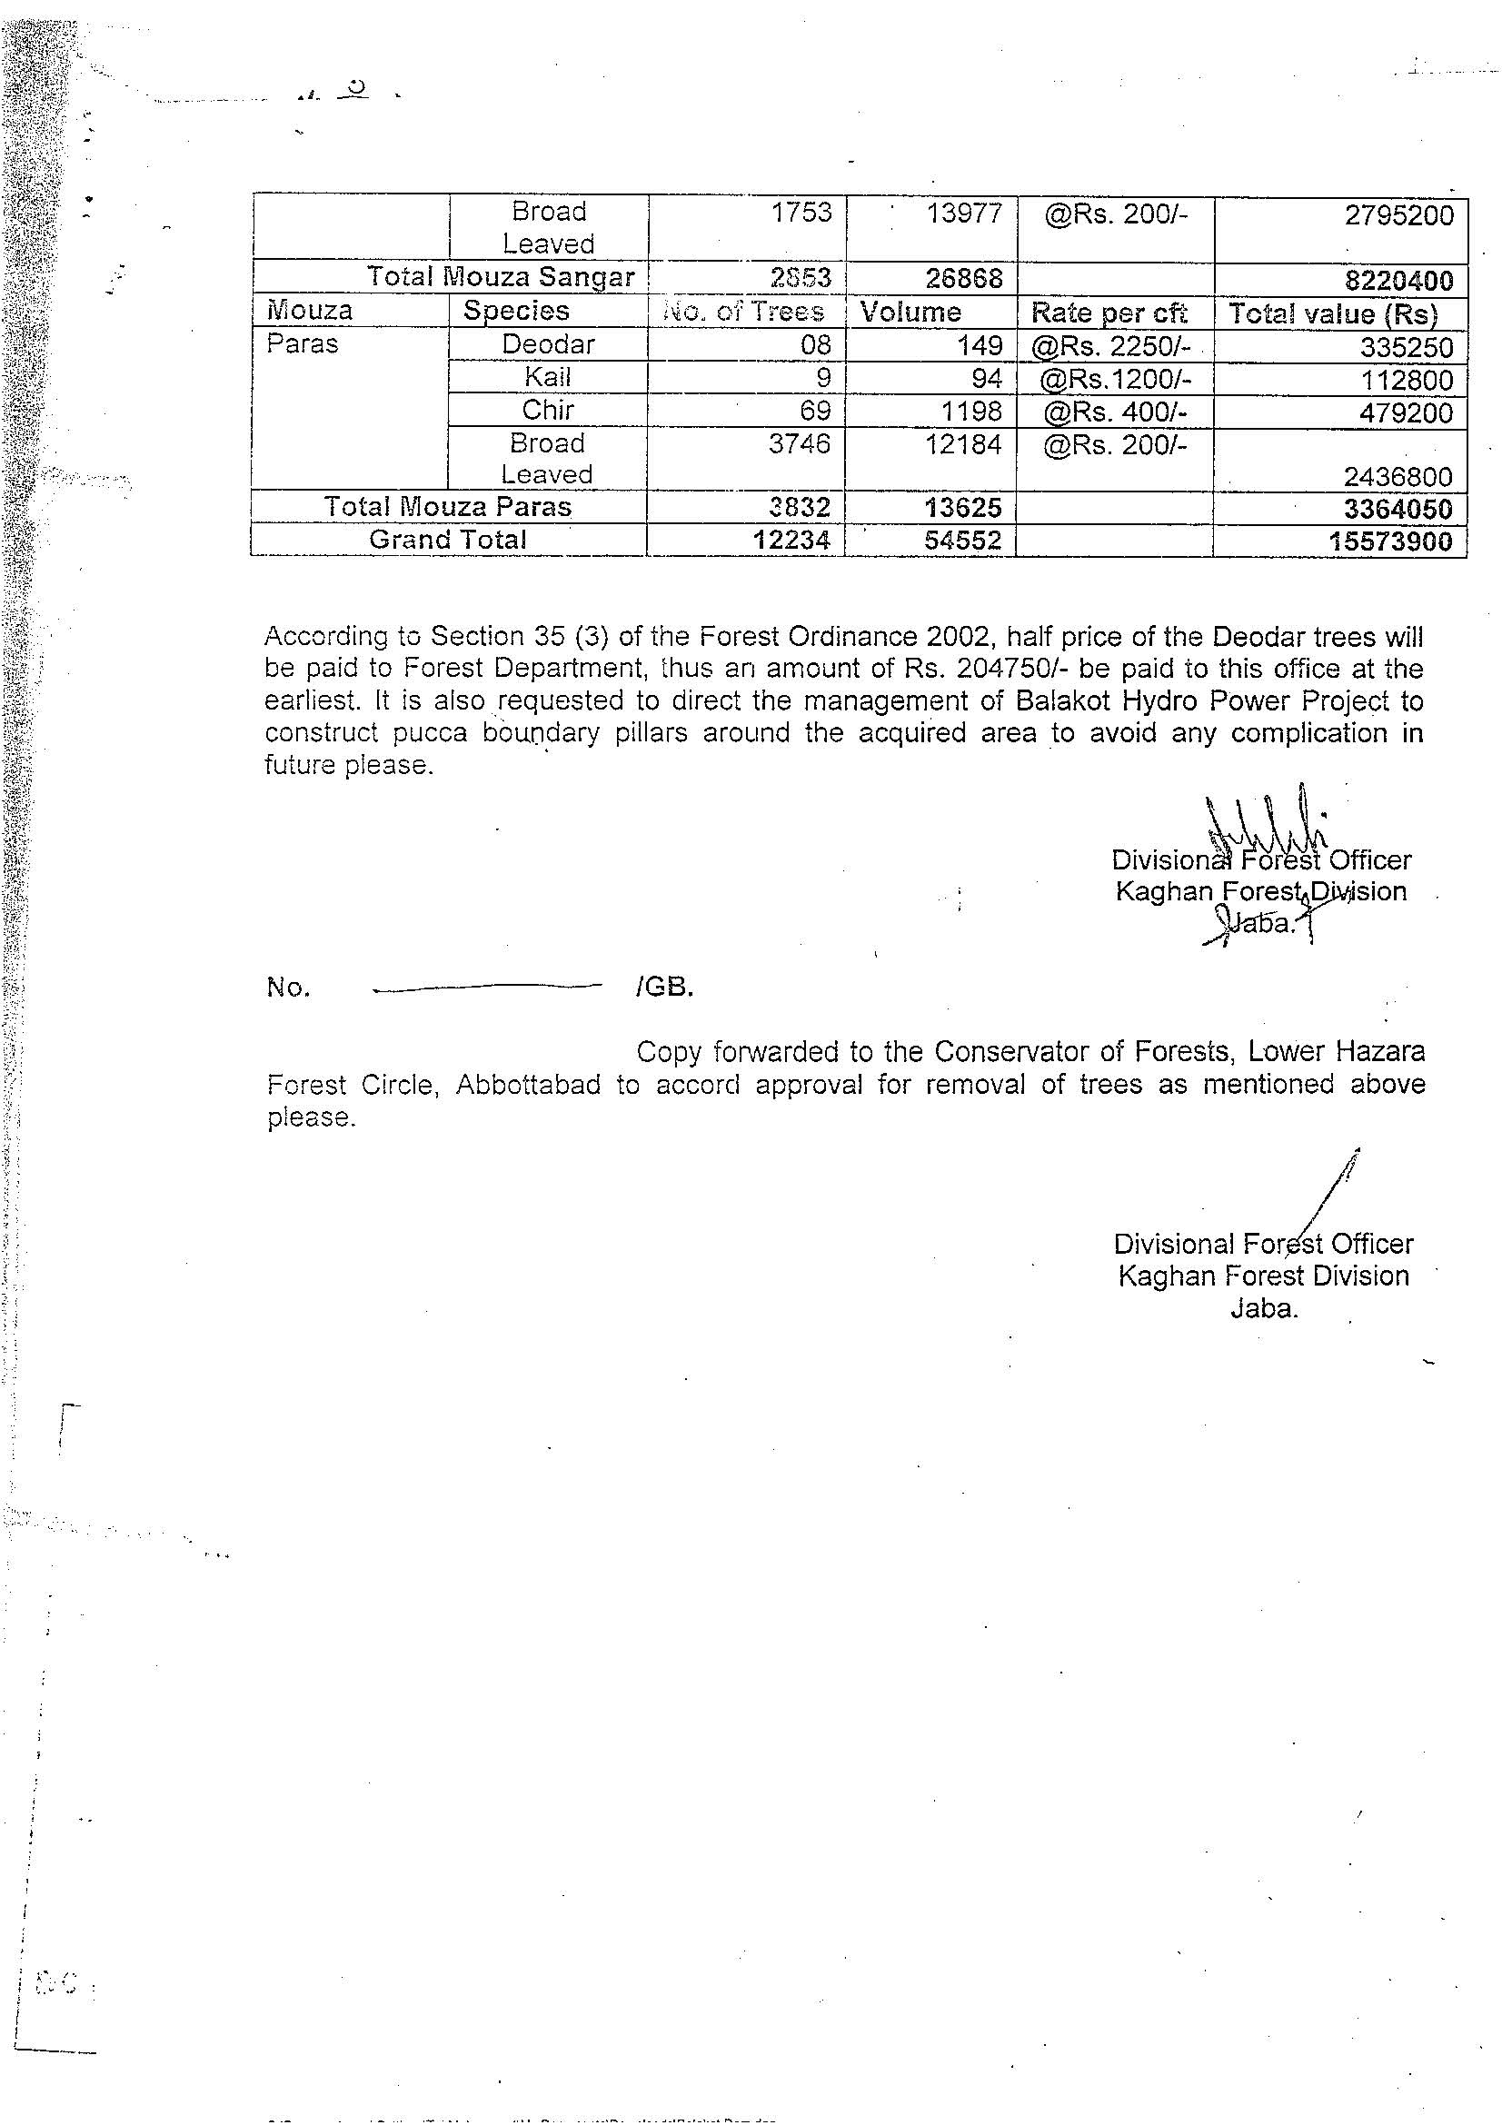

- Notification of Grievance Redress Mechanism (GRM)
